**Station Accumulation/Drift Survey**

***Primary Contact:*** Matt Okraszewski, 303 984 1450 x227, matthew@polarfield.com

***Secondary Contact:*** Amy Burzynski, Bob Haehnel, Jim Lever, CREEL

Prepared by CREEL, edited by Summit Science Techs

Introduction: Science techs at Summit Station have conducted GPS-based surface-elevation surveys bi-annually in the vicinity of the main buildings since 2007. CRREL personnel have compiled the data and generated maps showing snowdrift patterns. The actual survey patterns have varied, so questions arise regarding the most appropriate pattern to use.

Survey Objectives

* Document drift patterns around the main buildings
* Estimate annual winter snowdrift accumulation volumes
* Provide guidance on preferred locations of buildings to minimize maintenance owing to snowdrifts
* Provide guidance on building layout at proposed Isi station to minimize maintenance owing to snowdrifts
* Acquire datasets to validate snowdrift simulation models for building design and station layout at Summit and Isi

Supplies needed:

1. Trimble Zephyr GPS antenna
2. Trimble R7 roving receiver
3. Interstate battery for receiver
4. PolyPod survival sled
5. Snowmachine
6. Equipment for the accumulation survey (see UNAVCO GPS & PPK Guide)
7. Handheld Garmin GPS to keep track of speed, navigate grid layout

Survey Methods

Current surveys use Trimble GPS receivers and a base station. Personnel drive the roving antenna around the area on a snowmobile. The data are high quality but their usefulness depends on the area surveyed and the data spacing.

Please use the same set-up as the ICESAT survey. The only difference is you need to load a different configuration file onto the R7 Receiver.

A serpentine pattern offers a good approach to execute the survey on snowmobile. Based on past surveys, we recommend

* 5-m data spacing along the direction of travel
* 5-m spacing between adjacent survey lines (perpendicular to the direction of travel)
* Drive around 3km/h during the survey, REMEMBER that you might need to drive faster when driving the polypod over snowdrifts to avoid getting stuck

This provides a compromise between resolution needed to meet the objectives and the duration (cold exposure time) to conduct the survey.

Because the objectives focus on the drift patterns near Summit’s main buildings, we recommend limiting the extent of the survey to that area. Figure 1 shows the recommended survey area and approximate serpentine pattern. Table 1 provides the corner coordinates. Survey lines across the direction of the main snowdrifts provide good definition of those drifts, hence we recommend generally east-west line orientation.

* This survey requires you to drive over snowdrifts and uneven terrain, so please wait for a day with good visibility! Avoid days with flat light. Avoid windy days so you can see your tracks during the entire survey.
* Put the 12 volt battery used for ICESAT on the charger the night before you intend to run the survey.
* Setup everything as you would for an ICESAT survey, except you will need to transfer the configuration file called accumSurvey_2sec_ppk.cfg to the R7 receiver. This file can be found here: Y:\data\GEOSummit\UNAVCO\Manuals Software ConfigFiles\Receiver Configuration Files. There are instructions on how to transmit files to the R7 Receiver in the protocol for ICESAT. Make sure to double check that you have the correct configuration file loaded on the R7 before you start the survey.
* It is advisable to make a layout of the survey prior to starting to make navigating easier. You may do this by marking the four corners with flags and driving the perimeter first so you know where to start and end the lines you drive during the survey.
* After you have a good idea of the route and the survey gear is set-up you can begin the survey. Although the area is rather contained, expect the survey to take a few hours due to slow speeds you will be traveling at (3km/h).
* When you are finished with the survey, process the data in the same way you would for an ICESAT survey. Email Matt to let him know that you are finished, and the data is processed and available on the FTP.
* Put the ICESAT configuration file back on the R7 Receiver. There are instructions on how to do this in the ICESAT protocol.

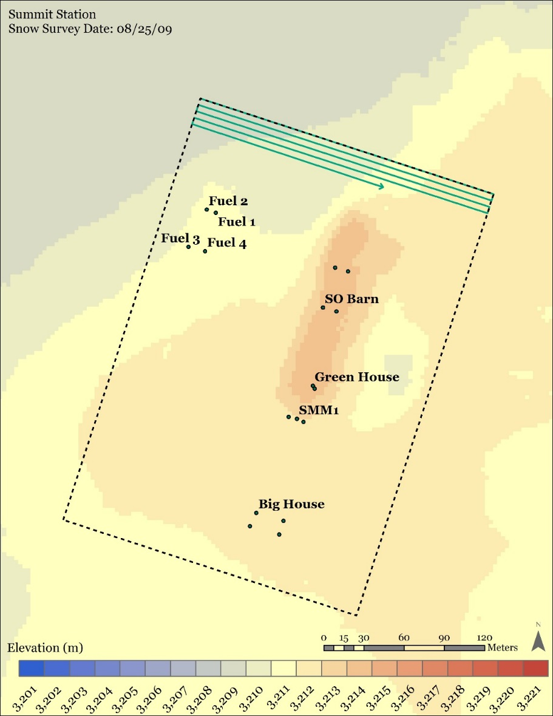

Figure 1. Recommended survey area and serpentine pattern. Data points should be 5 m apart along the direction of travel and lines should be 5 m apart perpendicular to travel. The box is ~ 330 m x 230 m.

Table 1. Survey corner coordinates in Degrees and Decimal Minutes

|  |  |  |
| --- | --- | --- |
| **Corner** | **Lat** | **Long** |
| NW | 72° 34.904 | -38° 27.677 |
| NE | 72° 34.864 | -38° 27.285 |
| SE | 72° 34.696 | -38° 27.474 |
| SW | 72° 34.735 | -38° 27.864 |

|  |  |
| --- | --- |
| **Corner** | **Lat/Long** |
| NW | N72.58173 W38.46128 |
| NE | N72.58107 W38.45475 |
| SE | N72.57827 W38.45790 |
| SW | N72.57892 W38.46440 |

Table 2. Survey coordinates in Decimal Degrees.