**Summit Survey for Snowdrift Analysis**

Amy Burzynski, Bob Haehnel, Jim Lever

CRREL

6 March 2013

**Background**

Science techs at Summit Station have conducted GPS-based surface-elevation surveys in the vicinity of the main buildings since 2007. CRREL personnel have compiled the data and generated maps showing snowdrift patterns. The actual survey patterns have varied, so questions arise regarding the most appropriate pattern to use. Clearly, the objectives for conducting the surveys bear on this question. CRREL, CPS and SCO personnel recently discussed the objectives of the survey, and CRREL agree to generate a document outlining the objectives and the survey methods best able to meet them.

**Survey Objectives**

* Document drift patterns around the main buildings
* Estimate annual winter snowdrift accumulation volumes
* Provide guidance on preferred locations of buildings to minimize maintenance owing to snowdrifts
* Provide guidance on building layout at proposed Isi station to minimize maintenance owing to snowdrifts
* Acquire datasets to validate snowdrift simulation models for building design and station layout at Summit and Isi

**Survey Methods**

Current surveys use Trimble GPS receivers and a base station. Personnel drive the roving antenna around the area on a snowmobile. The data are high quality but their usefulness depends on the area surveyed and the data spacing.

A serpentine pattern offers a good approach to execute the survey on snowmobile. Based on past surveys, we recommend

* 5-m data spacing along the direction of travel
* 5-m spacing between adjacent survey lines (perpendicular to the direction of travel)

This provides a compromise between resolution needed to meet the objectives and the duration (cold exposure time) to conduct the survey.

Because the objectives focus on the drift patterns near Summit’s main buildings, we recommend limiting the extent of the survey to that area. Figure 1 shows the recommended survey area and approximate serpentine pattern. Table 1 provides the corner coordinates. Survey lines across the direction of the main snowdrifts provide good definition of those drifts, hence we recommend generally east-west line orientation.

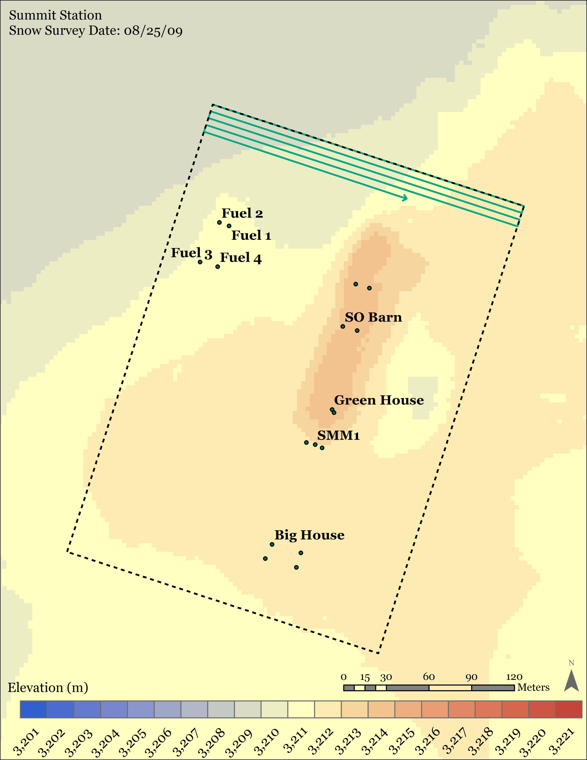

Figure 1. Recommended survey area and serpentine pattern. Data points should be 5 m apart along the direction of travel and lines should be 5 m apart perpendicular to travel. The box is ~ 330 m x 230 m.

Table 1. Survey corner coordinates.

|  |  |  |
| --- | --- | --- |
| **Corner** | **Lat** | **Long** |
| NW | 72° 34.904 | -38° 27.677 |
| NE | 72° 34.864 | -38° 27.285 |
| SE | 72° 34.696 | -38° 27.474 |
| SW | 72° 34.735 | -38° 27.864 |