**Station Accumulation/Drift Survey**

***Primary Contact:*** Matt Okraszewski, 303 984 1450 x227, matthew@polarfield.com

***Secondary Contacts:*** Jason Weale, [jason.weale@erdc.dren.mil](mailto:jason.weale@erdc.dren.mil)

Liu, Julia, Julia.Liu@erdc.dren.mil

Deeb, Elias, [Elias.J.Deeb@erdc.dren.mil](mailto:Elias.J.Deeb@erdc.dren.mil)

Deeb, Elias, Elias.J.Deeb@usace.army.mil

Prepared by CRREL, edited by Summit Science Techs April 2017  
 Contacts updated Jan 2019

How Often: Twice a year:   
-- Spring (mid-February or early March) before major snow movement occurs  
-- Fall (September-early October) after all major drifts have been pushed out and berms have been built, but before major winter storms start drifting station in.

Introduction: Science techs at Summit Station have conducted GPS-based surface-elevation surveys bi-annually in the vicinity of the main buildings since 2007. CRREL personnel have compiled the data and generated maps showing snowdrift patterns. The actual survey patterns have varied, so questions arose regarding the most appropriate pattern to use.

Survey Objectives

* Document drift patterns around the main buildings
* Estimate annual winter snowdrift accumulation volumes
* Provide guidance on preferred locations of buildings to minimize maintenance owing to snowdrifts
* Provide guidance on building layout at proposed Isi station to minimize maintenance owing to snowdrifts
* Acquire datasets to validate snowdrift simulation models for building design and station layout at Summit and Isi

Supplies needed:

1. Trimble equipment for the accumulation survey:
   1. Trimble backpack
   2. 12’’ extension pole for antenna
   3. Trimble Zephyr GPS antenna
   4. Interstate battery for receiver
   5. Trimble R7 roving receiver
2. Handheld Garmin GPS to mark survey corners

**For more information about the Trimble Equipment, refer to the UNAVCO binder located in the Tech office.

Survey Methods

Current surveys use Trimble GPS receivers and a base station. Personnel walk the length of the survey using the roving antenna with the backpack setup. The data are high quality but their usefulness depends on the area surveyed and the data spacing.

A serpentine pattern offers a good approach to execute the survey on foot. Based on past surveys, we recommend

* 5-m data spacing along the direction of travel
* 5-m spacing between adjacent survey lines (perpendicular to the direction of travel)

This provides a compromise between resolution needed to meet the objectives and the duration (cold exposure time) to conduct the survey.

Because the objectives focus on the drift patterns near Summit’s main buildings, we recommend limiting the extent of the survey to that area. Figure 1 shows the recommended survey area and approximate serpentine pattern. Tables 1 and 2 provide the corner coordinates. Survey lines across the direction of the main snowdrifts provide good definition of those drifts, hence we recommend generally east-west line orientation.

This survey requires you to walk over snowdrifts and uneven terrain, so please wait for a day with good visibility! Avoid days with flat light. Avoid windy days so you can see your tracks during the entire survey.

Procedure

Put the 12 volt battery used for ICESAT on the charger the night before you intend to run the survey.

* + Measure the distance (in meters) from the bottom of the antenna mount to the ground while the person who will be conducting the survey has the backpack on (see below for instructions). It is important that the measurement take place while the tech is wearing the gear (boots especially) they will have on during the survey, and the backpack is fit to comfort.
  + Load the proper Accumulation Survey Configuration file on to the R7 receiver:
    - Connect the R7 receiver into the science tech laptop in the Greenhouse using the power and comms cable plugged into the R7 Port 2 and a comm port on the PC.
    - Notes for powering the R7 receiver: As of July 2010, the power port 1 on the R7 receiver is not functioning. If desired, the external battery can be used instead of the cable with the AC adapter specified above to supply power to the receiver.
    - Power on the receiver by pressing the green button.
    - From the start menu, launch “Configuration toolbox” (Start > All Programs >Trimble >Configuration Toolbox > Configuration Toolbox)
    - Select Communications -> Get File…
    - From the dialog box, select “power_up” and click “Get File”
    - Select File -> Open…
    - In the dialog box choose the file “accumSurvey_2sec_ppk.cfg”. This file can be found at: Y:\data\GEOSummit\UNAVCO\Manuals Software ConfigFiles\Receiver Configuration Files.
    - Click “Open”
    - Verify the file settings are as indicated above.
    - Click “Transmit”
    - If the dialog comes up asking if you want to replace the file “power_up,” select “Yes”
    - You should see the message “the application successfully transmitted to the receiver”- click “OK”
    - Navigate to the “Antenna” page and enter the height (in meters) from the ground to the base of the antenna while the person who is conducting the survey is wearing the backpack and boots he or she will be wearing outside. ** Note: If two different people perform the survey, this measurement must be changed in the configuration file before the second person starts their portion of the survey**
    - Click “Save”
    - Click “Close”
  + Set up the backpack as pictured below:
    - Connect the battery to Port 2 of the R7, being careful to line up the red marks from the cable to the R7 port. This connection can come loose quite easily, so placing a piece of tape to hold it may be helpful.
    - Attach the extension pole to the outside of the backpack.
    - Attach the Trimble Zephyr GPS antenna to the top of the extension pole.
    - Connect the antenna to the R7 using the yellow TNC antenna cable, running the cable through the top of the backpack. The 90 degree end attaches to the antenna. Make sure there is plenty of slack so neither end is stressed.
    - If it is very cold outside, hot water bottles can be added to the pack to extend the life of the battery.

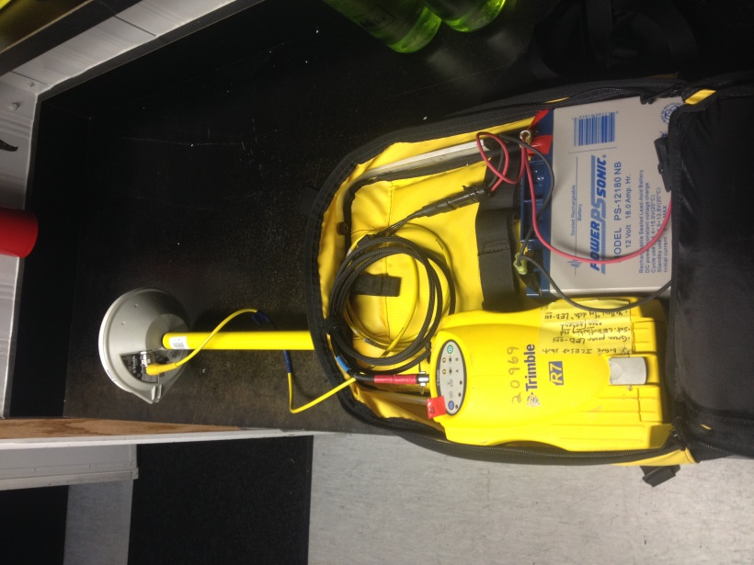 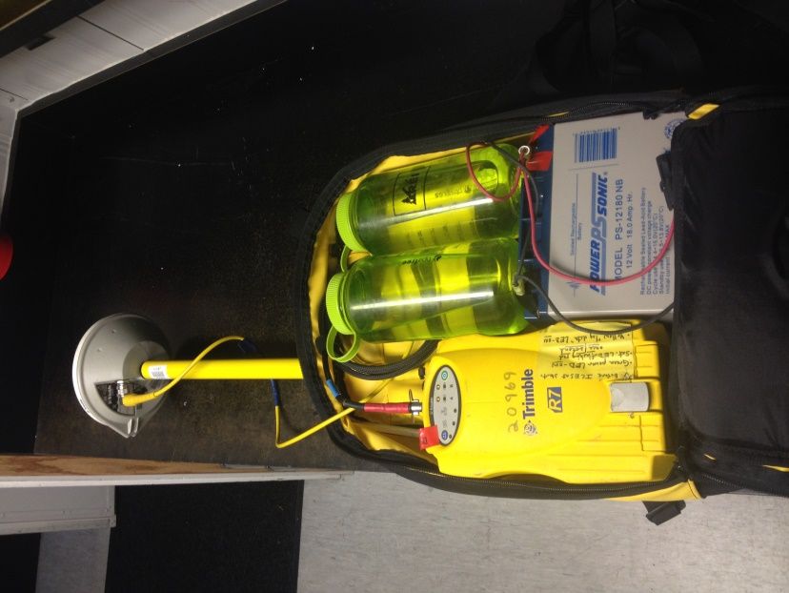

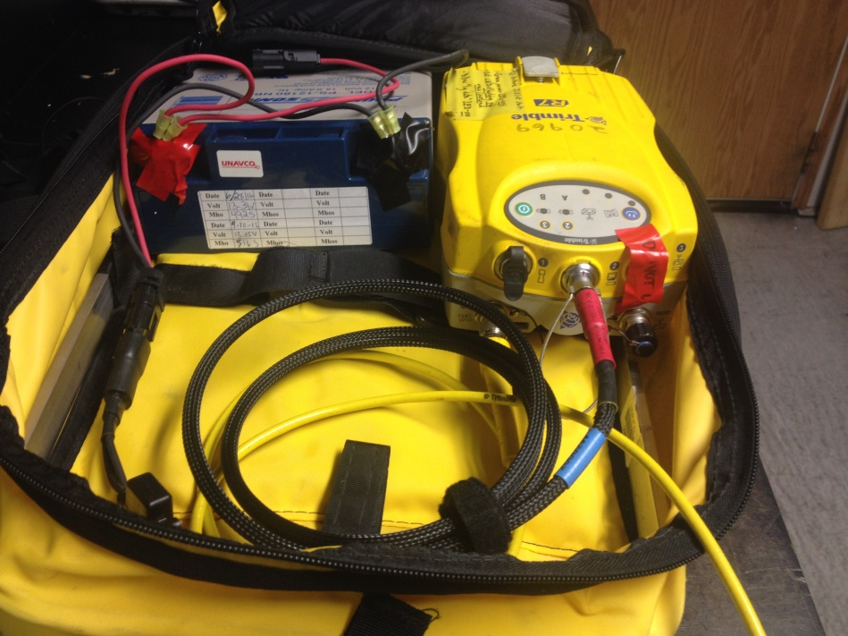

GPS Antenna connection

Port 2 battery connection

* It is advisable to make a layout of the survey prior to starting to make navigating easier. You may do this by marking the four corners with flags and driving the perimeter on a snowmobile first so you know where to start and end the lines you walk during the survey.
* After you have a good idea of the route and the survey gear is set-up you can begin the survey. Although the area is rather contained, expect the survey to take a few hours due to slow speeds you will be traveling at (3km/h).
* Because the battery cable connection is loose, it is advisable to have a second person check that the battery cable is still connected to the R7 and all the appropriate lights are on about every 30 minutes to 1 hour during the survey.
* When you are finished with the survey, process the data in the same way you would for an ICESAT survey. Save the survey in a new folder named “YYMMDD_camp_survey” under \\Server\ftp\Operations\GPS\Accumulation_Surveys
* Email Matt O. to let him know that the data is processed and available on the FTP.
* Put the ICESAT configuration file back on the R7 Receiver. There are instructions on how to do this in the ICESAT protocol.

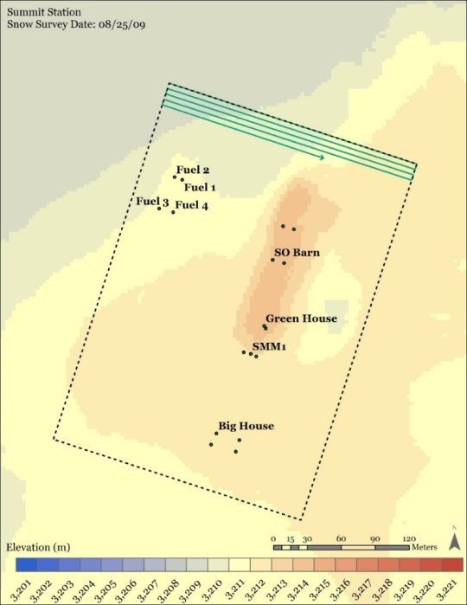

Figure . Recommended survey area and serpentine pattern. Data points should be 5 m apart along the direction of travel and lines should be 5 m apart perpendicular to travel. The box is ~ 330 m x 230 m.

|  |  |
| --- | --- |
| **Survey corner coordinates in Decimal Degrees** | |
| **Corner** | **Lat/Long** |
| NW | N72.58173 W38.46128 |
| NE | N72.58107 W38.45475 |
| SE | N72.57827 W38.45790 |
| SW | N72.57892 W38.46440 |

|  |  |  |
| --- | --- | --- |
| **Survey corner coordinates in Degrees and Decimal Minutes** | | |
| **Corner** | **Lat** | **Long** |
| NW | 72° 34.904 | -38° 27.677 |
| NE | 72° 34.864 | -38° 27.285 |
| SE | 72° 34.696 | -38° 27.474 |
| SW | 72° 34.735 | -38° 27.864 |

* Science Project Manager will send the ftp link to the survey data to Emma Menio and Jason Weale and cc Stephen Newman (all with CRREL). Station Operations and Facilities managers will also be cc’d.