Performed by Battelle ARO Science Technicians:

Nate Bowker, Nicolette Ratz and Alicia Bradley in May 2022

Roving receiver: Trimble R7 with Trimble Zephyr Geodetic antenna

Base receiver: Septentrio PolaRx5 with Septentrio PolaNt-x MF antenna

**Site 1: 1816 – 1847 UTC on 2022-05-02**

**Midpoint where GPS was positioned: 31.17m**

**Snow surface to base of antenna: 1.93m**

**Roving receiver file: 32031220**

**Base receiver file: SMM3122s.22_.gz**

**Antenna position:**

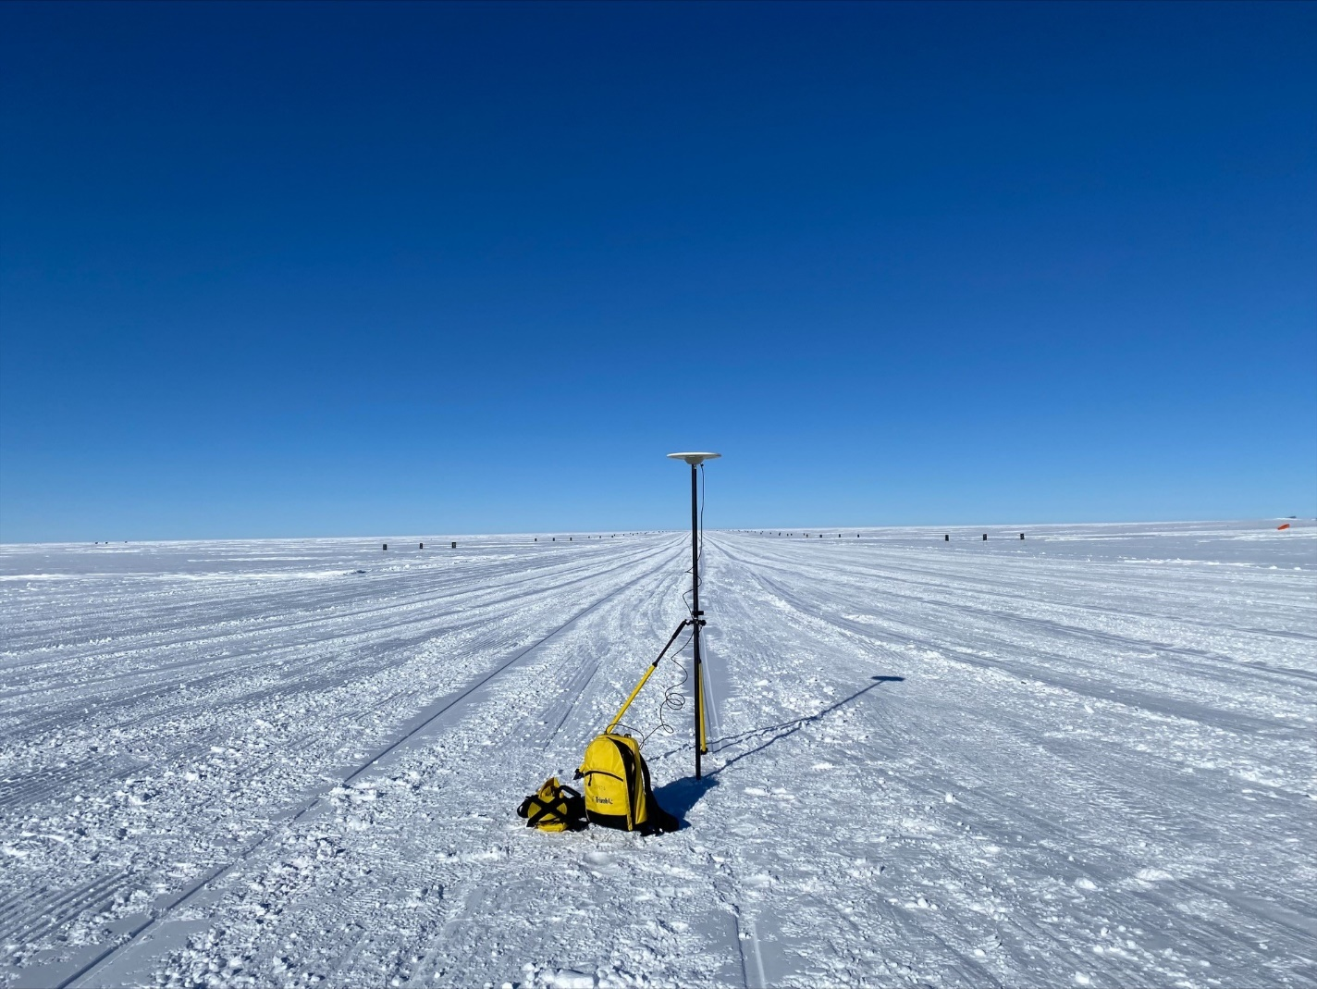

Vertical measurement from snow surface to base of antenna: 1.93 m

Antenna mount positioned 31.17m between thresholdmarkers

**Site 2: 1905 – 1937 UTC on 2022-05-02**

**Midpoint where GPS was positioned: 31.915m**

**Snow surface to base of antenna: 1.95m**

**Roving receiver file: 32031221**

**Base receiver file: SMM3122t.22_.gz**

**Antenna position:**

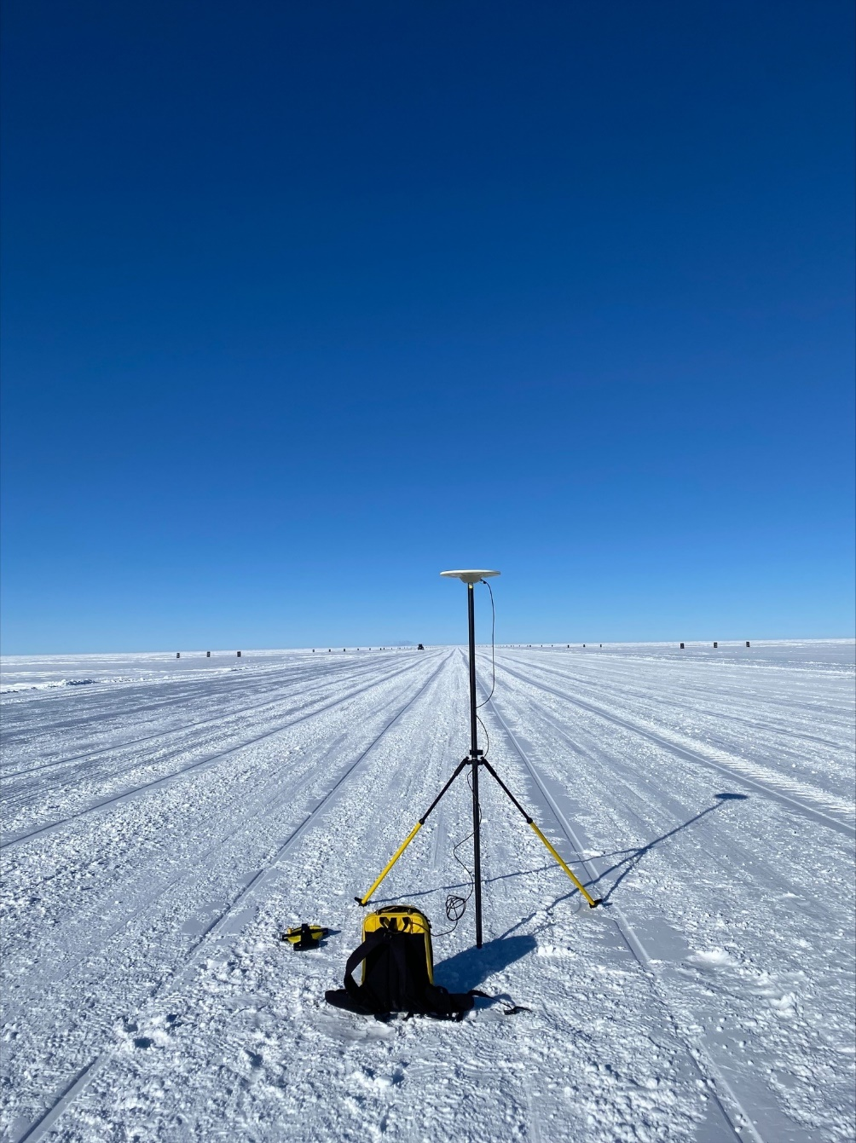

Antenna mount positioned 31.915m between threshold markers

Vertical measurement from snow surface to base of antenna: 1.95 m

**Site 3: 1829 – 1900 UTC on 2022-05-03**

**Midpoint where GPS was positioned: 31.485 m**

**Snow surface to base of antenna: 1.935 m**

**Roving receiver file: 32031230**

**Base receiver file: SMM3123s.22_.gz**

**Antenna position:**

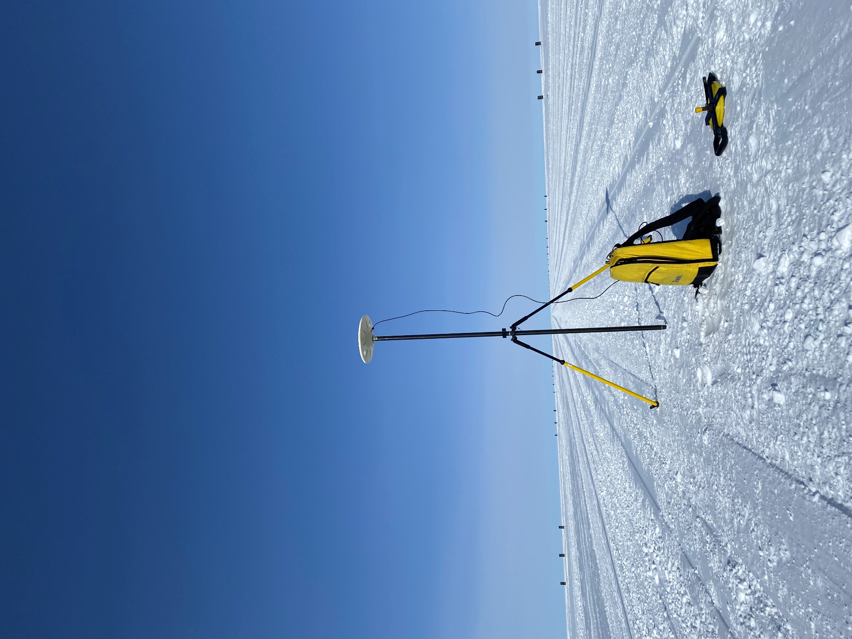

Antenna mount positioned 31.485 m between threshold markers

Vertical measurement from snow surface to base of antenna: 1.935 m

**Site 4: 1925-1955 UTC on 2022-05-03**

**Midpoint where GPS was positioned: 31.285 m**

**Snow surface to base of antenna: 1.925 m**

**Roving receiver file: 32031231**

**Base receiver file: SMM3123t.22_.gz**

**Antenna position:**

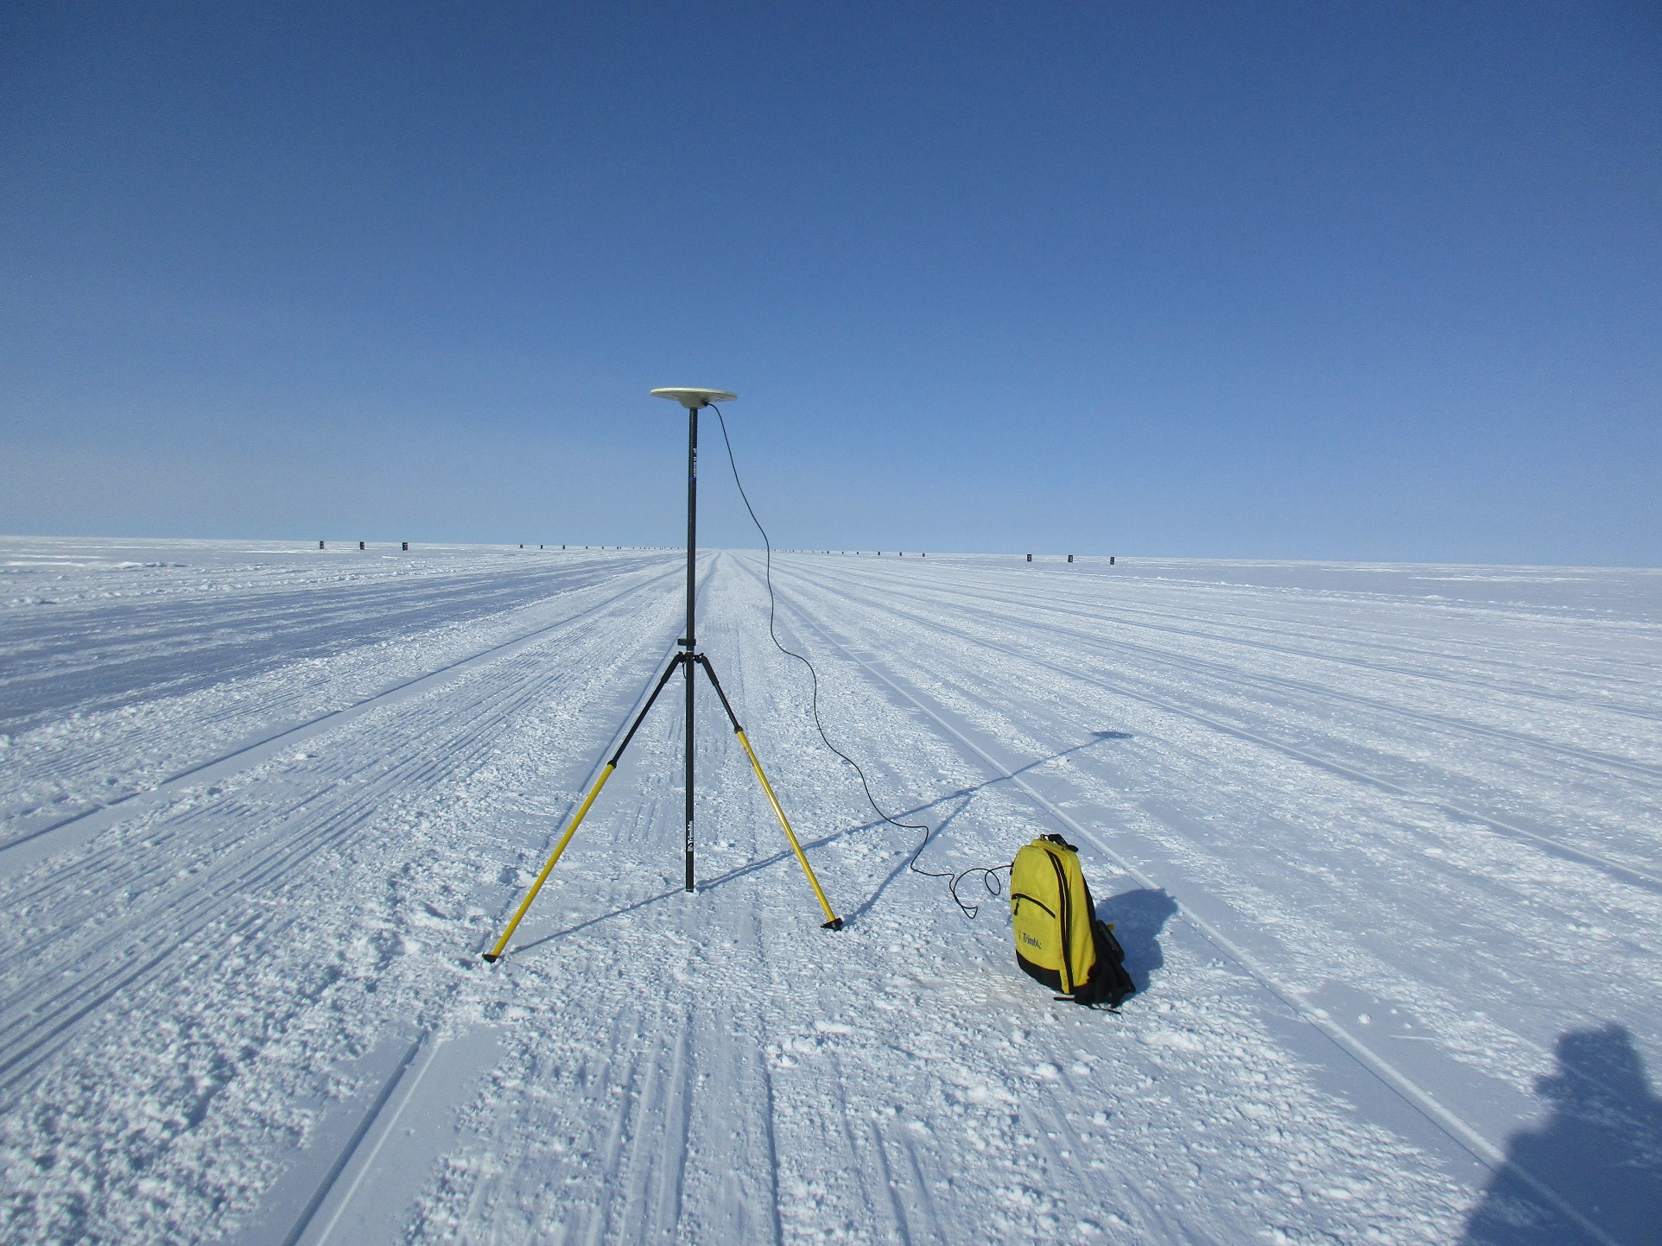

Vertical measurement from snow surface to base of antenna: 1.925m

Antenna mount positioned 31.285m between threshold markers

**Site 5: 1721-1751 UTC on 2022-05-04**

**Midpoint where GPS was positioned: 30.70 m**

**Snow surface to base of antenna: 1.93 m**

**Roving receiver file: 32031240**

**Base receiver file: SMM3124r.22_.gz**

**Antenna position:**

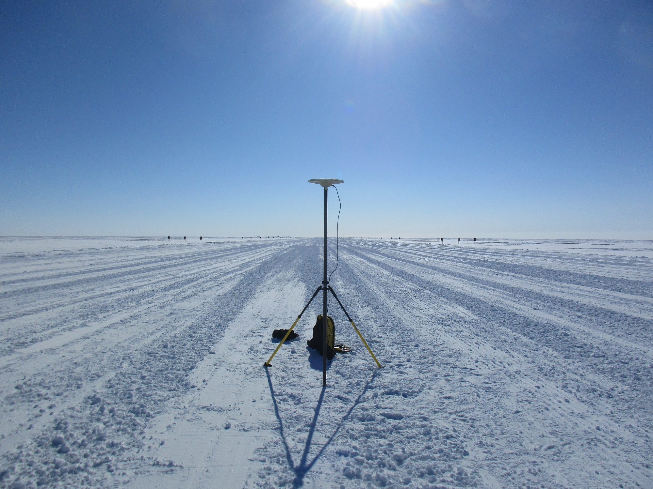

Vertical measurement from snow surface to base of antenna: 1.93 m

Antenna mount positioned 30.70 m between threshold markers