Performed by Battelle ARO Science Technicians:
Nate Bowker, Nicolette Ratz and Alicia Bradley in May 2022
Roving receiver: Trimble R7 with Trimble Zephyr Geodetic antenna
Base receiver: Septentrio PolaRx5 with Septentrio PolaNt-x MF antenna

Site 1 – South Threshold: 1816 – 1847 UTC on 2022-05-02
Center point where GPS was positioned: 31.17m
Snow surface to base of antenna: 1.93m
Roving receiver file: 32031220.t01
Base receiver file: SMM31220.22O
Antenna position:

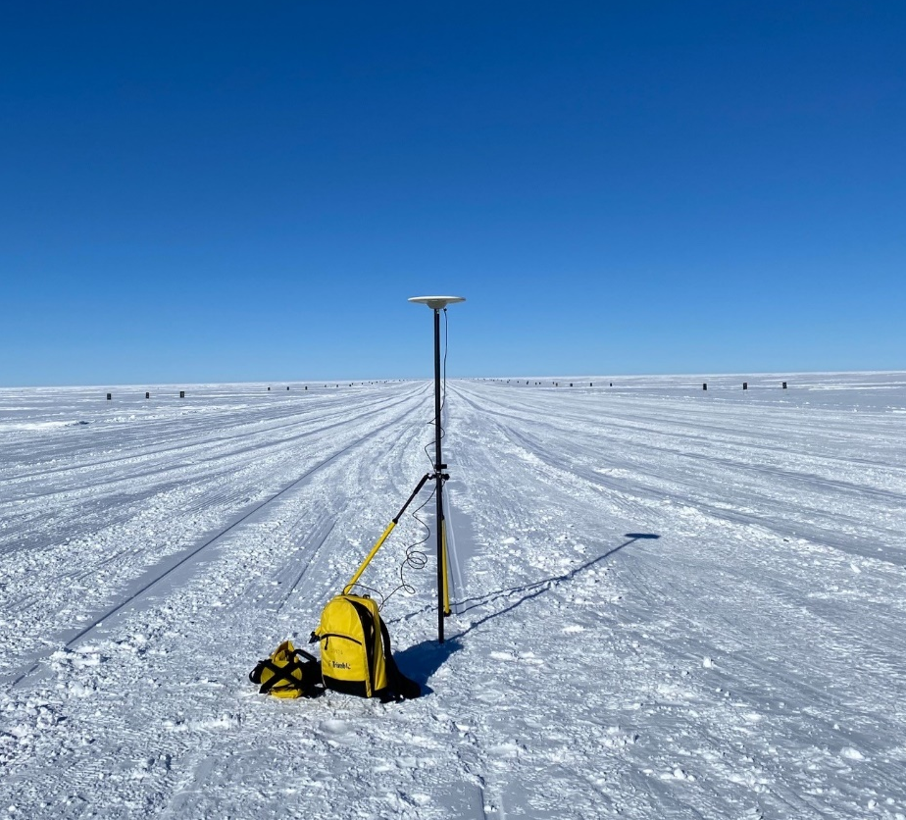
Vertical measurement from snow surface to base of antenna: 1.93 m
Antenna mount positioned 31.17m between threshold markers

Site 2 – “Point #2” : 1905 – 1937 UTC on 2022-05-02
Center point where GPS was positioned: 31.915m
Snow surface to base of antenna: 1.95m
Roving receiver file: 32031221.t01
Base receiver file: SMM31221.22O
Antenna position:

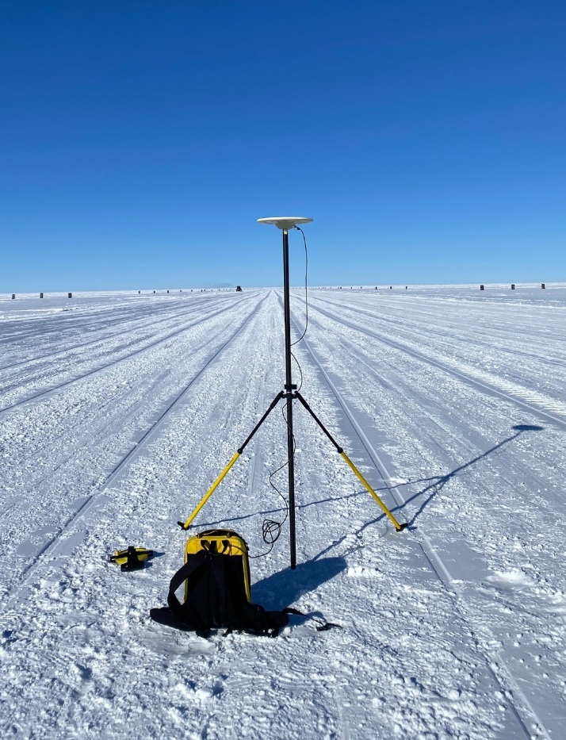
Antenna mount positioned 31.915m between threshold markers
Vertical measurement from snow surface to base of antenna: 1.95 m
Site 3 – Skiway Midpoint: 1829 – 1900 UTC on 2022-05-03
Center point where GPS was positioned: 31.485 m
Snow surface to base of antenna: 1.935 m
Roving receiver file: 32031230.t01
Base receiver file: SMM31230.22O
Antenna position:

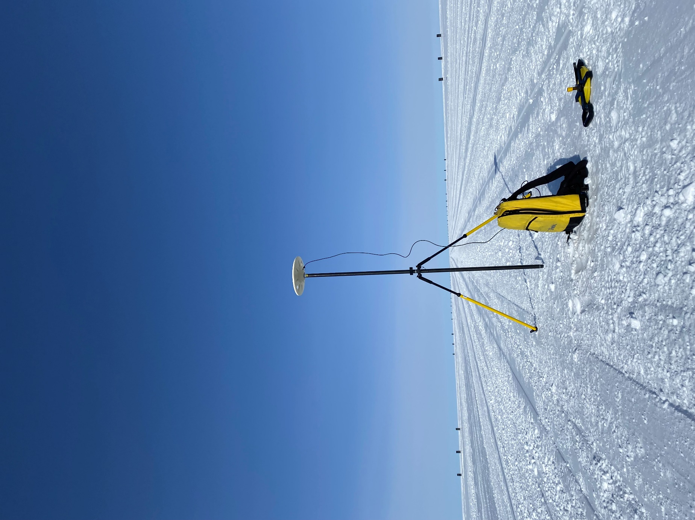
Antenna mount positioned 31.485 m between threshold markers
Vertical measurement from snow surface to base of antenna: 1.935 m

Site 4 – “Point #1”: 1925-1955 UTC on 2022-05-03
Center point where GPS was positioned: 31.285 m
Snow surface to base of antenna: 1.925 m
Roving receiver file: 32031231.t01
Base receiver file: SMM31231.22O
Antenna position:

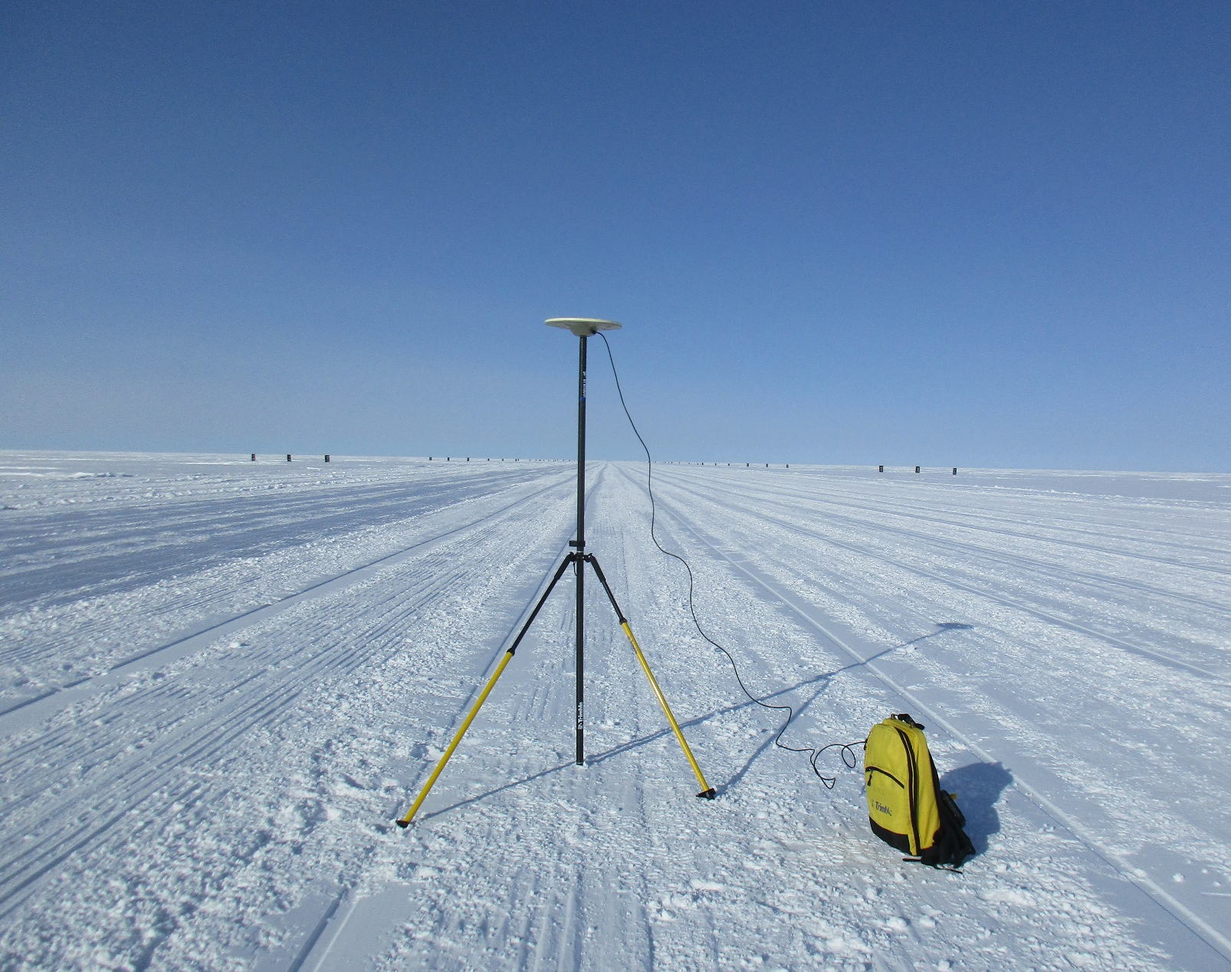
Vertical measurement from snow surface to base of antenna: 1.925m
Antenna mount positioned 31.285m between threshold markers

Site 5 – North Threshold: 1721-1751 UTC on 2022-05-04
Center point where GPS was positioned: 30.70 m
Snow surface to base of antenna: 1.93 m
Roving receiver file: 32031240.t01
Base receiver file: SMM31240.22O
Antenna position:

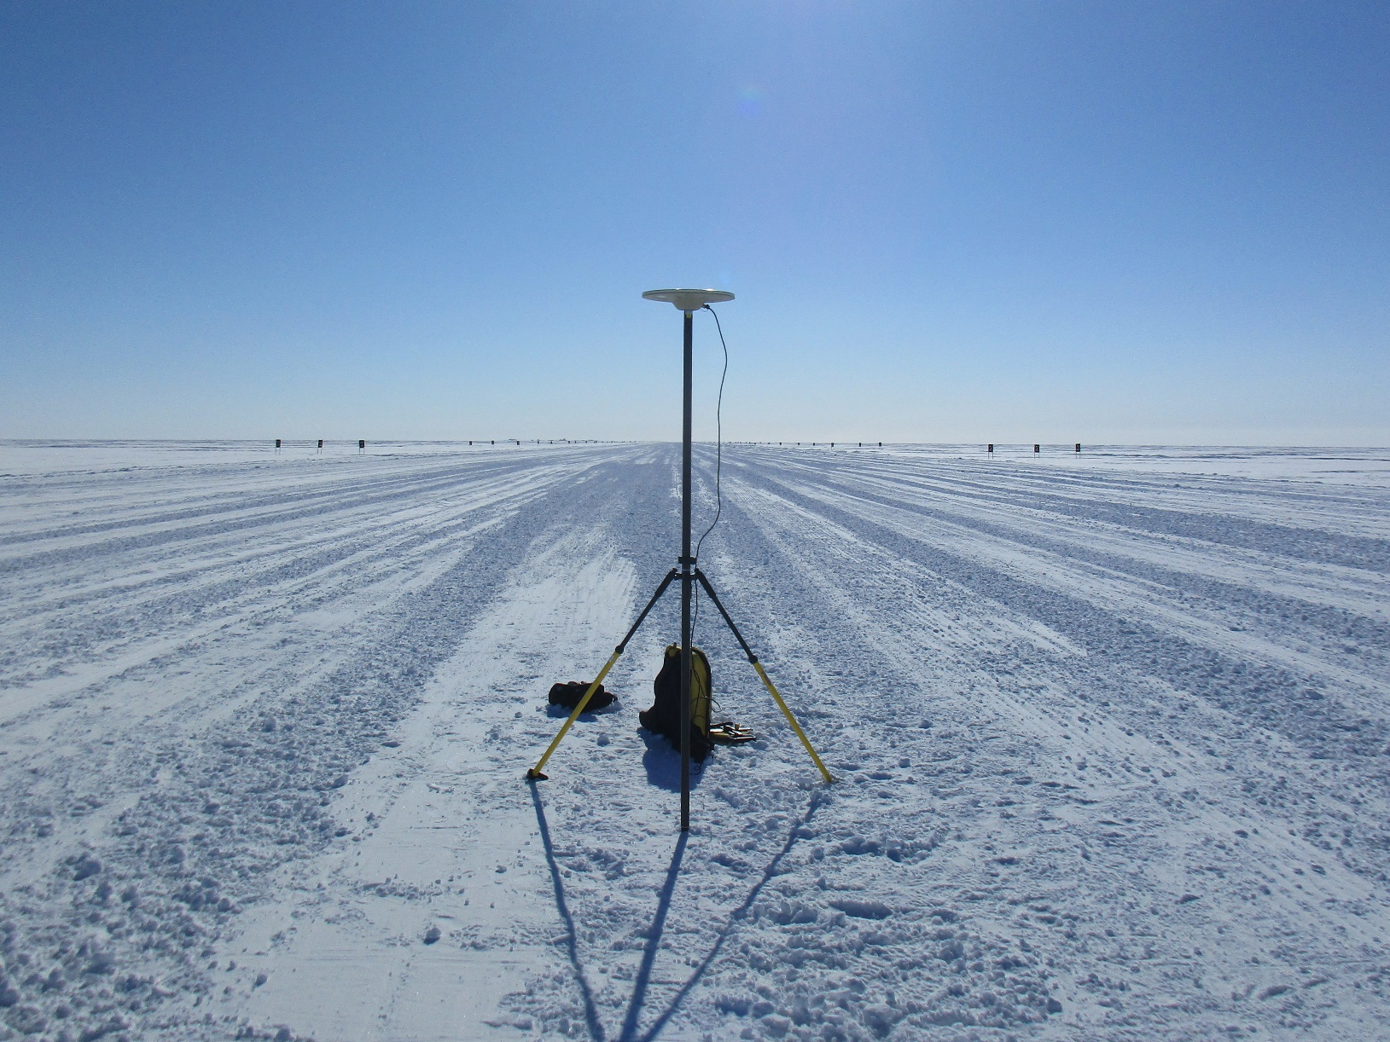
Vertical measurement from snow surface to base of antenna: 1.93 m
Antenna mount positioned 30.70 m between threshold markers

