# Summit Station Skiway Report - July 30, 2020

**SKIWAY:**

Use of center skiway is recommended. Rammsonde penetrometer measurements for snow strength taken weekly.

**Markers**: Skiway markers are raised and are free of frost/snow.

**Surface Grooming Completed:**

|  |  |  |
| --- | --- | --- |
| **Phase Type:** | **# since last flight period:** | **# since beginning of season:** |
| **Full width Grooming** | 6 | 6 |
| **Centerline** | 0 | 0 |
| **Turnarounds** | 6 | 6 |

* Skiway construction in accordance with SOP418 - Construction, Surface and Strength Maintenance Procedures for Summit Station Skiway with the exception of compaction cycles. This was not done in accordance with discussion with CRREL due to the temperatures during construction.
* Skiway is free of all major undulations and there is currently zero drifting.
* Additional maintenance will be performed prior to flights as weather conditions / drifting dictate.
* Maintenance will be done after each flight.
* Skiway will receive one more cycle of full grooming prior to the first flight and be allowed to sinter 72 hours.

**TAXIWAY:**

Markers: Red flags denoting taxiway area have been raised / replaced as necessary.

|  |  |  |
| --- | --- | --- |
| **Phase Type:** | **Since last flight period:** | **Since beginning of season:** |
| **Full Width Grooming** | 4 | 4 |

**APPROACH MARKERS:** CompletelyRaised.

**COMMUNICATIONS:**

|  |  |  |
| --- | --- | --- |
| **VHF/AM** | 122.8 MHz Primary | 123.45 MHz Secondary |
| **HF** | Not in operation | Not in operation |
| **Iridium** | 8816.314.60730 |  |

**WEATHER:**

Weather station operational.

Weather observations:

* Begin 3 hours prior to first scheduled off deck from BGSF.
* Are transmitted 10 minutes prior to each hour (00:50)
* Continue hourly. Provided more frequently in intermittent conditions or upon request.
* End upon departure of final aircraft from Summit or as directed.
* Updated conditions available upon request during flight operations.

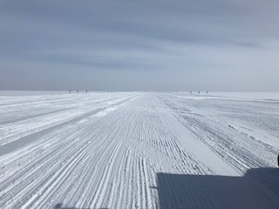

Skiway Kneeling

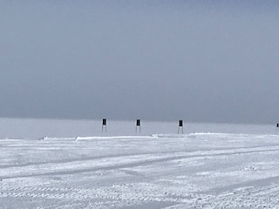

Example of flags

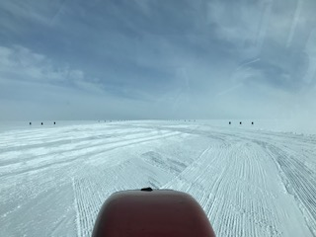

From equipment

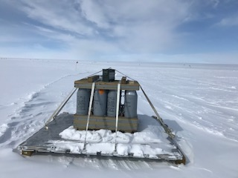

ATO near taxiway

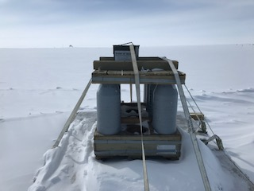

Side view