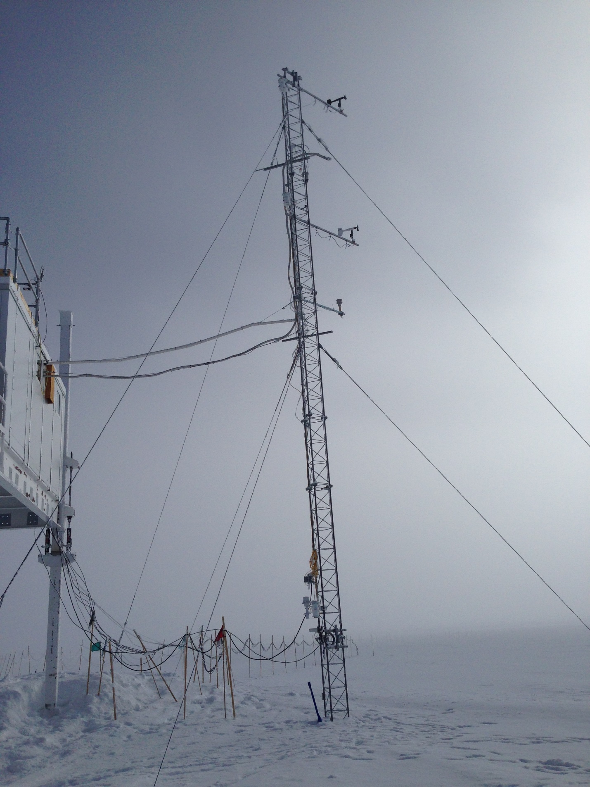

Outlets powering RTD fans

\*\* Note: The stated heights of the met sensors are not necessarily accurate. They were raised summer 2015 in anticipation of accumulation and to avoid disturbance after the TAWO raise.

Seismometer antenna

\*\* Black capped inlet at ~13m is spare inlet to NOAA GC\*\*

Surface Ozone inlet (orange/while plastic)

NOAA CATS GC inlets (silver bells)

CUGC inlet

10m wind bird

TAWO Tower Map

August 2015

AE16 inlet (black tube)

Neph/CLAP/AE33 inlet (silver hook)

10m Cambridge housing RTD

16m wind bird

16m Cambridge housing RTD

2m Cambridge housing RTD

2m Honeywell humidity sensor

9m Sonic anemometer