University of Adelaide – Polarsonde: A Meteorological Sensor To Detect Aircraft Icing Hazard

Primary contact: Murray Hamilton, murray.hamilton@adelaide.edu.au, +61 8 8313 3994 / +61 8 8264 6635 (h)
Secondary contact: Matthew Shupe, matthew.shupe@noaa.gov, 303-497-6471

Polarsonde Balloon launches

How often: Only launch during heavy overcast conditions, ideally when ICECAPS instruments indicate possibility of mixed phase cloud.

Clean requirements: None

Supplies needed: Polarsondes with batteries and foam boxes, RSA921 interfaces, 500 g or 600 g balloons, Helium.

Introduction:
The project is an instrument development and validation exercise. The polarsonde is intended to profile clouds to determine whether they consist of super-cooled liquid water or ice crystals. This knowledge is important for aviation weather forecasting, for weather and climate modeling and for fundamental cloud physics.

Procedure:

Modifications since 2012
- The connection to the radiosonde via the RSA921 ozone sonde interface has changed.
- The battery configuration has changed.

Precautions
- Be careful not to touch the output surface of the LED lens or the photodiodes. Fingerprints will compromise the polarizing properties of these surfaces. Fingerprints can be cleaned off with alcohol, but do not use acetone, which will attack the polarizer.
- Be aware that the time in the polarsonde output data file starts from when the preparation of the radiosonde starts. However the time in the EDT file starts (re-zeros actually) when the actual launch takes place. It is often necessary to manually note the time from beginning of the preparation to the launch so as to apply this re-zeroing to the polarsonde time data.
- Be careful that the LED lens does not become loose in the metal ring. If this happens, do not launch – the realignment is not possible in the field.
- The power input to the board is via regulator IC’s that were an afterthought. Check that the leads of these regulators (wrapped in blue and white heatshrink) have not broken. This is a field repair if you feel up to it!

Bits needed
1 x polarsonde
1 x RSA921 ozonesonde interface
3 x 9 V batteries
Duct tape ca 1.5 m
Terminal strip with two connectors
500 g or 600 g balloon
RS92-SGP Vaisala radiosonde

Tools needed
Multimeter
Screwdriver with blade small enough to adjust the trimpots
Larger screwdriver for terminal block
Black foam block with recess for covering photodetectors

Preparing the batteries.
Connect two 9V batteries in series to make one 18V battery. Note Duracell batteries do not seem to like this treatment! Use the Energizer brand for this. The terminals can have wires soldered to them as shown in the picture of the foam box. It is easiest if the batteries are taped together as shown. (Five pairs of batteries with wires soldered appropriately have been left behind. Connect red to red and green to black.)
The unconnected leads on the battery will go to the red and black unconnected leads on the polarsonde, using a piece of terminal strip. This terminal strip doubles as a switch, so don’t finish this connection until power is needed on the polarsonde! This battery combination is good for several hours. The battery powering the LED is good only for about 90 min.

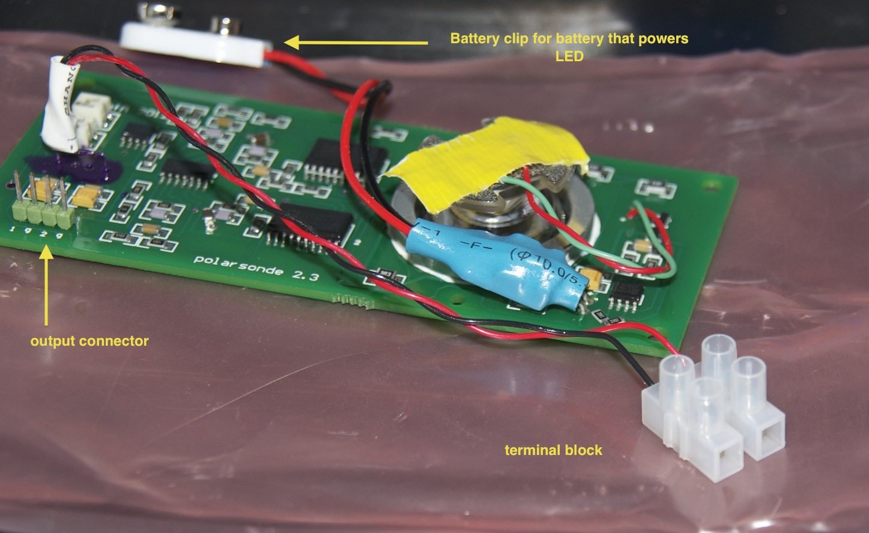
Polarsonde

No special preparation is needed for the 9V battery that powers the LED. However do not connect this battery until it is needed. It is good for only about 90 min of operation.
(Note: polarsonde numbers 18 and 19 have a little circuit board on one of the power inputs – the leads from the 18V battery are attached to the flying leads from this small board.)

Preparing the foam box.
The batteries fit into polyurethane foam box sideways as shown.
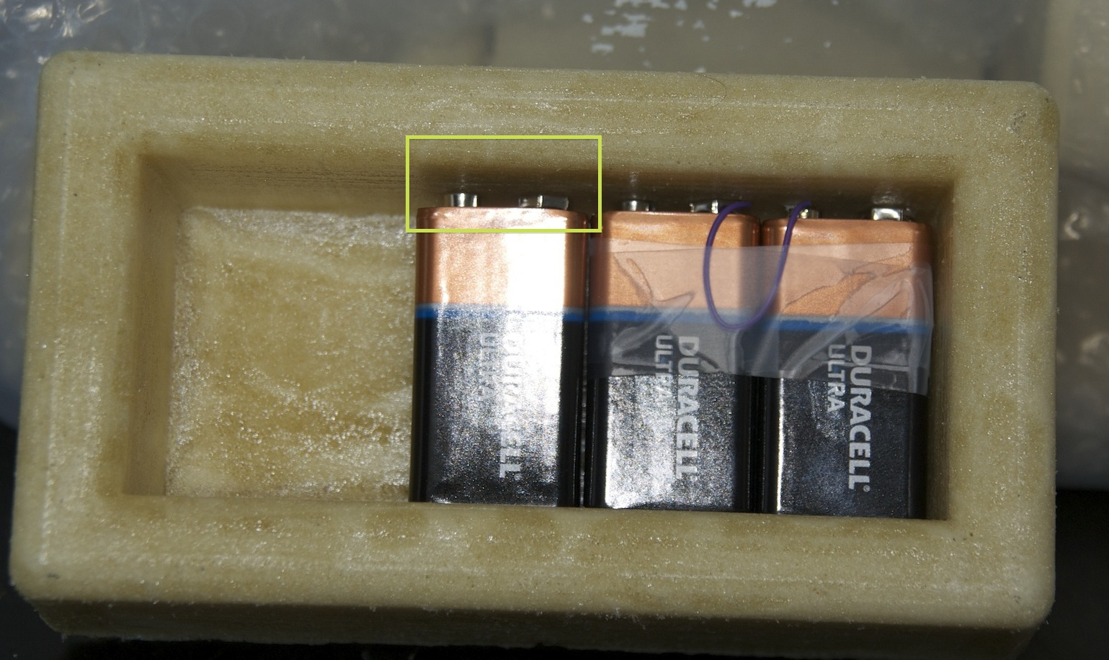
Batteries packed into foam box. The two joined by the purple wire should be Energizer brand, not Duracell!! The green rectangle shows where the clip on the left battery (powering the LED) needs to be accommodated. The space to the left of the batteries accommodates the RSA921 interface.

The clip for the battery that powers the LED does not fit in to the box until the inside wall of the box has a little rebate pushed or cut into it. With the rigid white clips, this can be done simply by pushing the battery with the clip attached down into the box with a small degree of violence. Chiseling a small recess out with a screwdriver is more elegant!
(The greasiness of the boxes is just a residue of Vaseline used as a release agent for the polyurethane.)

Preparing the RS92 SGP radiosonde
This preparation is mostly the same as preparing for an ordinary radiosonde flight, but there are a couple of extra points.
- The RSA921 needs to be connected to the RS92 (Vaisala radiosonde) while it is being prepared (and must remain attached?). The polarsonde need not be attached at this stage. (The RSA921 derives its power from the radiosonde.) The ground check station must detect the presence of the RSA921, in order for the four data channels from the RSA921 to be included in the data recording.
- At the window below, you must select Special>Ozone-OIF92
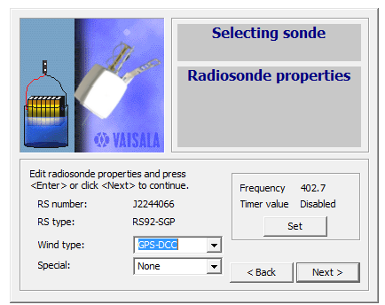
- The option Ozone-OIF92 must be selected (see step above). Associated with this option are a number of inputs that need to be added by the operator:
- For flow rate enter “1”.
- For ‘sensor type’, any of the options can be chosen.
- The RSA921 serial number needs to be entered.
- When an input for the sensor current is required, enter any number that the software will accept (0 to 0.2).
These inputs associated with ozone measurements are demanded by the software, because the software is calculating ozone concentrations, or at least thinks it is. This is irrelevant for the polarsonde.

Balloon filling.
Using a 500 g balloon, filling until it lifts 200 g plus the mass normally used for a 350 g balloon will give an initial ascent rate of about 6 m/s. It would be better if this additional mass were about 150 g, rather than 200 g.

Adjustment of output offset voltages
Connect the batteries to the polarsonde.

Check the output levels with no light getting to the photodetectors. This is important as the output voltage offset must not be negative because the RSA921 interface cannot accept negative voltage inputs. The batteries do need to be connected at this point. Cover the photodiodes with the recess in the black foam block as shown. Be careful that the foam does not cover or intrude over the LED output window. Monitor each of the output pins with a multimeter, and adjust the corresponding trimpot so that the output voltage is 200 mV. This setting is arbitrary – anything between 100 mV and 500 mV is appropriate, but it needs to be the same for both channels, and it needs to be recorded. Then connect the polarsonde to the RSA921

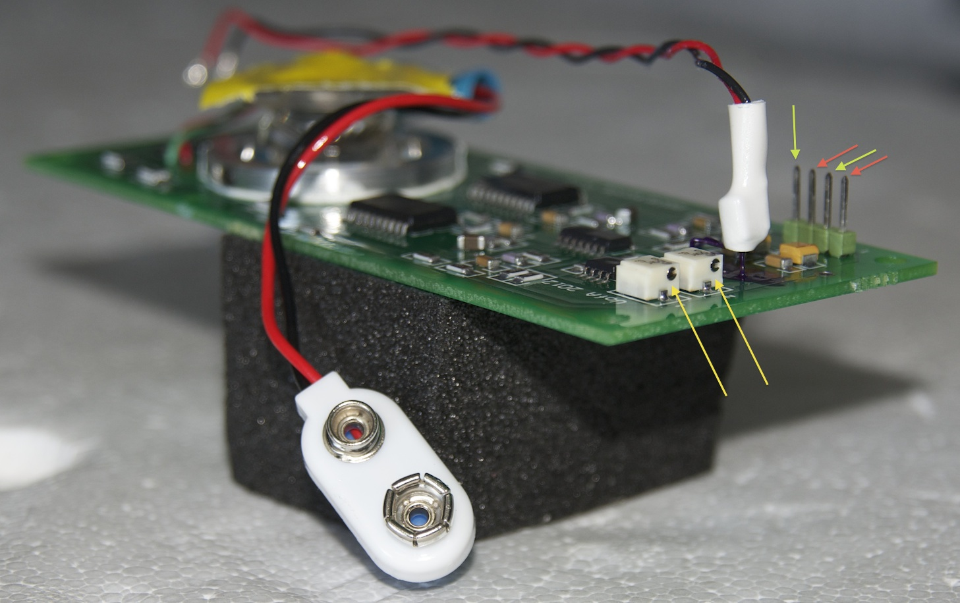
The polarsonde, with the foam covering the photodetectors but not the LED.
The trimpots are shown with the yellow arrows. The output pins are shown with the red arrows, and their corresponding grounds with the green arrows.

Assembly of polarsonde package
Tape the thermistor on the RSA921 to one of the batteries. Ensure that the green wire coming from the RSA921 is connected to the “g” on the output of the polarsonde.

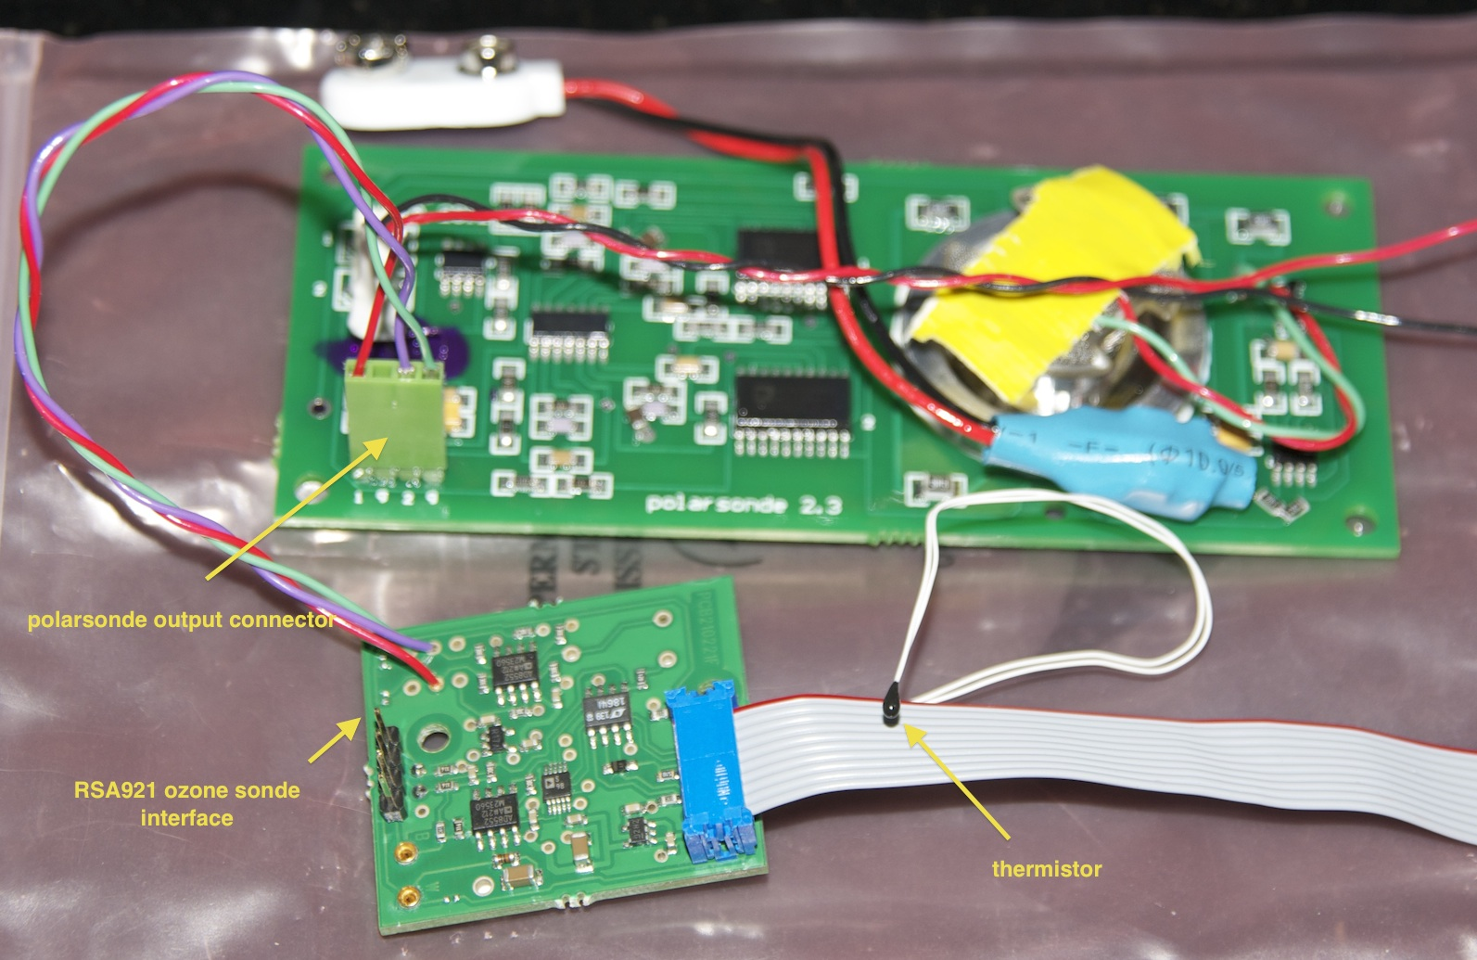
Polarsonde and RSA921 interface (ribbon cable from RSA921 goes to Vaisala radiosonde).

Pack the batteries in a row into the bottom of the foam box (as shown in photo above) with the RSA921 in the bottom at the other end. Cover this with the polarsonde (light shining outward!). Use duct tape to hold this assembly together, being careful not to cover either the photodetectors, or the LED with the tape.
Duct tape the polarsonde assembly to the radiosonde, again without blocking any of the optical surfaces. It doesn’t matter whether the LED is above or below the photodiodes.

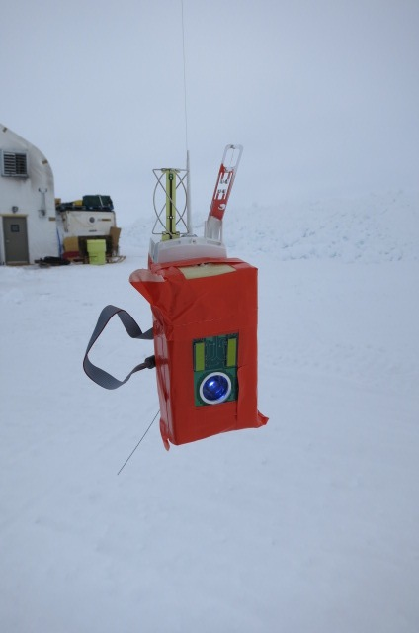
Picture of completed polarsonde/radiosonde assembly.

While the sonde is hanging outside to stabilize the PTU signal:
-Standing behind the polarsonde, hold a sheet of paper in front of it for 5 seconds, then remove for 5 seconds, then hold again for 5 seconds. Note the time on the Digicora display when the paper first went up.

Extraction of polarsonde data & info to send to Murray

The Digicora III system records the data to a *.dc3db file. In fact this is a Microsoft Access database, but the data within is stored as binary files. To extract the data, click on the Archive Manager button in the Digicora software. A window listing recent .dc3db data files will appear. Right click the desired file and select Export → Convert. A window will appear listing the various possible outputs. The files to be converted are EDT, FRAWPTU, and SPECSENSORS. These should be output as ASCII → General, which will create .tsv files. SPECSENSORS is the critical file.

Send the EDT.tsv, FRAWPTU.tsv, and SPECSENSORS.tsv files along with the appropriate .dc3db file to Murray. (Or can put these files in a directory on the summit ftp drive.)

You will also need to email Murray with the following information:

- Polarsonde #
- Channel 1 & 2 V_{out}
- Time on Digicora display when paper is first put up
- Sonde launch time

Retro:
None – surplus batteries and balloons can be used for other projects

Consumable Resupply Items:
None – project ends when polarsondes are all launched!

