ICECAPS Weekly Report
Oct. 7 – Oct. 13, 2012
Lance Roth – Phase II Tech

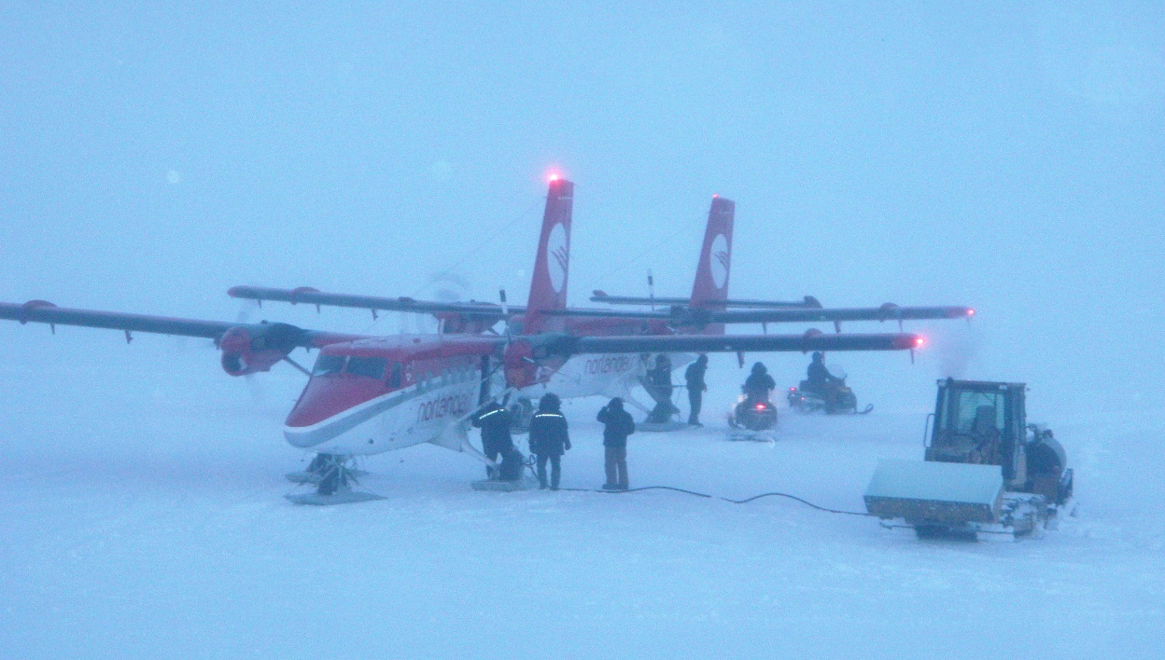

General Items
• Turnover was completed and Phase I has departed.

Dataman Account:
• Normal

PAERI:
• 11/9, Partial blue flags
• 11/10, Partial blue flags
• 11/13, Fan quit working. Will replace ASAP.

MPL:
• 11/7, 12:43:05, "AMCS Timeout", "Can't Open AMCS Card: 2". Reboot. Measurements resumed at
14:17:37.
• 11/10, 14:53:00, Found Computer Logged Outed. Measurements resumed at 14:53:00.
• 11/12, 17:45:00, Found Computer Logged Outed. Measurements resumed at 17:45:00

CAPABL:
• Normal

MMCR:
• Normal

MWR:
• 11/11, 17:30:00, Receiver 2 Temp Stability was Red.

ASIA-A:
• 11/7, break in communication w/radiometer at 1740 UTC. Power cycle radiometer, restart software. Back up at 1832 UTC.
• 11/8, software frozen at 1123 UTC. No computer control, ctl-alt-del will not work. Manually turned off computer w/power button. Computer will not reboot. Contacted Pierre.
• 11/9, Replaced old computer with spare computer. Reconnected to radiometer and currently collecting data. Elevated new computer to increase ventilation. 1445 UTC.

SODAR:
• Normal

POSS:
• Normal

VCEIL:
• Normal

IceCAM:
• Normal

IcePIC:
• No snowflake pictures taken this week.

Radiosonde:
• Normal

