ICECAPS Weekly Report
Nov. 14 – Nov. 20, 2012
Lance Roth – Phase II Tech

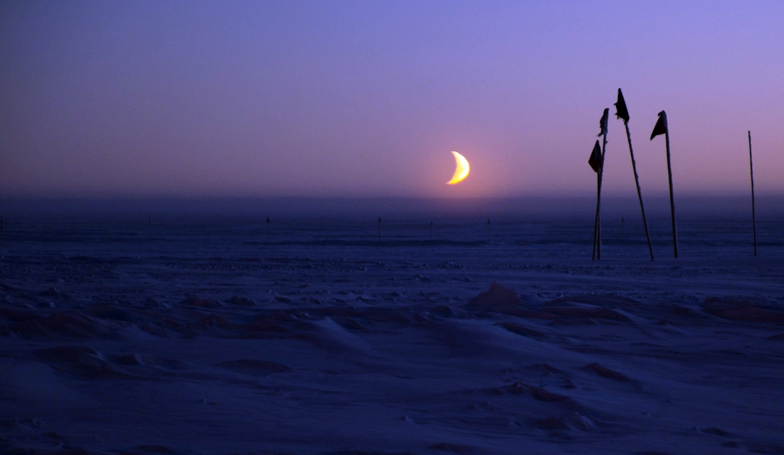

Interesting weather events:
• 11/15 North winds
• 11/16 20+ Knot North winds
• 11/19 North winds

General Items
• It was a busy first week with a lot of North Winds. Pipes froze in the Big House on Friday morning due to strong North Winds. 40 full Helium cylinders were moved into the SOB on Tuesday.

Dataman Account:
• Normal

PAERI:
• 11/18 At 1930 noted. LW HBB NEN, SW HBB NEN, LW Responsivity, and SW Resoponsivity.
Scene mirror w/ Light Snow. Brushed snow off mirror 1948 UTC. Flagged returned to Green
• 11/19 At 1125 noted. LW HBB NEN, SW HBB NEN, LW Responsivity, and SW Resoponsivity.
Scene mirror w/ Light Snow. Brushed snow off mirror 1129 UTC. Flagged returned to Green.
Brushed snow off mirror again at 2052 UTC.
• 11/20 At 1800 noted. LW HBB NEN, SW HBB NEN, LW Responsivity, and SW Resoponsivity.
Scene mirror w/ Light Snow. Brushed snow off mirror 1807 UTC. Flagged returned to Green.

MPL:
• 11/16, 12:30:00, Found Computer Logged Outed. Measurements resumed at 13:05:00.
Richard Coulter

CAPABL:
• Normal

MMCR:
• 11/19, 1412 UTC found in Standby mode and would not switch to Operate mode “Helix Overcurrent
Fault.” Rebooted MMCR twice. 1442 UTC system running normal.

MWR:
• Normal

ASIA-A:
• 11/17 Lost connection at 1939 UTC. Re-established connection at 0124 UTC

SODAR:
• 11/19, 1540 UTC Removed Snow.

POSS:
• Normal

VCEIL:
• Normal

IceCAM:
• Normal

IcePIC:
• No pictures taken this week.

Radiosonde:
• 11/16 Late termination.
• 11/19 Late termination.

