ICECAPS Weekly Report
Nov. 21 – Nov. 27, 2012
Lance Roth – Phase II Tech

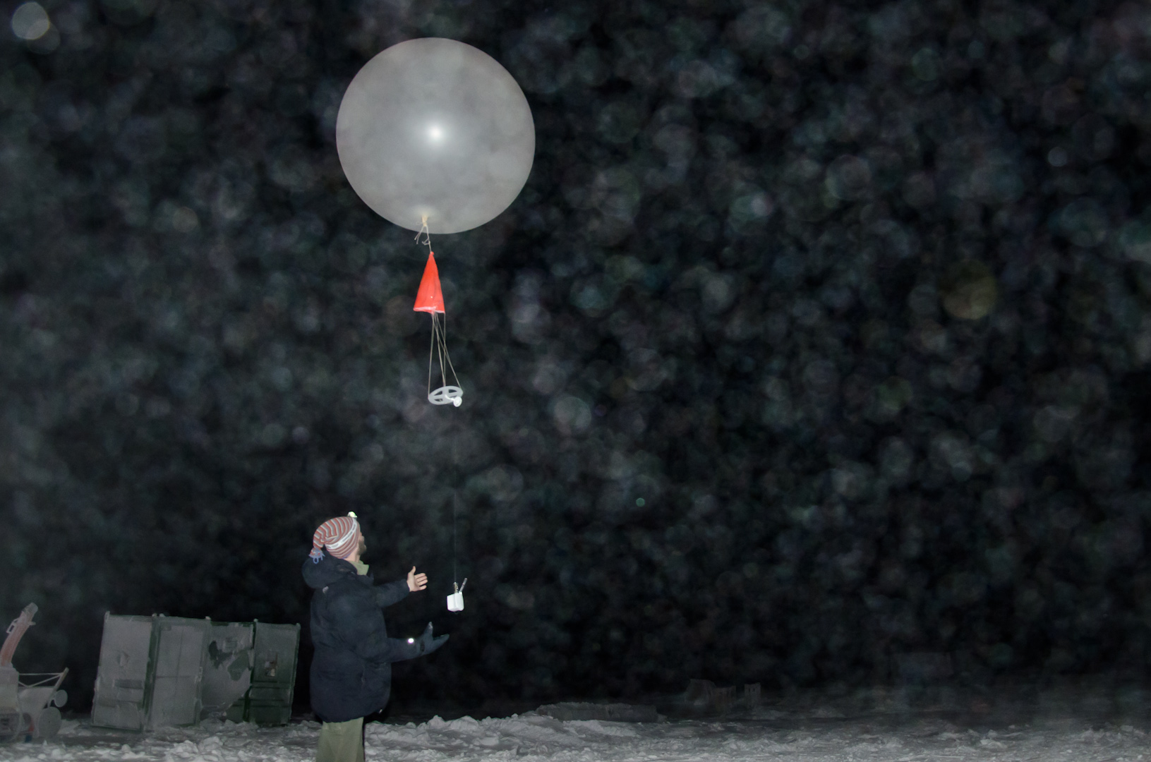

Interesting weather events:
• 11/21 Little to No Winds, Cloud, and clear.
• 11/23 High Winds exceeding 25 knots
• 11/26-27 Warm temps (-8 F)

General Items
• 11/27 MSF extremely warm (80.0 F near PAERI). Turned down heaters and increased air flow.

Dataman Account:
• Normal

PAERI:
• 11/21 At 1220 noted. LW HBB NEN, SW HBB NEN, LW Responsivity, and SW Resoponsivity.
Scene mirror w/ Light Snow. Brushed snow off mirror 1240 UTC. Flagged returned to Green.
• 11/25 Partial Blue Flags
• 11/27 Partial Blue Flags

MPL:
• 11/23, 1641 UTC, “Can’t find AMCS Card. Restarted MPL at 1644 UTC.

CAPABL:
• Normal

MMCR:
• Normal

MWR:
• Normal

SODAR:
• Normal

POSS:
• Normal

VCEIL:
• Normal

IceCAM:
• Normal

IcePIC:
• No pictures taken this week.

Radiosonde:
• Normal.

ASIA-A:
• 11/23 Lost connection at 1939 UTC. Re-established connection at 0124 UTC
• 11/26 Lost connection at 1322 UTC. Re-established connection at 1327 UTC
Lost connection at 1451 UTC. Re-established connection at 1453 UTC
• 11/26 Trouble shooting Arduino camera.

