ICECAPS Weekly Report
Nov. 28 – Dec. 04, 2012
Lance Roth – Phase II Tech

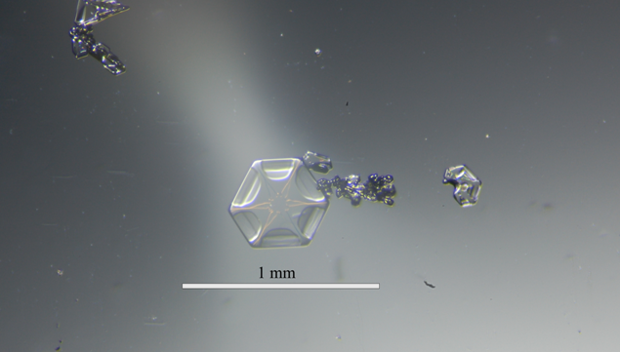

General Weather:
• 11/28 FEW200 -8F 25+ knots
• 11/29 BKN030 87% RH -4F 15 knots -SN
• 11/30 FEW080 -20F 10 knots
• 12/01 BKN120 -24F 9 knots
• 12/02 SCT100 -40F 10 knots
• 12/03 BKN030 80% RH -20F 12 knots
• 12/04 BKN030 81% RH -18F 10 knots

General Items
• 11/28 adjusted thermostat settings on air handler: No result. Found Actuator slipping on shaft and
fixed in the open position with the louvers closed. Adjusted actuator on 11/29 and continued
close monitoring room temp (65 F).
• 11/29 an unusually warm air mass passed through bringing significant snow. I was able to take
pictures of plates, but had trouble collecting snow on slides.

Dataman Account:
• 12/04 1300 UTC Computer unresponsive. Rebooted computer at 1630 UTC. Remounted all at 2020 UTC.
PAERI:
• 11/29 Partial Blue Flags. Fan stopped working. “Bump” started at 1640 UTC.
• 11/30 Fan stopped spinning. “Bump” started at 1245 UTC. And again at 1730 UTC.
• 12/01Fan stopped working. “Bump” started.
• 12/02 Partial Blue Flags. Fan stopped working. “Bump” started.
• 12/03 Replaced Fan at 1400 UTC.

MPL:
• 11/29 1250 UTC - Found computer Logged out. Restarted at 1250 UTC.
• 12/03 1435 UTC Successfully completed after pulse calibration.

CAPABL:
• 11/28, Actual V45 value 9.35
• 11/30, Computer found logged out and emissions light off. Restarted software but failed to start Laser.

MMCR:
• 11/29 1250 UTC – Entire system shutdown. Restarted UPS and the radar came right back at 1305 UTC.

MWR:
• Normal

SODAR:
• 11/29 1335-1338 UTC checked and removed snow from enclosures.

POSS:
• 12/04 Restarted software at 1709 UTC after rebooting ICECAPS computer.

VCEIL:
• Normal

IceCAM:
• Normal

IcePIC:
• 11/29 1400 UTC attempted to take pictures. Trouble catching snow on slide. Left slides outside.
1645 UTC accumulated excessive snowflakes. Left slides out for one hour.
1745 UTC captured several good plates.

Radiosonde:
• 11/28 PM Sonde failed do to High Winds. No Launch Detected.
• 11/29 Late closeout on PM Sonde.

ASIA-A:
• 12/02 Break in Connection, Reconnected at 1626 UTC
• 12/03 Break in Connection, Reconnected at 1329 UTC

