ICECAPS Weekly Report
Dec. 05 – Dec. 11, 2012
Lance Roth – Phase II Tech

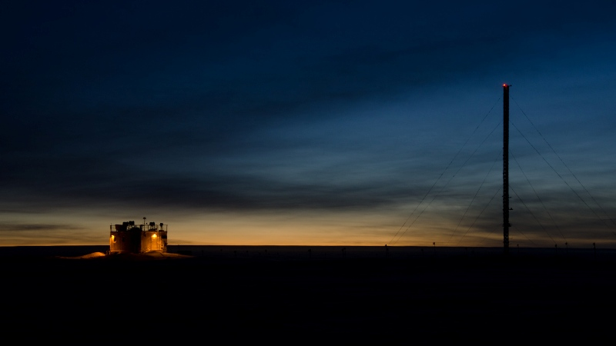

General Weather:
• 12/05 FEW100 70% RH -40F 10 knots
• 12/06 BKN030 79% RH -20F 15 knots BLSN
• 12/07 BKN080 73% RH -30F 10 knots
• 12/08 FEW100 58% RH -60F 10 knots
• 12/09 SCT020 79% RH -30F 15 knots
• 12/10 SCT030 67% RH -40F 10 knots
• 12/11 VV010 91% RH 0F 30 knots BLSN

General Items:
• Issues with ICECAPS computer.

Dataman Account:
• 12/05 1300 UTC Computer unresponsive. Rebooted computer at 1305 UTC. Remounted all at 1305 UTC.
• 12/10 1250 UTC Computer unresponsive. Rebooted computer at 1255 UTC. Remounted all at 1300 UTC.

PAERI:
• 12/09 Partial Blue Flags

MPL:
• 12/11 0545 UTC “Can’t find AMCS card: 2.” Rebooted computer at 1345 UTC.

CAPABL:
• 12/05 1654 UTC Resolved issues and started collecting data.

MMCR:
• 12/06 Found in Standby Mode. Rebooted at 1310 UTC. 1325 UTC Operational.
• 12/09 Found in Standby Mode. Rebooted at 1425 UTC. 1440 UTC Operational.
• 12/11 Found in Standby Mode. Stuck in 61 antenna position and would not switch between 90/50.
Rebooted several time. 1500 UTC Operational.

MWR:
• Normal

SODAR:
• 12/10 1340-1343 UTC checked and removed snow from enclosures.

POSS:
• 12/05 Restarted software at 1310 UTC after rebooting ICECAPS computer.
• 12/10 Restarted software at 1355 UTC after rebooting ICECAPS computer.

VCEIL:
• Normal

IceCAM:
• Normal

IcePIC:
• No Pictures Taken

Radiosonde:
• 12/11 AM sonde failed due to High Winds.

ASIA-A:
• 12/06 Break in Connection, Reconnected at 1320 UTC
• 12/11 Break in Connection at 1430 UTC, Reconnected at 1438 UTC

