ICECAPS Weekly Report
Dec. 12 – Dec. 18, 2012
Lance Roth – Phase II Tech

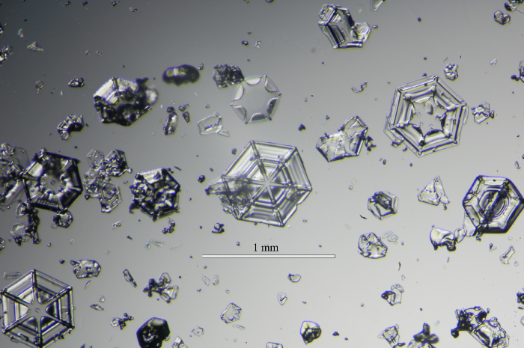

General Weather:
• 12/12 BKN020 91% RH 0F 20 knots SN, BLSN
• 12/13 BKN010 90% RH 0F 10 knots -SN
• 12/14 BKN010 88% RH -5F 5 knots
• 12/15 FEW100 73% RH -30F 5 knots
• 12/16 FEW100 73% RH -30F 2 knots
• 12/17 FEW080 68% RH -40F 5 knots
• 12/18 FEW100 80% RH -20F 3 knots FzFg

Dataman Account:
• Normal

MWR:
• Normal

SODAR:
• 12/13 1628-1630 UTC checked and removed snow from enclosures.

POSS:
• Normal

MMCR:
• 12/15 1300 UTC Found in Standby Mode during receiver calibration “Error 7 occurred at
Open File +.vi:)Open File.” Pressed continue and system began operating.
• 12/18 Found in Standby Mode after receiver calibration. Rebooted system at 1245 UTC.
System found shut down at 2330 UTC. System up and running at 2340 UTC

CAPABL:
• Normal.

MPL:
• 12/13 Found computer logged out. Logged in and started MPL 1255 UTC.

VCEIL:
• Normal

IceCAM:
• Normal

PAERI:
• 12/09 Partial Blue Flags
• 12/16 Red Flags on Responsivity due to frost on mirror.
• 12/18 1238 UTC Red Flag. Removed frost from fan causing issue with responsivity. 1255-1258 UTC
removed heavy frost from railing and mirror.

ASIA-A:
• 12/13 Connected new network cable to Arduwina at UTC

IcePIC:
• 12/12 1415 UTC and 1700 UTC Took pictures of several broken snowflakes due to high winds.
• 12/13 1400 UTC Took pictures of plates.
• 12/18 Loaded pictures onto Dataman.

Radiosonde:
• 12/11 PM sonde failed due to High Winds.

