ICECAPS Weekly Report
Dec. 19 – Dec. 25, 2012
Lance Roth – Phase II Tech

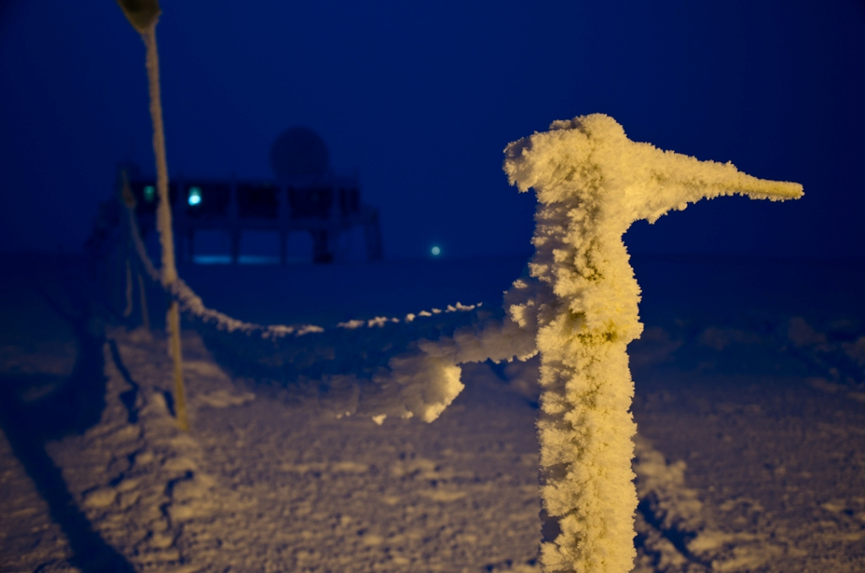

General Weather:
• 12/19 FEW100 74% RH -30F 10 knots
• 12/20 BKN100 75% RH -30F 0 knots FzFg
• 12/21 OVC003 80% RH -15F 5 knots FzFg
• 12/22 BKN003 80% RH -20F 5 knots -SN
• 12/23 FEW030 60% RH -40F 2 knots
• 12/24 FEW080 61% RH -50F 5 knots North Winds
• 12/25 FEW100 55% RH -65F 10 knots BLSN

Dataman Account:
• Normal

MWR:
• Normal

SODAR:
• Normal

POSS:
• Normal

MMCR:
• 12/21 Hung during Calibration. Rebooted. System started normally
• 12/25 Hung during Calibration. Rebooted several times due to a constant 61 antenna position.
Normal Operation at 1414 UTC.

CAPABL:
• 12/19 Found Laser off. Hit Emission button on remote at 1245 UTC. System began running normal.

MPL:
• 12/21 Found computer logged out. Opened computer and checked AMCS card 1530 UTC.

VCEIL:
• Normal

IceCAM:
• Normal

PAERI:
• 12/24 Partial Blue Flags
• 12/24 1327-1328 UTC, Covered hatch and removed frost from railing.

ASIA-A:
• Normal

IcePIC:
• 12/22 Took Pictures of snowflakes. Trouble catching flakes on slide.

Radiosonde:
• Normal

