ICECAPS Weekly Report
Jan. 02 – Jan. 08, 2013
Lance Roth – Phase II Tech

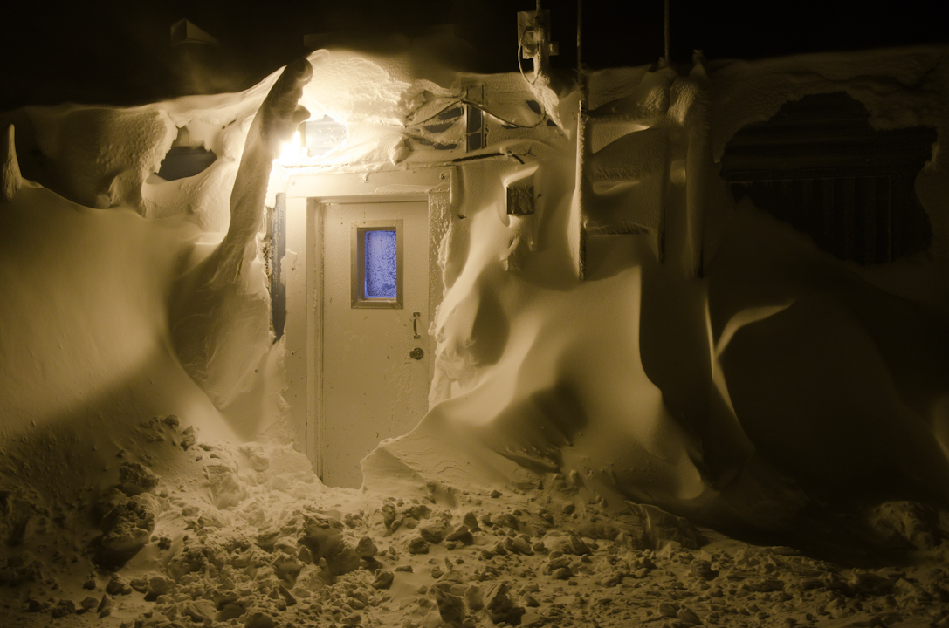
Back door of the Green House/Berthing.

General Weather:
High winds and warm temperatures present most of the week.

Dataman Account:
• Normal

MWR:
• 01/04 Temporary Red flags on Receiver 1 and 2 temperatures for both instruments.
• 01/05 Temporary Red flags on Receiver 2 temperature for Hatpro.

SODAR:
• Normal

POSS:
• Normal

MMCR:
• 01/07 Hung during calibration. Reset the error and was able to operate without rebooting 1240UTC.

CAPABL:
• 01/04 Removed Snow from window 1255 UTC

MPL:
• 01/04 Removed Snow from window 1255 UTC

VCEIL:
• Normal

IceCAM:
• Normal

PAERI:
• 01/05 Red flags on Responsivity due to snow on mirror. Removed snow 1320-1323 UTC.

ASIA-A:
• 01/05 Communication issue at 0800 UTC. Cycled pwr on Radiometer and reconnected at 1315 UTC.
• 01/06 Communication issue at 2050 UTC. Cycled pwr on Radiometer and reconnected at 1247 UTC
Communication issue at 1400 UTC. Cycled pwr on Radiometer and reconnected at 1455 UTC
• 01/08 Communication issue at 1610 UTC. Cycled pwr on Radiometer and reconnected at 1652 UTC.

IcePIC:
• No Pictures taken this week

Radiosonde:
• Normal

