ICECAPS Weekly Report
Jan. 09 – Jan. 15, 2013
Lance Roth – Phase II Tech

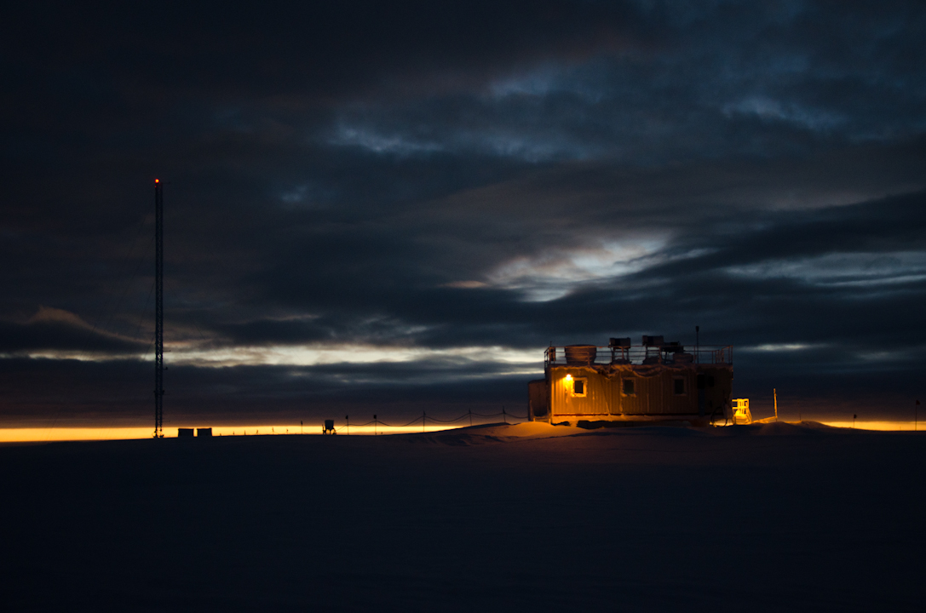

General Weather:
On Thursday morning January 10th we experienced a brief power outage due to issues in the SOP. Power was switched over to the Emergency Generator for four hours and all operations continued as normal. All instruments in the MSF were found to be operating fine.

Dataman Account:
• Normal

MWR:
• Normal

SODAR:
• Normal

POSS:
• Normal

MMCR:
• 01/07 Hung during calibration. Reset the error and was able to operate without rebooting 1240UTC.
• 01/13 Hung during calibration. Had to reboot at 1330 UTC.
• 01/14 Hung during calibration. Had to reboot at 1300 UTC.

CAPABL:
• Normal

MPL:
• 01/10 Found computer logged out. May have been related to power outage.

VCEIL:
• Normal

IceCAM:
• Normal

PAERI:
• Normal

ASIA-A:
• 01/09 Communication issue at 1000 UTC. Cycled pwr on Radiometer and reconnected at 1315 UTC.
• 01/14 Communication issue at 1230 UTC. Cycled pwr on Radiometer and reconnected at 1300 UTC.

IcePIC:
• No Pictures taken this week

Radiosonde:
• 01/09 PM Sonde Launch failed due to 35+ knot winds.

