ICECAPS Weekly Report
Feb. 13 – Feb. 19, 2013
Sven Lidstrom – Phase I Tech

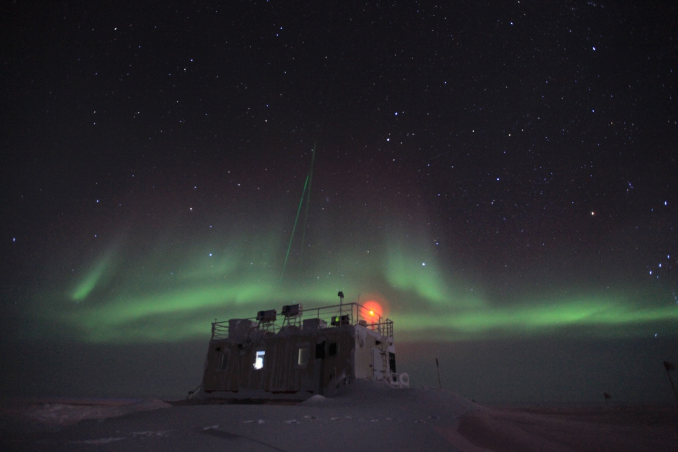

MSF with the Lidars in action on February 14.

General:
• The snow pile in front of the entrance door was removed by the 933 on February 18.

Dataman Account:
• Normal.

MWR:
• Normal

SODAR:
• 02/13 Cleaned out enclosures 14.02 -14.15 UTC.

POSS:
• Normal

MMCR:
• 02/17 Hung during calibration. Resetting the fault and restarting failed as did rebooting. Tried both multiple times after which the radar equipment was powered down and left for a couple of hours. Powered back up successfully again at 1815 UTC.
• 02/18 Hung during calibration. Resetting fault and restarting it was successful after a couple of tries. Normal operations again from 12.40UTC

CAPABL:
• 02/15 Cleaned window at 13.29 UTC

MPL:
• 02/14. Computer had been rebooted during the night; it seems like it happen at 03.18 UTC. SigmaPML started again at 12.48UTC.

VCEIL:
• Normal.

IceCAM:
• Normal.

PAERI:
• 02/15 Cleaned the PAERI window at 13.29UTC. Removed the outside fan structure at 13.32 UTC for
Fan replacement. Fan replaced and structure put back in place at 17.47 UTC.

ASIA-A:
• 02/17 Lost communication at 0440 UTC. Rebooted Radiometer at 1312 UTC.
• 02/18 Tried to replace the spare ICECAPS monitor that is in use with one of the new ASIAA
monitors that arrived with the cargo. Unfortunately the connector as well as provided adaptors don’t
match the computer’s monitor connector so we are still using the spare ICECAPS monitor.

IcePIC:
• No pictures taken.

Radiosonde:
• 2/18 Forgot to close out the morning balloon launch in time

