ICECAPS Weekly Report
March 13 – March 19, 2013
Sven Lidstrom – Phase I Tech

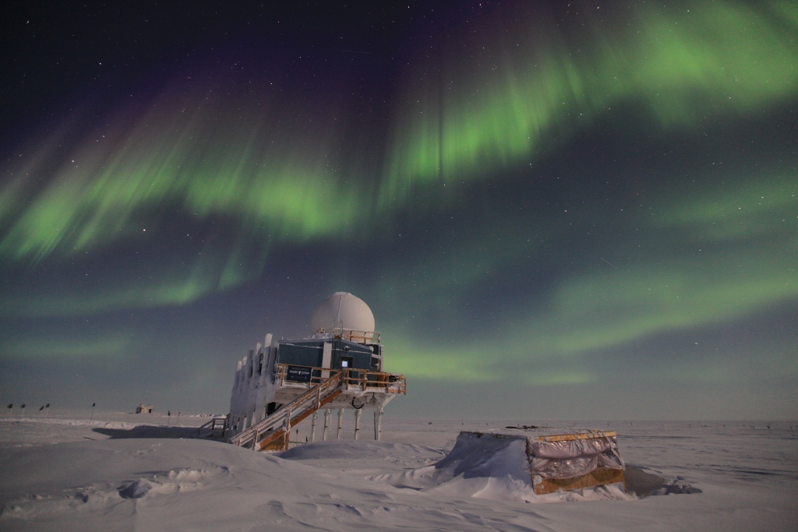

Tuesday evening auroras over Summit.

General:
CAPABL continued to have issues and was eventually shut down. Experienced radiosonde problems as well as the normal ASIA-A and MMCR issues.

Dataman Account:
• Normal.

MWR:
• Normal.

SODAR:
• Normal.

POSS:
• Normal.

MMCR:
• 03/13 Hung during calibration. Resetting the fault and restarting failed. Rebooting the system failed. Shut everything down and let it sit for 1 hr after which it was successfully restarted again at 14.52 UTC.

• 03/19 Hung during calibration. Resetting the fault and restarting multiple times failed. Rebooting the system resolved the issue and data taking resumed at 10.08 UTC.

CAPABL:
• 03/16 Could not see any data in integrated channel 2 graph. After emailing Ryan and getting the OK rebooted the software.

• 03/17 CAPABL shut down (Robert & Ryan).

MPL:
• Normal.

VCEIL:
• Normal.

IceCAM:
• Normal.

PAERI:
• Normal.

ASIA-A:
• 03/17 Lost communication at 21.50 UTC 03/16. Rebooted Radiometer at 13.20 UTC.

IcePIC:
• No pictures taken.

Radiosonde:
• 03/19 The morning balloon launch experienced telemetry error after 22 min, managed to resume flight but it ended after 25 min at 12117 m. On Matt’s request inspected cabling and connectors without seeing anything obviously wrong. Some of the cabling is buried under the snow that is covering one side of the Greenhouse and this has not yet been dug out.

For the evening flight we were unable to start a new sounding, the “New Sounding” option was not clickable. The VAISALA program was shut down and restarted twice without resolving the issue. The computer was then rebooted after which the VAISALA program behaved normal again. However the launched terminated already at 11523 m.

