ICECAPS Weekly Report
March 20 – March 26, 2013
Sven Lidstrom – Phase I Tech

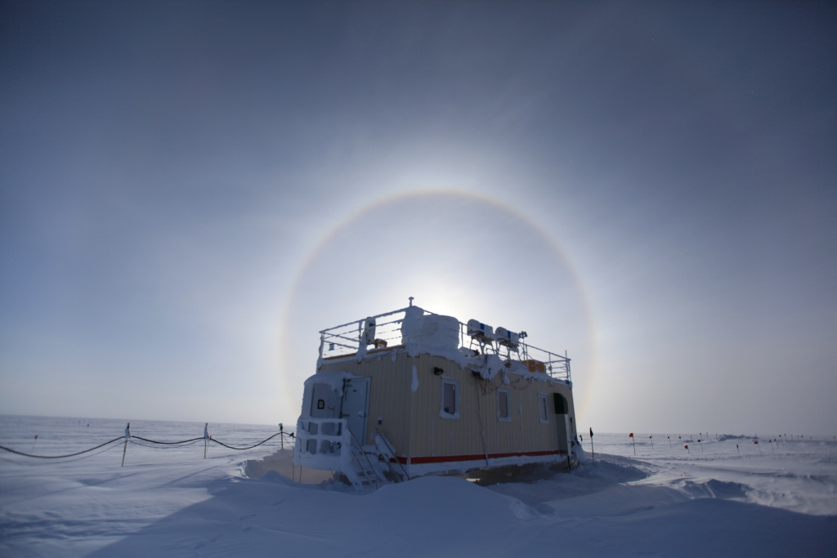

MSF Halo on March 21.

General:
CAPABL laser replaced on 03/21. Snow removed from MSF roof on 3/25. New MMCR Radar Monitor Software version installed on 03/26

Dataman Account:
• Normal.

MWR:
• Normal.

SODAR:
• 03/25 Removed snow from enclosures at 12.45 -12.55 UTC.

POSS:
• Normal.

MMCR:
• 03/25 Hung during calibration. Resetting the fault and restarting successful at 12.42 UTC.
• 03/26 MMCR shutdown for software upgrade. New version of Radar Monitor software installed.

CAPABL:
• 03/21 CAPABL powered down completely, then powered up and started following instructions from Robert & Ryan.
• 03/24 No data displayed and the computer was extremely slow. Got OK from Ryan to replace the laser. Once the laser was replaced there were still issues with the computer being extremely slow. Unable to enter commands or start programs. Discovered problems with virtual E disk (I/O error) and the Norton Ghost installation. Unsuccessful in disabling Norton Ghost and finally decided to uninstall it and remove the E disk (virtual disk). With that done everything was started back up again successfully at 22.15 UTC

MPL:
• 03/20. When doing morning checks the MPL computer did not respond, and then the screen went black. After several failed tries to get it to respond the computer was rebooted and things running as normal again at 13.45 UTC.

VCEIL:
• Normal.

IceCAM:
• Normal.

PAERI:
• Normal.

ASIA-A:
• Normal.

IcePIC:
• 03/25 pictures taken.

Radiosonde:
• 03/22 Evening radiosonde not closed off and reported in time.
• 03/25 Morning radiosonde not closed off and reported in time.

