ICECAPS Weekly Report
March 27 – April 2, 2013
Sven Lidstrom – Phase I Tech

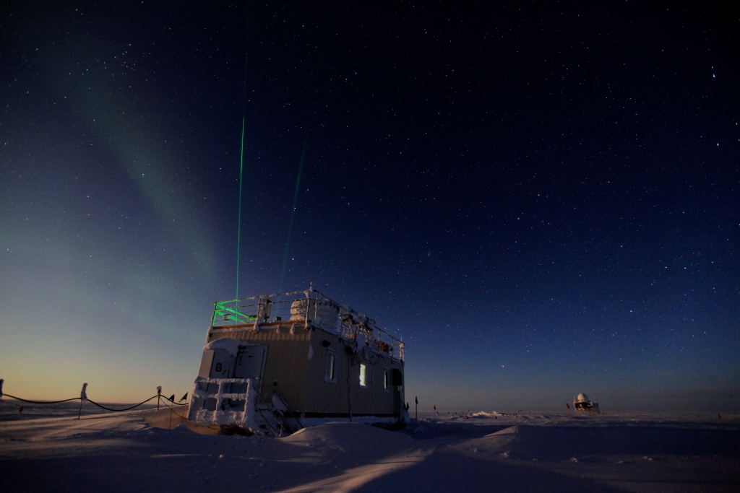

Lidars in action at MSF.

General:
Heavy equipment has been operating all week as preparations for the summer has commenced.

Significant Weather Observations:
3/29 Freezing fog in the afternoon from 19.00 UTC.
3/30 Halos in the morning, blowing snow.
3/31 Very faint fogbow in the morning.
4/01 Freezing fog in the afternoon.
4/02 Freezing fog as well as weak halo early morning, freezing fog in the late afternoon.

Dataman Account:
• 03/31 System hung for unknown reasons. No data transferred. Rebooted after contacting Matt.
• 04/01 Delayed data transfer.
• 04/02 Limited data transfer, 96 sondar jpegs not transferred

MWR:
• Normal.

SODAR:
• Normal.

POSS:
• 03/31 Computer rebooted and restarted POSS at 15.55 UTC.

MMCR:
• Normal.

CAPABL:
• 04/02 Cleaned window at 13.25 UTC.

MPL:
• 04/02 Cleaned window at 13.25 UTC.

VCEIL:
• Normal.

IceCAM:
• Normal.

PAERI:
• 04/01 Shelter fan turned off and frost removed 13.04 – 13.09 UTC.

ASIA-A:
• Normal.

IcePIC:
• 04/02 Pictures taken.

Radiosonde:
• Normal.

