ICECAPS Weekly Report
April 17 – April 23, 2013
Sven Lidstrom – Phase I Tech

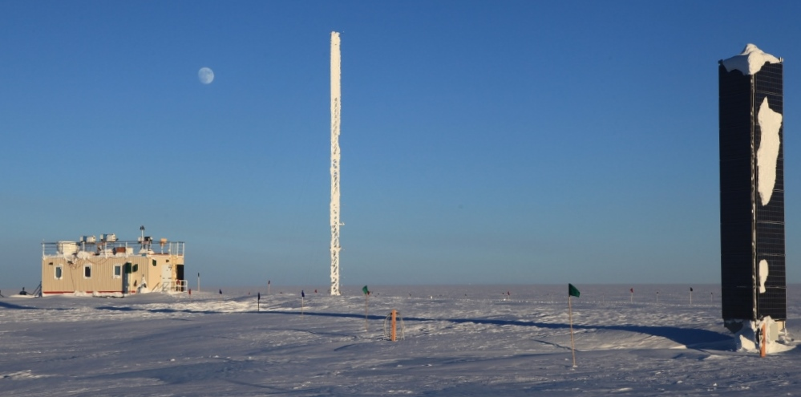

Moon over MSF on Tuesday.

General: We are still waiting for the first LC-130 for the season that was scheduled for Sunday. CAPABL was shut down on 4/19.

Significant Weather Observations:
4/17 Freezing fog and halos.
4/18 Freezing fog in the morning and halos throughout the day.
4/19 Freezing fog and halos.
4/20 Strong winds, drifting snow and halos.
4/22 Halos.
4/23 Halos.

Dataman Account:
• 4/23 97 items, all JPEG pictures, were not transferred as scheduled.

MWR:
• Normal.

SODAR:
• Normal.

POSS:
• Normal.

MMCR:
• 4/21 Found MMCR off and UPS in alarm state, beeping and Alarm LED red. Power cycled UPS and powered up radar successfully at 12.30 UTC.
• 4/23 Reverted back to the old Radar Monitor software version.

CAPABL:
• 04/18 CAPABL not operating. Tried, unsuccessfully to reboot and power cycle. After talking to Ryan replaced the Laser Power Supply with the old Laser Power Supply removed on 03/24. Operational from 21.40 UTC but the data looked strange.
• 04/19 CAPABL turned off 12.00 UTC as instructed by Ryan.

MPL:
• 04/20 MPL computer experienced an unexpected shutdown for unknown reasons and had been rebooted. Logged back in and started SigmaMPL at 14.30 UTC.

VCEIL:
• Normal.

IceCAM:
• Normal.

PAERI:
• Normal.

ASIA-A:
• 04/20 Computer clock was reset since it was11 hours behind. Lost communication at 14.10 UTC. Rebooted Radiometer multiple times at 14.45 UTC.

IcePIC:
• No pictures taken.

Radiosonde:
• Normal.

