ICECAPS Weekly Report
April 24 – April 30, 2013
Ben Catellani

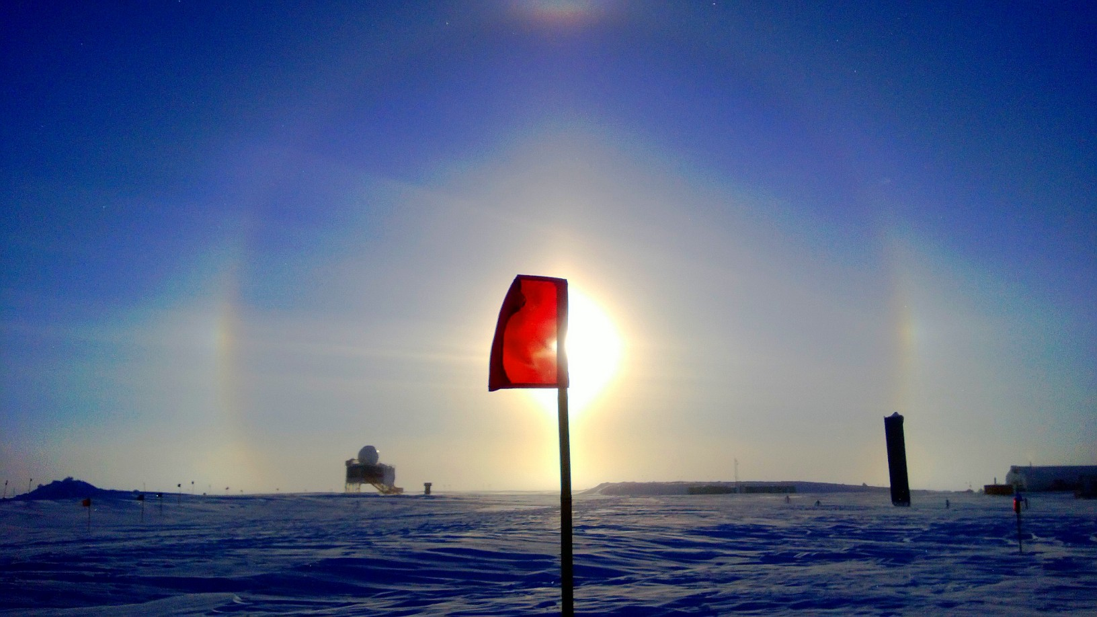

General:
•04/24 MSF wireless router not working.
•04/25 New wireless router installed.
•04/25 Cleaned MSF roof of snow.
•04/26 Power fluctuation due to generator maintenance at 1225 UTC
•04/29 Power outage (1443-1456UTC).

Significant Weather Observations:
•4/26 Halos and drifting snow in the morning
•4/27 Blowing snow. Halos most of day.
•4/29 Halos most of the day.
•4/30 Halos most of the day. Drifting snow.

Dataman Account:
• Normal.

MWR:
• 04/25 LN2 calibration (both radiometers, including HATPRO flop)
• 04/26 LN2 calibration (HATPRO only, including flop)
• 04/27 LN2 calibration (HATPRO only, including flop)
• 04/28 LN2 calibration (HATPRO only, including flop) – OUT OF LN2

SODAR:
• 4/26 Cleaned of snow. 1404-1412 UTC.

POSS:
• Normal.

MMCR:
• Normal

CAPABL:
• Offline entire week as requested by Ryan

MPL:
• 04/27 Afterpulse Calibration 1715 – 1804 UTC.

VCEIL:
• Normal.

IceCAM:
• 04/26 Repositioned IceCAM slightly. 1900 UTC.

PAERI:
•04/26 Cleaned fan. 1402 UTC.
•04/26 Demonstrative snow removal from mirror. 1852-1859 UTC.
•04/29 Issue with mirror. Seems to have resolved itself.

ASIA-A:
• 04/25 LN2 calibration.
•04/26 Started up again with proper batch file at 1245 UTC.
•04/27 Lost communication at 0030 UTC. Rebooted Radiometer at 1215 UTC
Clock out of sync by 6 hours. Updated time and changed the automatic time synchronization schedule to daily instead of weekly. Rebooted computer.

IcePIC:
• 04/27 Pictures taken.
• 04/29 Pictures taken.

Radiosonde:
• 04/27 Morning sonde lost signal after 20 minutes (10.9km). May be related to strong winds.
• 04/28 Evening sonde launched 10 minutes late. Issues with GPS sonde signal.

