ICECAPS Weekly Report
May 1 – May 7, 2013
Ben Castellani

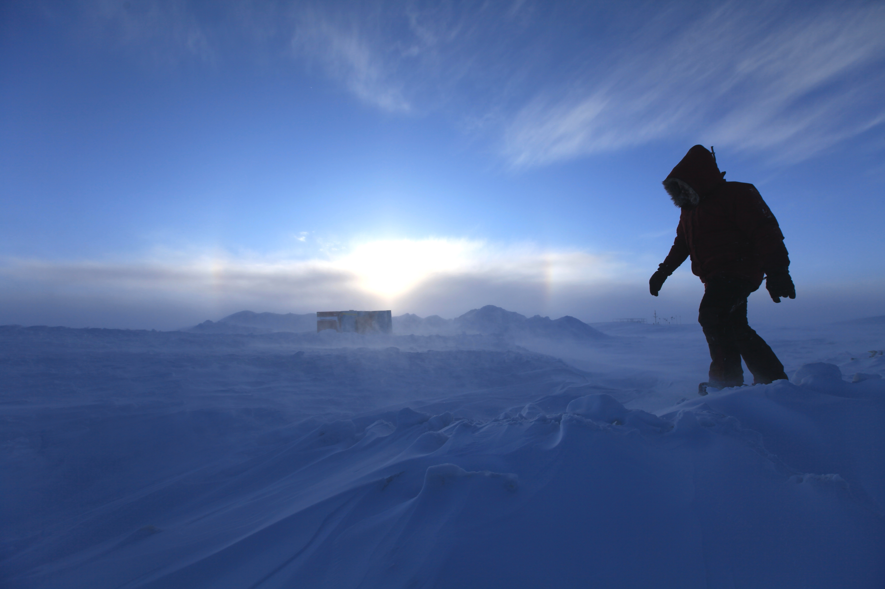

General:

•05/08 Camp-wide power outage (1038-1048 UTC). All instruments appear fine.

Significant Weather Observations:
•05/01 Blowing snow and halos most of day. 30 knots after 5pm.
•05/02 Blowing snow and 25+ knots most of day. Halos near sunset.
•05/03 Clear skies and no wind. Occasional halos with passing cirrus.
•05/04 Halos most of day.
•05/05 Some halos. 15-25 knot winds all day.
•05/07 Halos. Blowing snow. 20+ knots winds.

Dataman Account:
• Normal.

MWR:
• Normal

SODAR:
• Normal

POSS:
• Normal.

MMCR:
• Normal

CAPABL:
• 05/01 Booted up at 1800 UTC. Replaced laser supply. Still not emitting a laser. Shutdown at 1900 UTC.

MPL:
• 05/01 AMCS Card Timeout (1530 UTC on 4/30) – Rebooted at 1139 UTC

VCEIL:
• Normal.

IceCAM:
• Normal

PAERI:
•05/03 Rebooted itself around 1300 UTC. Returned later at 1530 UTC and it was off.
•05/06 Rebooted computer and resumed normal data taking. 1900 UTC. Issue being diagnosed.

ASIA-A:
• 05/05 Connection error at 1140 UTC. Rebooted software at 1255 UTC and measurement running by 1300 UTC.

IcePIC:
• 05/03 Pictures taken. Mostly bullet rosettes from light snow in afternoon. 1700 UTC.
• 05/04 Pictures taken. Mostly bullet rosettes from light snow in evening. 2100 UTC.

Radiosonde:
• 05/05 – Evening sonde battery was defective. Will attempt repair.
• 05/06 – Morning sonde launched at 1035 UTC to avoid conflict with incoming Herc.

