ICECAPS Weekly Report
May 1 – May 7, 2013
Ben Castellani

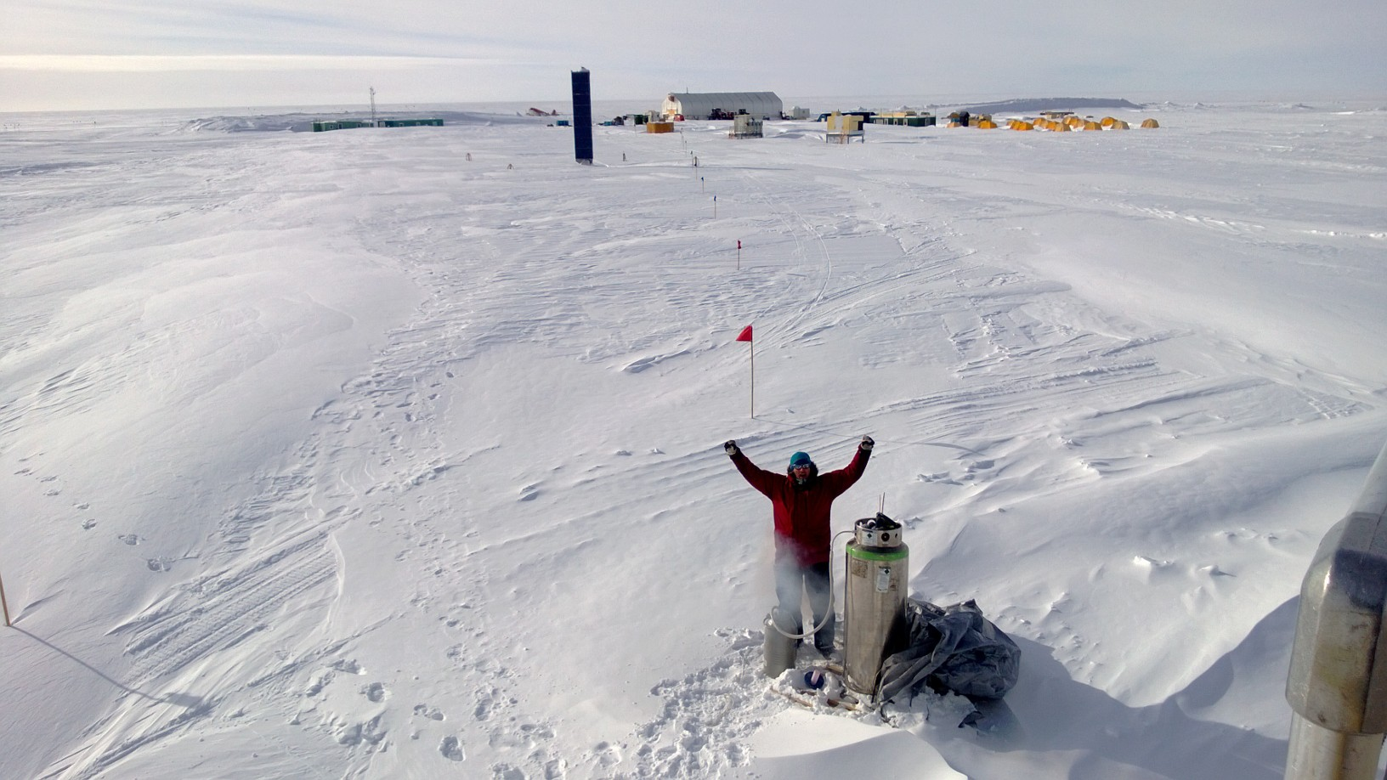

General:
•Week plagued by bad weather and postponed and cancelled flights.
•A big thanks to Sven for continued help with LN2 calibrations
•05/10 Camp-wide power outage 1723-1729 UTC. All instruments appear fine. This power issue is currently being diagnosed but a major fix will not be until a generator man comes up in July 2013.

Significant Weather Observations:
•05/09 Blowing snow and halos most of day. 15-25 knots.
•05/10 Drifting snow / cirrostratus / halos. Light winds <15 knots
•05/11 Overcast with increasing winds to 25+ knots. Light snow. 1-2’’ accumulation.
•05/12 Winds up to 25 knots decreasing through day. Weak halos most of day.
•05/13 20+ knot winds all day. Clearing skies. Some halos.
•05/14 20+ knot winds all day. Clearing skies. Some halos. Light snow.

Dataman Account:
• Normal.

MWR:
• 05/08 LN2 Calibration of HATPRO.
• 05/09 LN2 Calibration of HATPRO.
• 05/10 LN2 Calibration of HATPRO.
• 05/12 LN2 Calibration of HATPRO.
• 05/13 LN2 Calibration of HATPRO.
• 05/14 LN2 Calibration of HATPRO.

SODAR:
• Normal

POSS:
• Normal.

MMCR:
• Normal

CAPABL:
• 05/13 Removed upper tube to prepare for move. Covered telescope hole with plastic. CAPABL will be fixed by Ryan in July.

MPL:
• Normal.

VCEIL:
• Normal.

IceCAM:
• Normal

PAERI:
• Normal.

ASIA-A:
• Normal

IcePIC:
• No pictures taken.

Radiosonde:
• 05/09 – Morning sonde launched at 1223 UTC (1 hour late) due incoming C130.
• 05/10 – Morning sonde not launched at all due to incoming Basler flight arriving at 1300 UTC.
• 05/11 – Morning sonde not launched at all due to incoming Basler flight arriving at 1215 UTC.
• 05/12 – Morning sonde launched at 16 UTC (5 hours late) due to incoming Basler flight. Terminated at 13km.
• 05/12 – Evening sonde launched at 00 UTC (1 hour late) due to incoming Basler flight.

