ICECAPS Weekly Report
May 15 – May 21, 2013
Ben Castellani

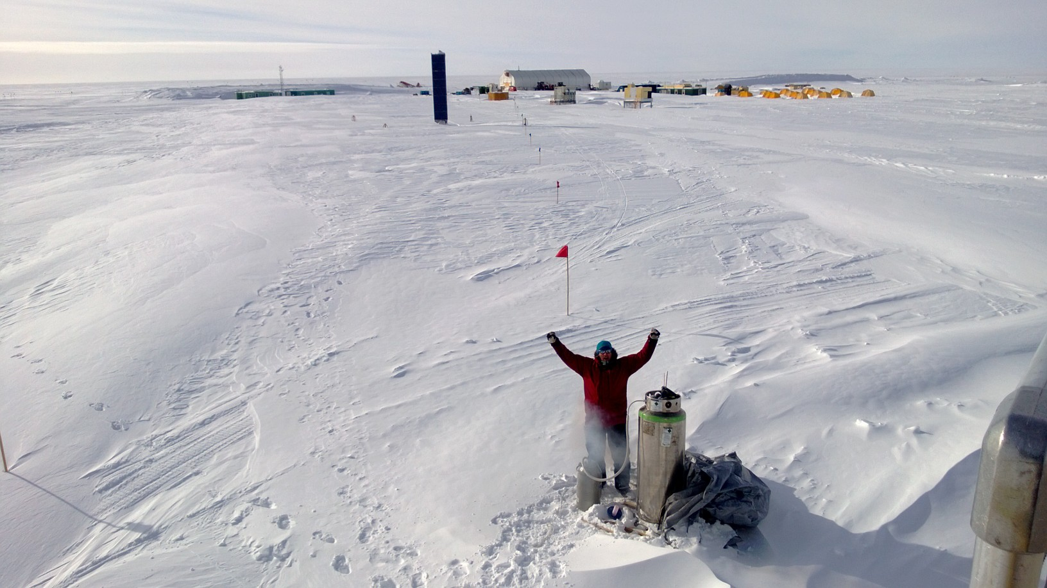

General:
•MSF pad was flagged off on 5/14. No further progress towards move. It appears now that the move will be pushed back until July due to weather delaying the carpenters progress.
•05/16 Camp-wide power outages as generators were swapped for maintanance.1156-1159 UTC and 2046-2048 UTC. All instruments appear fine.

Significant Weather Observations:
•05/15 Beautiful weather. No wind. Sundogs periodically throughout day.
•05/16 Clear skies in morning with diamond dust and halos. Increasing winds through day to 30+ knots.
•05/17 Clear skies. Windy up to 30 knots increasing through day. Intermittent halos and sun dogs.
•05/18 Increasing winds up to 35 knots by evening. Blowing snow.
•05/19 Winds 15-25 knots all day. Blowing snow and light snow.
•05/20 Beautiful and winds less than 10 knots. Very light snow and accumulations. Warmest day up to -14C.
•05/21 Sunshine and winds around 5 knots all day.

Dataman Account:
• Normal.

MWR:
•Empty LN2 dewar awaiting transit back to NY.

SODAR:
• 05/15 Removed snow from enclosures. 1141-1146 UTC.

POSS:
• Normal.

MMCR:
• Normal

CAPABL:
• OFFLINE until July.

MPL:
• Normal.

VCEIL:
• Normal.

IceCAM:
• Normal

PAERI:
• Normal.

ASIA-A:
• Normal

TSI:
• 05/16 -35C overnight.
• 05/18 -31C overnight

IcePIC:
• 05/19 Pictures taken at 1930 UTC during a very light snow event. Bullet rosettes and columns.

Radiosonde:
• 05/16 Desiccant changed as ground values for RH were >0.5% consistently. 4 months since last change.
• 05/19 Time on computer 6 hours off. Updated to local time server at 11UTC. Caused the times for the sounding to be off.
• 05/21 Automatic time update schedule for computer changed from weekly to daily.

