ICECAPS Weekly Report
May 29 – June 4, 2013
Ben Castellani / Elena Willmot

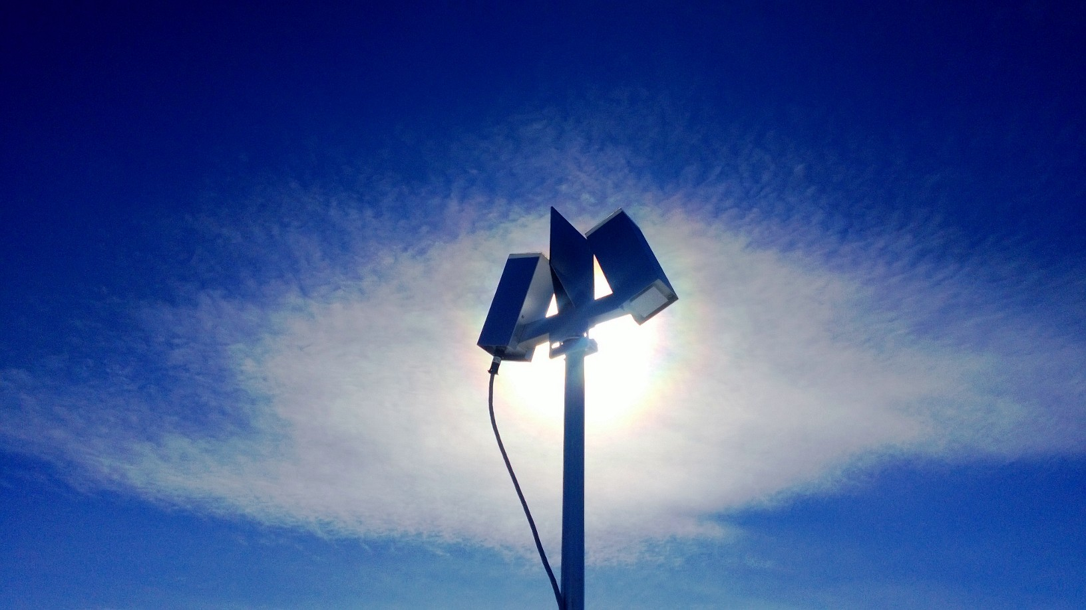

General:
• 05/31 Elena/Duane arrived to Summit
• Duane doing repairs on MMCR this week.
• 06/02 Lowered MSF indoor temperature – it was around 70F.
• 06/03 Duane trained Elena on MMCR (oscilloscope, leveling radar, and calibration).

Significant Weather Observations:
• 06/01 Weak winds, warm, with light snow. Occasional 22 degree halos.
• 06/02 Freezing fog, light winds.
• 06/03 Clearing skies and light winds. Light snow in morning. Halos in the evening.
• 06/04 Blowing snow, 15+ knot winds, overcast.

Dataman Account:
• 06/03 Data disk was full.
• 06/04 Swapped out data disk.

MWR:
• Empty LN2 dewar awaiting transit back to NY. Should be on the 06/06 flight out, to NY by 06/08.

SODAR:
• 06/01 Cleaned snow out of sodar enclosures 1735-1755 UTC.

POSS:
• Normal.

MMCR:
• 06/03 Calibration from 1605 - 1818 UTC.

CAPABL:
• OFFLINE until August.

MPL:
• 06/03 Afterpulse calibration 1204 – 1251 UTC.

VCEIL:
• Normal.

IceCAM:
• Normal

PAERI:
• 06/01 Checked fan for snow/rime.

ASIA-A:
• Normal

TSI:
• 06/04 Noticed it takes a few weird pictures per day (sent to Matt), rest are normal.

IcePIC:
• 06/03 Pictures taken at 1310 UTC. Snow gathered from ground for training purposes. Irregular shapes and a few plates.

Radiosonde:
• 06/02 Balloon launch / ANG aircraft protocol left unchanged. Better communication promised.
• 06/03 Launched balloon early at 1020 UTC due to incoming Basler flight.
• 06/04 Launched balloon early at 0945 UTC due to incoming C-130 flight.

