ICECAPS Weekly Report
Jan. 29 – Feb. 05, 2013
Lance Roth – Phase II Tech

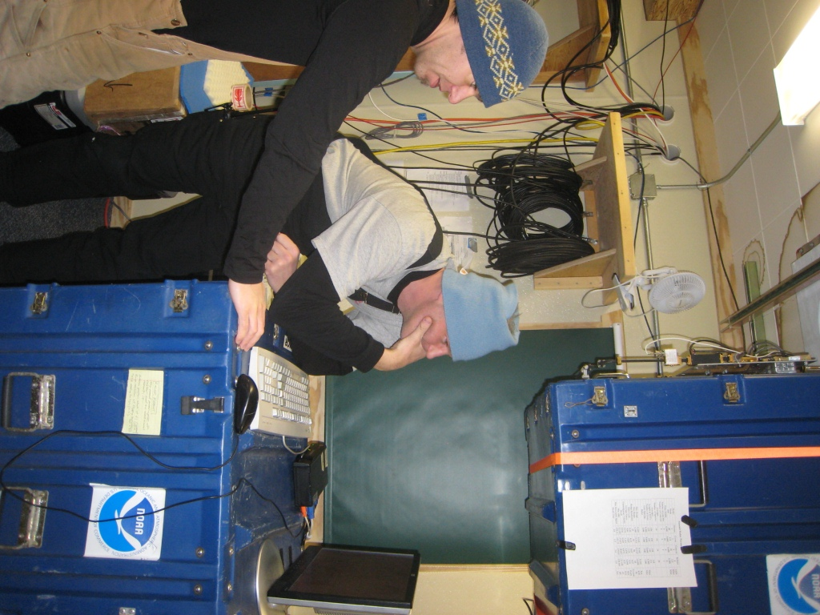

General:
Turnover with Sven has been going well.

Dataman Account:
• Normal

MWR:
• Normal

SODAR:
• 02/03 cleaned out both enclosures at 1409-1418 UTC.

POSS:
• Normal

MMCR:
• 01/30 Hung during calibration. Had to reboot at 1245 UTC.
• 02/02 Hung during calibration. Had to reboot multiple times. Antenna position stuck at 61.
• 02/04 Hung during calibration. Had to reboot at 1340 UTC.

CAPABL:
• 02/01 1330 UTC Green Emissions light was not illuminated. Pressed emission button on remote
controller and data began streaming again.

MPL:
• 02/04 Afterpulse Calibration 1405-1432 UTC.

VCEIL:
• Normal

IceCAM:
• Normal

PAERI:
• 01/30 Shelter Fan Quit. Replacing existing fan with new fan during turnover.
• 01/31 Adjusted J16 Connection at 2125 UTC.
• 02/01 Snow on Scene Mirror due to high winds (33+ knots) Red Flags resolved during night.
1508-1510 UTC covered hatch and cleaned snow from roof/railing.
• 02/05 Shelter Fan Quit and snow found on Mirror. Brushed Mirror off at 1415 UTC. Installed 3rd fan
and plywood.

ASIA-A:
• 02/02 Lost communication at 0050 UTC. Rebooted Radiometer at 1337 UTC.

IcePIC:
• No Pictures taken this week

Radiosonde:
• 02/01 PM sonde failed launched due to high winds. Recovered sonde and re-launched at 2345 UTC.
• 02/03 PM sonde experienced a premature termination just after launch. Re-launched at 2345 UTC.
• 02/05 AM sonde failed launched. Recovered sonde and re-launched. Sonde was bad. Re-launched again
at 2350 UTC.

