ICECAPS Weekly Report
Feb. 06 – Feb. 12, 2013
Sven Lidstrom – Phase I Tech

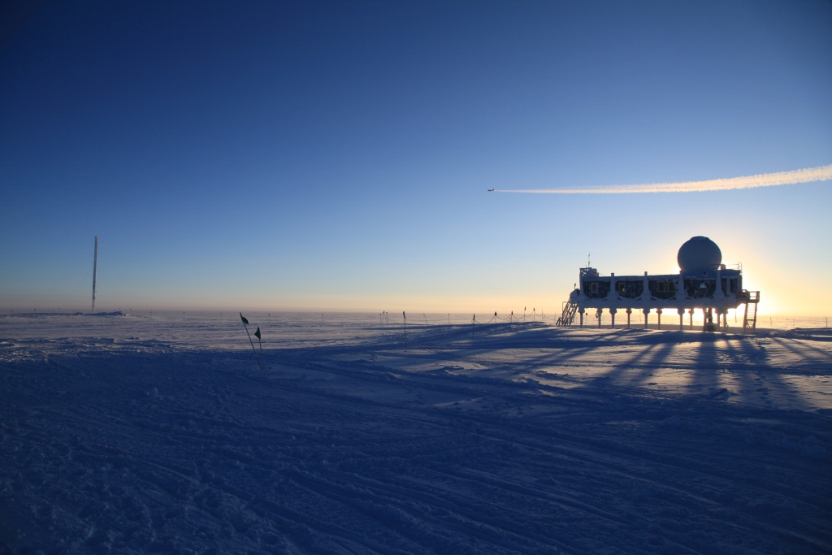

Phase 2 crew departed on Friday February 8.

General:
• 02/07 1750 – 1815 UTC Shoveled off MSF roof.
Raised MSF power cable from 1820 – 1837 UTC.
• 02/08 An Arctic Fox was seen running around camp in the morning. Probably saying goodbye to the departing Phase 2 crew that left later in the afternoon.

Dataman Account:
• 02/07 Replaced USB hard drive. Katrine Gorham will bring it back to the US and send it to Matt.

MWR:
• Normal

SODAR:
• Normal

POSS:
• Normal

MMCR:
• 02/14 Hung during calibration and got stuck in Stanby mode. After pressing Operate several times, in Faulted every time, it finally became operational again at 1316 UTC without needing to reboot.
• 02/12 Hung during calibration. Multiple reboots needed before it became operational again at 17.18 UTC.

CAPABL:
• Normal

MPL:
• 2/14 Computer was found as if had been rebooted with no programs running so SigmaMPL was started at 12.48UTC. It looks like that the computer was rebooted at 03.18 UTC

VCEIL:
• Normal

IceCAM:
• Normal

PAERI:
• 02/06 Partial Red Flags on Responsivity due to snow on scene mirror. Issue resolved itself.
• 02/10 Partial Red Flags on Responsivity due to snow on scene mirror. Issue resolved itself

ASIA-A:
• 02/06 Lost communication at 0210 UTC. Rebooted Radiometer at 1324 UTC.
• 02/08 Lost communication at 1100 UTC. Rebooted Radiometer at 1300 UTC.
• 02/09 Lost communication at 1050 UTC. Rebooted Radiometer at 1309 UTC.
Lost communication again at 1328 UTC. Rebooted Radiometer at 1338 UTC.
• 02/10 Lost communication at 0958 UTC. Rebooted Radiometer at 1258 UTC.
• 02/11 Lost communication at 0209 UTC. Rebooted Radiometer at 1303 UTC.
• 02/11 Lost communication at 1320 UTC. Rebooted Radiometer at 1340 UTC.
• 02/12 Lost communication at 1240 UTC. Rebooted Radiometer at 1306 UTC.
• 02/12 Lost communication at 1740 UTC. Rebooted Radiometer at 2012 UTC.

IcePIC:
• 02/06 Pictures taken.

Radiosonde:
• 02/13 For the evening launch a GPS sonde was unpacked when it was discovered that is sonde antenna was completely loose. It had never been soldered to circuit board. A new sonde was unpacked and successfully launched.
•

