Summit Station Weekly Science Report
Reporting Period: Aug. 12-18, 2013
Completed by: Shawntel Stapleton, David Benson
Comments: This week began with preparing for the upcoming and final flight period for the season. We attempted to frontload all weekly science to leave later week time open to winter-over trainings and turnover. The first flight came in on Thursday, and with it came managers, scientists, IT technicians, and our new station manager and ICECAPS tech. A member of the NOAA team has successfully installed new radiometers alongside the Steffen solar experiments. An ICECAPS PI and other members are onsite repairing their various equipment as well as making calibrations to ensure more accurate data collection over the winter. With much appreciation we have had assistance in calibrating the NOAA Met Suite, from the NOAA members onsite. A mechanic/electronics technician is onsite, successfully making repairs and alterations to our electric snowmobile, in the hopes of its reliable use throughout the cold winter seasons.
Overall, we’ve had a very successful and engaging summer season, and as we are both staying for the first winter phase, we are looking forward to a great winter season as well.
Below is a photo of the new NOAA Radiometer installed this flight period. There is also a photo of us at the Bamboo Forest and one of Dave working away on the TAWO tower.
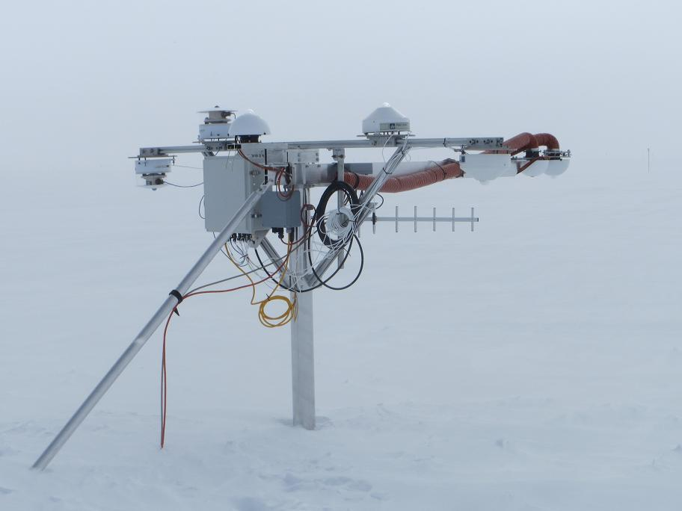
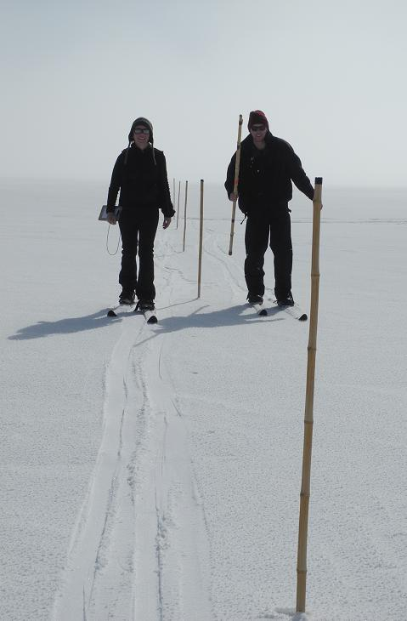
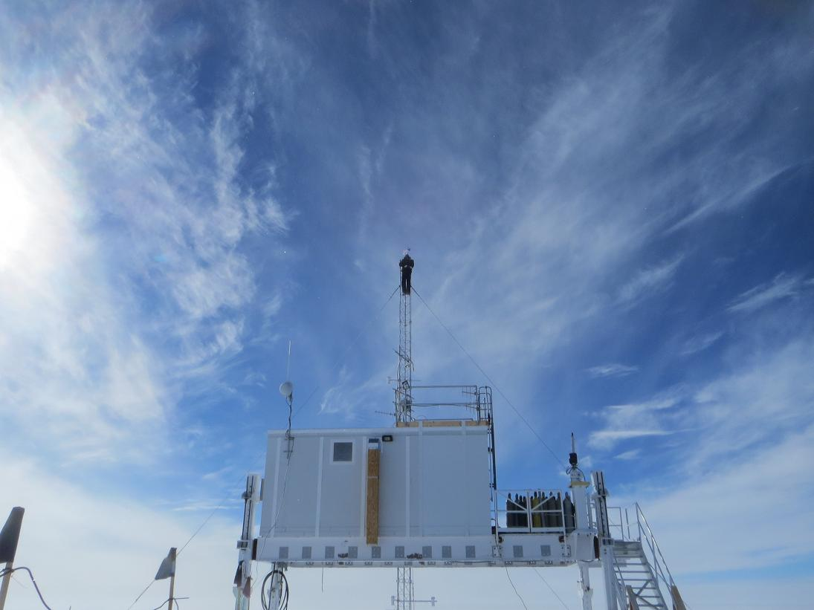

Please visit the clean air log at ftp://ftp.summitcamp.org/pub/data/GEOSummit/Clean%20Air%20Traffic/

Facilities | Comment
TAWO | Received updated Met equipment and mounts, are in the process of wiring and preparing to install 2 windbirds and another RTD.
MSF | Ventilation system fixed (Jeff Sever).
Green House
Experiment | Notes
NOAA CATS GC | Comment: The two repaired leaks have been proving successful, with lower gas consumption rates.  % of time operating: 100%
NOAA CCGG flasks | Comment:  Sample collection date(s): 8/12/2013
NOAA HATS flasks | Comment:  Sample collection date(s): 8/12/2013
NOAA Surface Ozone | Comment:  % of time operating: 100%  Data on ftp server: 8/12/2013
NOAA Aethelometer | Comment: Was taken offline on 8/18/2013, in order to access NOAA Met Suite connections. Will be put back online when NOAA Met installation is complete.  % of time operating: 95%  Data on ftp server: 8/12/2013
NOAA Met Suite | Comment: In the process of wiring, connecting and calibrating new windbird and RTD unit.  % of time operating: 60%
NOAA Ozonesonde | Comment: Dual launch with ICECAPS radiosonde throughout the summer months. Last weeks package with burst balloon was found at the north end of the skiway!  Date launched: 8/14/2013
NOAA Clidar | Comment: Not collecting data.  % of time operating: 0%
NOAA CLAP/PSAP/Neph | Comment:  % of time operating: 100%
NOAA Radiometers | Comment:  % of time operating: 100%
NOAA Firn Air Sampling | Comment:
Radionuclide filter | Comment:  % of time operating: 100%
Aerosol DRUM sampler | Comment: Taken offline and returned to PI.  % of time operating: 0%
UCM Surface Samples | Comment: Samples to date, are being sent out this flight period.  Sample collection date(s): 8/12/2013, 8/17/2013  Data on ftp server: 8/12/2013, 8/17/2013
DRI Surface Samples | Comment:  Sample collection date(s): 8/12/2013  Data on ftp server: 8/12/2013
UCM Snow Pit | Comment: Samples to date, are being sent out this flight period.  Sample collection date: 8/13/2013
UCM String Pit | Comment: Last laid String 8/7/2013.  Measurement date:
Bamboo Forest | Comment:  Observation date: 8/13/2013  Data on ftp server: 8/13/2013
ICESat accumulation | Comment:  Observation date:
BSI UVSIMN | Comment: Disruption to operation due to network outages.  % of time operating: 95%
Hanka Seismometer | Comment:  % of time operating: 100%
UNAVCO | Comment:
Helmig GC | Comment: PI was onsite this week, performing upgrades and maintenance on equipment.  % of time operating: 100%
Kramer NOx | Comment: Kramer team member onsite, making repairs to equipment and performing various tests.  % of time operating: 80%
Feng Sampling | Comment: Snow accumulation is creeping up on us, we intend to replace and raise the mast in the beginning weeks of winter.  Sample collection date(s): Site visited daily, samples collected when appropriate.
Noone Snow Sampling | Comment:  Sample collection date(s): Site visited daily, surface samples collected daily, drift and rime samples collected when appropriate.
Noone Tower Instruments | Comment: Received repaired MPS, we plan to reinstall it this upcoming week.
Hamilton Polarsondes | Comment: Updated SOP.  Date launched:
Steffen Tower Instruments | Comment:  Data on ftp server: 8/12/2013
Steffen Solar Instruments | Comment: Solar tracker had a temporary pause, but is now back online. NOAA has installed radiometers onto the fixed arm mount. The Steffen pyranometer needed to be raised by 8cm to keep level with new installation, and eliminate data interference.  Data on ftp server: 8/12/2013
Total Sky Imager | Comment:  % of time operating: 100%
ICECAPS Radiosonde | Comment: Several sonde launches early/late due to C130 flights.  Dates launched: Twice daily radiosonde launches
ICECAPS MWR | Comment: Liquid Nitrogen calibrations performed on both MWRs; Insulation added for winter.  % of time operating: 100
ICECAPS SODAR | Comment: Sodar enclosure leveled and reinforced.  % of time operating: 100
ICECAPS POSS | Comment:  % of time operating: 100
ICECAPS MMCR | Comment: Changed desiccant.  % of time operating: 100
ICECAPS CAPABL | Comment: PI reconfigured laser at 30˚ angle; system reconfigured and calibrated.  % of time operating: 0
ICECAPS MPL | Comment: Performed afterpulse calibration.  % of time operating: 100
ICECAPS Ceilometer | Comment:  % of time operating: 100
ICECAPS PAERI | Comment: PI onsite perform maintenance and system checks; outside fan replaced.  % of time operating: 90
ICECAPS IcePIC | Comment: Photos taken on 8/16.  % of time operating: NA
ASIAA MWR | Comment: Liquid Nitrogen calibrations performed.  % of time operating: 100

