**Summit Station Weekly Science Report**

**Reporting Period:**  Aug. 19-25, 2013

**Completed by:**  Shawntel Stapleton, David Benson, Lana Cohen

**Comments:**  This week began with the final flight of the summer season. We were able to get quite a bit of retro items off of station, including the years worth of various snow samples and another box of HATS samples.

We now are a population of five, with our new manager and ICECAPS tech. This week we have been working on odds and ends. We have been moving and organizing supplies, assisting in camp cleanup, continuing winter-over training and turnover with the ICECAPS tech, and are completing unfinished projects. We are in the process of wiring and calibrating the NOAA windbirds and new RTD, which includes a fair amount of tower work to mount accurately, line the cables, and collect and correct for calibrations. We have been raising the measurement poles of all of the UCM snow accumulation sights, mainly ICESat and the Bamboo Forest.

Overall, things are running well and we have a great winter crew.

The first photo below is pre-TAWO raise, the buried lower section of the stairs had to be dug out, and since we are right at the clean air sector, it was all done by shovel!

The second photo is the last Guard plane of the 2013 summer season, (an eight prop).

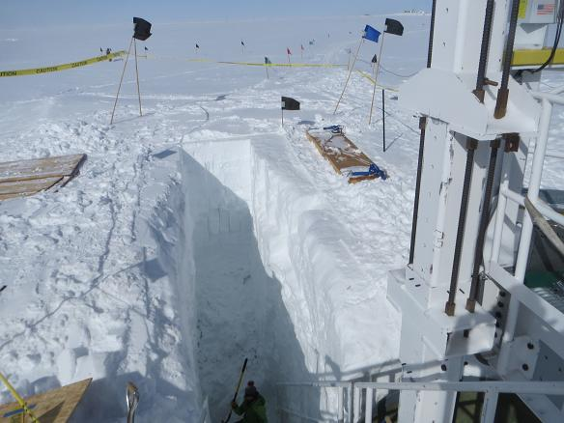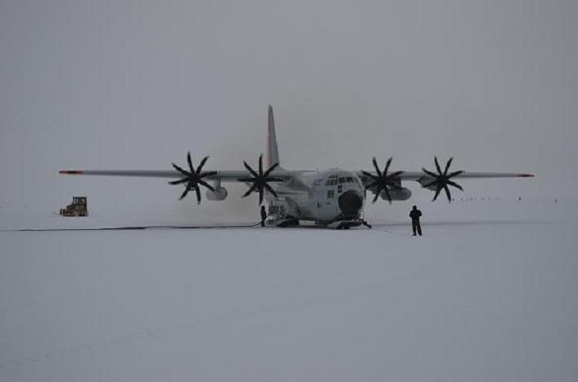

**Please visit the clean air log at ftp://ftp.summitcamp.org/pub/data/GEOSummit/Clean%20Air%20Traffic/**

|  |  |
| --- | --- |
| **Facilities** | **Comment** |
| TAWO | Received updated NOAA Met equipment and mounts, are in the process of wiring, calibrating and preparing to install 2 windbirds and another RTD. |
| MSF |  |
| Green House |  |
| **Experiment** | **Notes** |
| NOAA CATS GC | Comment:  % of time operating: 100% |
| NOAA CCGG flasks | Comment:  Sample collection date(s): 8/19/2013 |
| NOAA HATS flasks | Comment:  Sample collection date(s): 8/19/2013 |
| NOAA Surface Ozone | Comment:  % of time operating: 100%  Data on ftp server: 8/19/2013 |
| NOAA Aethelometer | Comment: Was taken offline on 8/18/2013, in order to access NOAA Met Suite connections. Will be put back online when NOAA Met installation is complete.  % of time operating: 0%  Data on ftp server: n/a |
| NOAA Met Suite | Comment: In the process of wiring, connecting and calibrating the windbirds and RTD unit.  % of time operating: 60% |
| NOAA Ozonesonde | Comment: Dual launch with ICECAPS radiosonde throughout the summer months.  Date launched: 8/22/2013 |
| NOAA Clidar | Comment: Not collecting data.  % of time operating: 0% |
| NOAA CLAP/PSAP/Neph | Comment:  % of time operating: 100% |
| NOAA Radiometers | Comment:  % of time operating: 100% |
| NOAA Firn Air Sampling | Comment: |
| Radionuclide filter | Comment:  % of time operating: 100% |
| Aerosol DRUM sampler | Comment: Taken offline and returned to PI.  % of time operating: 0% |
| UCM Surface Samples | Comment:  Sample collection date(s): 8/19/2013  Data on ftp server: 8/19/2013 |
| DRI Surface Samples | Comment:  Sample collection date(s): 8/19/2013  Data on ftp server: 8/19/2013 |
| UCM Snow Pit | Comment:  Sample collection date: 8/13/2013 |
| UCM String Pit | Comment: Last laid String 8/7/2013.  Measurement date: |
| Bamboo Forest | Comment: Raised all of the bamboo poles and recorded new heights.  Observation date: 8/21/2013  Data on ftp server: 8/21/2013 |
| ICESat accumulation | Comment: Raised all of the ICESat flags and recorded new heights.  Observation date: 8/23/2013 |
| BSI UVSIMN | Comment:  % of time operating: 100% |
| Hanka Seismometer | Comment:  % of time operating: 100% |
| UNAVCO | Comment: |
| Helmig GC | Comment:  % of time operating: 100% |
| Kramer NOx | Comment:  % of time operating: 100% |
| Feng Sampling | Comment:  Sample collection date(s): Site visited daily, samples collected when appropriate. |
| Noone Snow Sampling | Comment:  Sample collection date(s): Site visited daily, surface samples collected daily, drift and rime samples collected when appropriate. |
| Noone Tower Instruments | Comment: Installed repaired MPS. |
| Hamilton Polarsondes | Comment:  Date launched: |
| Steffen Tower Instruments | Comment:  Data on ftp server: 8/19/2013 |
| Steffen Solar Instruments | Comment:  Data on ftp server: 8/19/2013 |
| Total Sky Imager | Comment:  % of time operating: 100% |
| ICECAPS Radiosonde | Comment:  Dates launched: Twice daily radiosonde launches |
| ICECAPS MWR | Comment:  % of time operating: 100 |
| ICECAPS SODAR | Comment:  % of time operating: 100 |
| ICECAPS POSS | Comment:  % of time operating: 100 |
| ICECAPS MMCR | Comment:  % of time operating: 100 |
| ICECAPS CAPABL | Comment: PIs still working bugs out with software/OS; hardware reconfiguration of laser and optics all working well.  % of time operating: 80 |
| ICECAPS MPL | Comment:  % of time operating: 100 |
| ICECAPS Ceilometer | Comment: Files not written during one day.  % of time operating: 85 |
| ICECAPS PAERI | Comment: Several brief data dropouts during 8/21 (reason unknown).  % of time operating: 99 |
| ICECAPS IcePIC | Comment: Images taken during precipitation and diamond dust events this week.  % of time operating: -- |
| ASIAA MWR | Comment:  % of time operating: 100 |