Summit Station Weekly Science Report
Reporting Period: Aug. 26-Sep 1, 2013
Completed by: Shawntel Stapleton, David Benson, Lana Cohen
Comments: This week we have continued to move and organize supplies, assist in camp cleanup and tasking, make further progress on unfinished projects. We are still working on station close tasking, and once that is complete, we will begin to settle into a winter routine.

The first photo below is Dave and Shawntel in the process of Winter-over Tower Rescue Training.
The second photo is the most recent (8/29) Ozonesonde launch at sunset (The balloon and package are in the upper left corner).
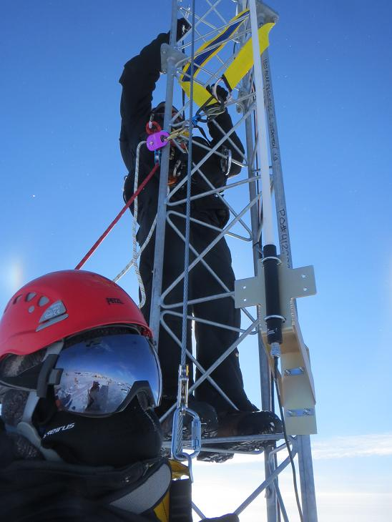

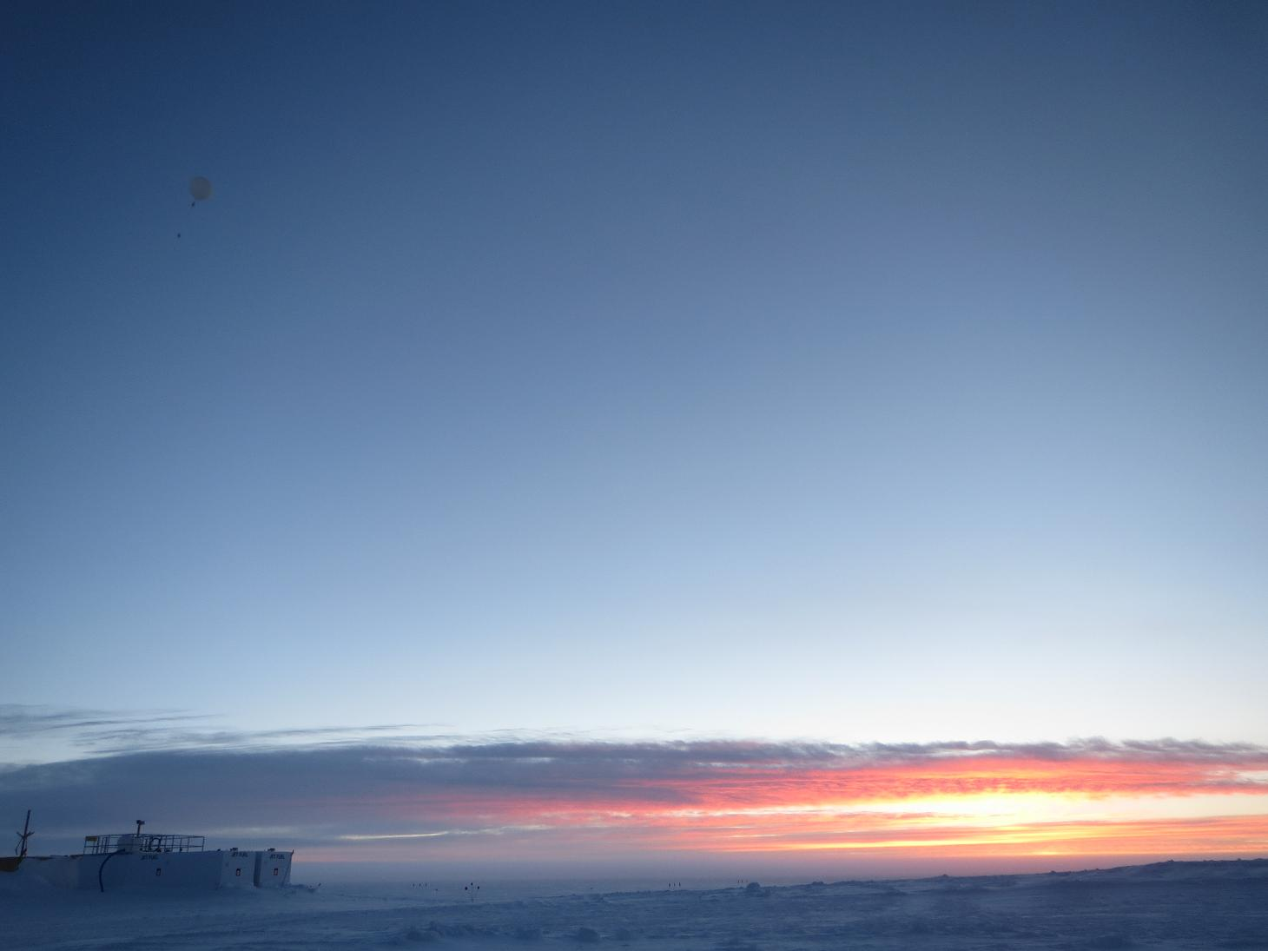

Please visit the clean air log at ftp://ftp.summitcamp.org/pub/data/GEOSummit/Clean%20Air%20Traffic/

Facilities | Comment
TAWO
MSF
Green House
Experiment | Notes
NOAA CATS GC | Comment:  % of time operating: 100%
NOAA CCGG flasks | Comment:  Sample collection date(s): 8/27/2013
NOAA HATS flasks | Comment:  Sample collection date(s): 8/27/2013
NOAA Surface Ozone | Comment:  % of time operating: 100%  Data on ftp server: 8/19/2013
NOAA Aethelometer | Comment: Was taken offline on 8/18/2013, in order to access NOAA Met Suite connections. Will be put back online when NOAA Met installation is complete.  % of time operating: 0%  Data on ftp server: n/a
NOAA Met Suite | Comment: In the process of diagnosing wiring issues, connecting and calibrating the windbirds and RTD unit.  % of time operating: 60%
NOAA Ozonesonde | Comment: Dual launch with ICECAPS radiosonde throughout the summer months.  Date launched: 8/29/2013
NOAA Clidar | Comment: Not collecting data.  % of time operating: 0%
NOAA CLAP/PSAP/Neph | Comment:  % of time operating: 100%
NOAA Radiometers | Comment:  % of time operating: 100%
NOAA Firn Air Sampling | Comment:
Radionuclide filter | Comment:  % of time operating: 100%
Aerosol DRUM sampler | Comment: Taken offline and returned to PI.  % of time operating: 0%
UCM Surface Samples | Comment: Delays due to North winds.  Sample collection date(s): 8/27/2013  Data on ftp server: 8/27/2013
DRI Surface Samples | Comment:  Sample collection date(s): 8/27/2013  Data on ftp server: 8/27/2013
UCM Snow Pit | Comment:  Sample collection date: 8/13/2013
UCM String Pit | Comment: Last laid String 8/7/2013.  Measurement date:
Bamboo Forest | Comment:  Observation date: 8/28/2013  Data on ftp server: 8/28/2013
ICESat accumulation | Comment:  Observation date: 8/23/2013
BSI UVSIMN | Comment:  % of time operating: 100%
Hanka Seismometer | Comment:  % of time operating: 100%
UNAVCO | Comment:
Helmig GC | Comment:  % of time operating: 100%
Kramer NOx | Comment:  % of time operating: 100%
Feng Sampling | Comment:  Sample collection date(s): Site visited daily, samples collected when appropriate.
Noone Snow Sampling | Comment:  Sample collection date(s): Site visited daily, surface samples collected daily, drift and rime samples collected when appropriate.
Noone Tower Instruments | Comment:
Hamilton Polarsondes | Comment:  Date launched:
Steffen Tower Instruments | Comment:  Data on ftp server: 8/26/2013
Steffen Solar Instruments | Comment:  Data on ftp server: 8/26/2013
Total Sky Imager | Comment:  % of time operating: 100%
ICECAPS Radiosonde | Comment: 8/31 Morning sonde data (12Z) not sent due to Greenhouse internet outage.  Dates launched: Twice daily radiosonde launches; dual launch once per week with ozonesonde.
ICECAPS MWR | Comment:  % of time operating: 100
ICECAPS SODAR | Comment:  % of time operating: 100
ICECAPS POSS | Comment:  % of time operating: 100
ICECAPS MMCR | Comment:  % of time operating: 100
ICECAPS CAPABL | Comment: Computer and data acquisition program issues causing significant data collection gaps. Troubleshooting is ongoing…  % of time operating: 50
ICECAPS MPL | Comment:  % of time operating: 100
ICECAPS Ceilometer | Comment:  % of time operating: 100
ICECAPS PAERI | Comment: Intermittent cooler current issue is ongoing. Outside fan got unplugged by high winds on 8/29.  % of time operating: 100
ICECAPS IcePIC | Comment: 8/29 1345Z pics taken during precipitation event.  % of time operating:
ASIAA MWR | Comment:  % of time operating: 100

