Summit Station Weekly Science Report
Reporting Period: Sept 2-Sept 8, 2013
Completed by: Shawntel Stapleton, David Benson, Lana Cohen
Comments: This week we are progressing on unfinished projects, tidying up science areas, and participating in camp cleanup and winter over trainings. The NOAA 10M wind bird is back up and running well. We are continuing to diagnose issues for getting a second bird going, at the top of the TAWO tower, with help from the NOAA team back in the States. It has been quite windy this week and we can feel the temperatures dropping already. Otherwise, there is still a fair amount of station maintenance, including organizing equipment and materials to be winterized, moving snow and grooming to prevent significant drifting.
For the ICECAPS projects, a couple of storms this week provided excellent opportunities for capturing pictures of snowflakes. These images are invaluable for providing a link between what is remotely sensed with the instruments and what we actually see on the ground.
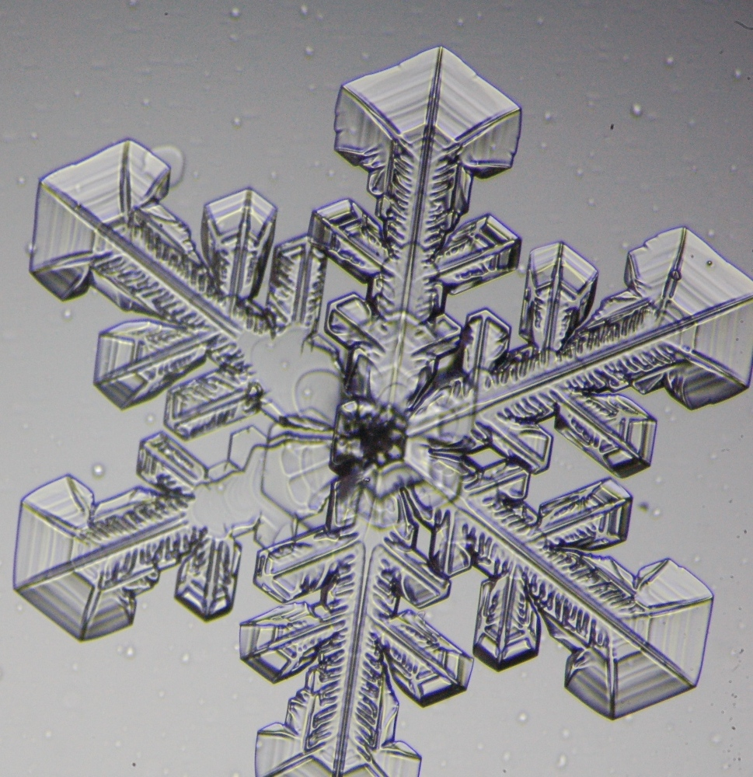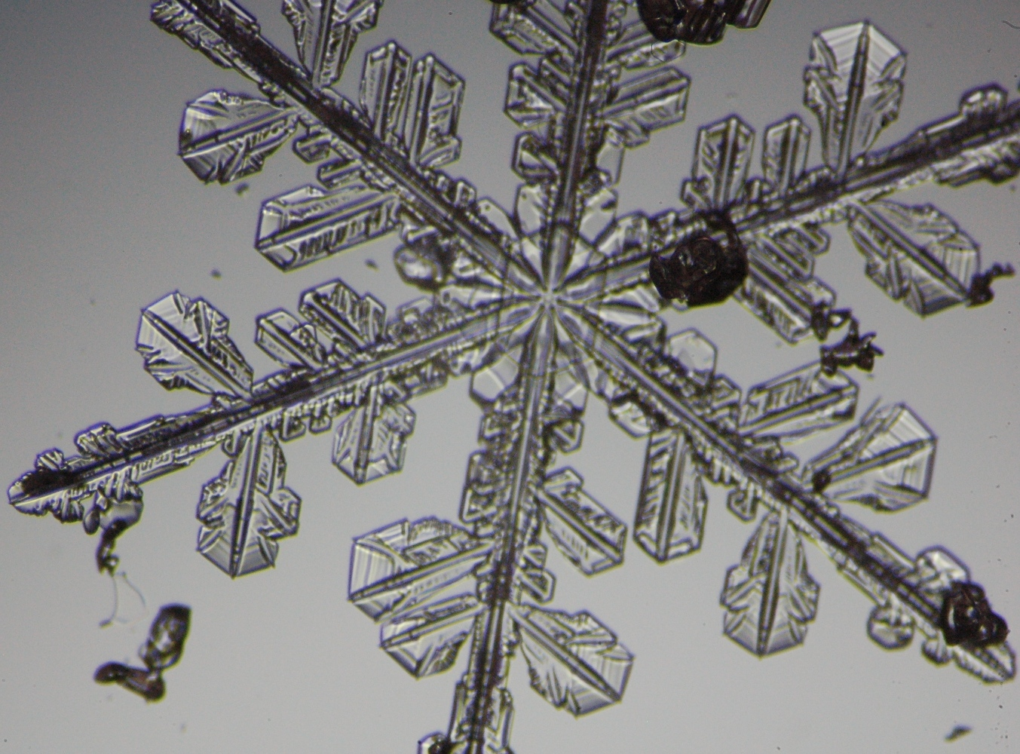
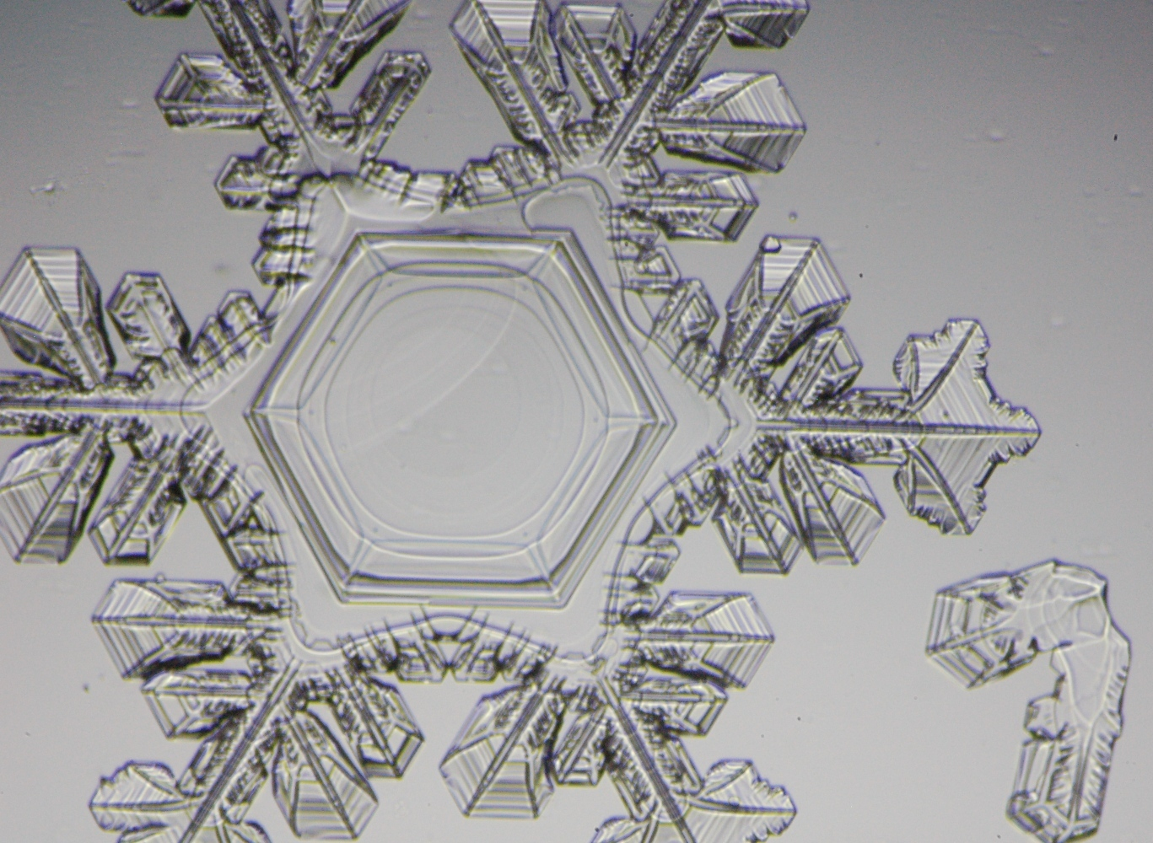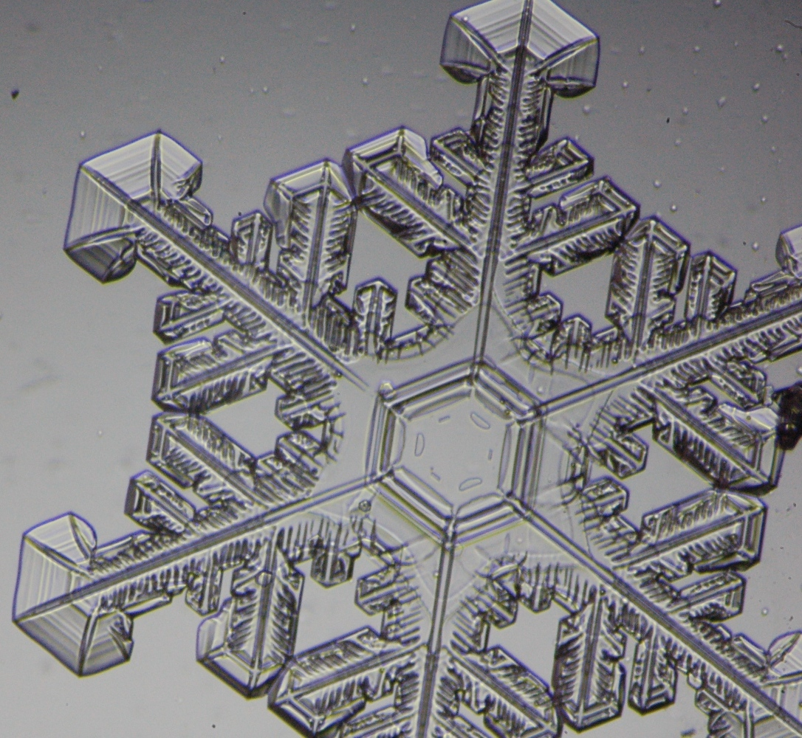
It has also been a good week for sundogs and halos (which are indicative of plate-shaped hexagonal ice crystals in the atmosphere).
The first photo below is a sundog and double-halo with TAWO glowing in the background.
The second photo is a sunset sundog.
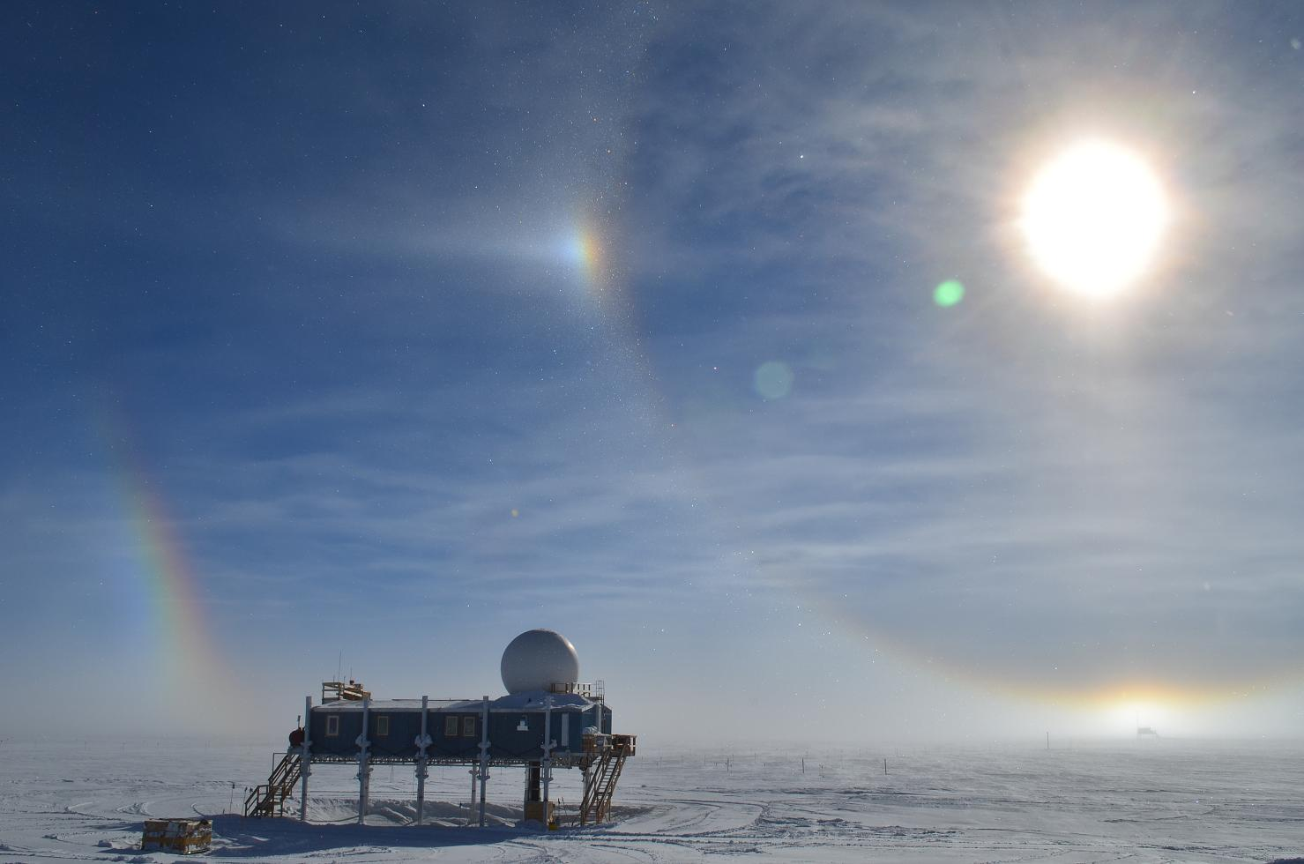
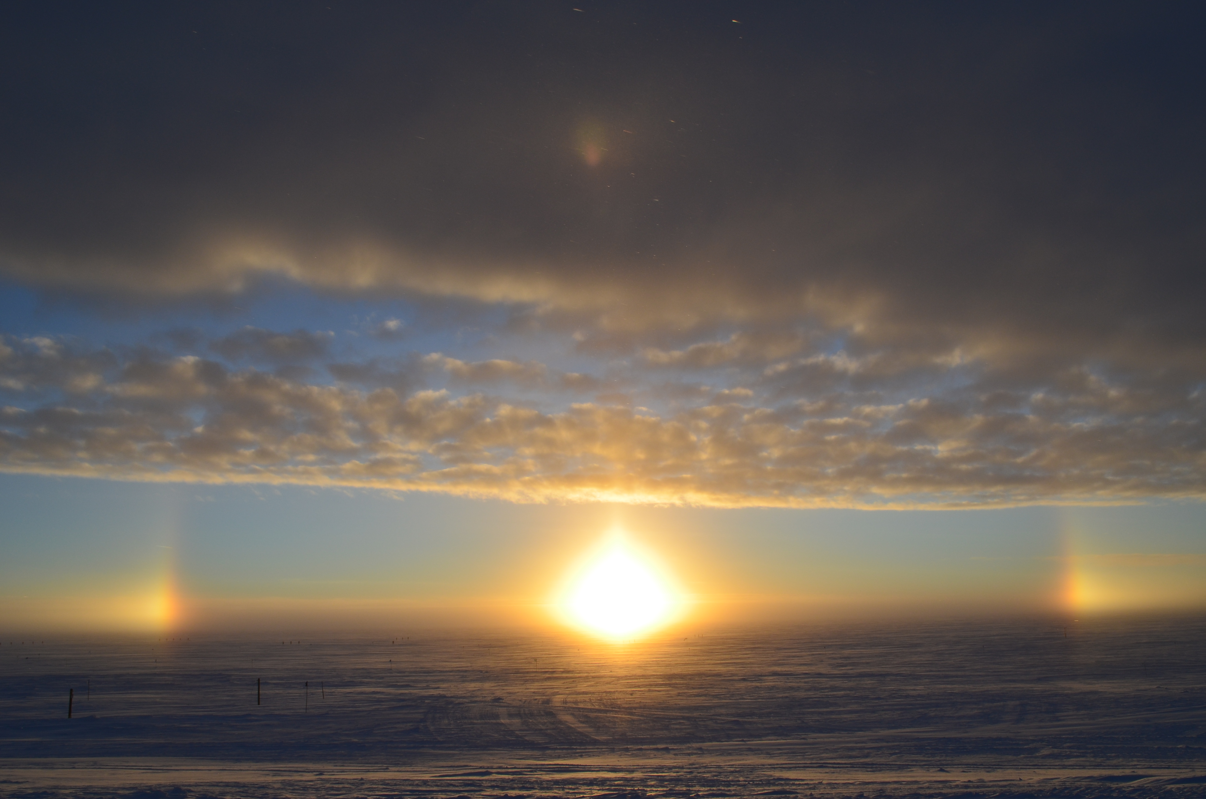

Please visit the clean air log at ftp://ftp.summitcamp.org/pub/data/GEOSummit/Clean%20Air%20Traffic/

Facilities | Comment
TAWO
MSF
Green House
Experiment | Notes
NOAA CATS GC | Comment:  % of time operating: 100%
NOAA CCGG flasks | Comment:  Sample collection date(s): 9/2/2013
NOAA HATS flasks | Comment:  Sample collection date(s): 9/2/2013
NOAA Surface Ozone | Comment:  % of time operating: 100%  Data on ftp server: 9/2/2013
NOAA Aethelometer | Comment: Was taken offline on 8/18/2013, in order to access NOAA Met Suite connections. Will be put back online when NOAA Met installation is complete.  % of time operating: 0%  Data on ftp server: n/a
NOAA Met Suite | Comment: 10M wind bird is online and running most of the time. We are diagnosing issues for the new wind bird, and must take the 10M bird offline occasionally to assist in troubleshooting.  % of time operating: 98%
NOAA Ozonesonde | Comment: Dual launch with ICECAPS radiosonde throughout the summer months.  Date launched: 9/5/2013
NOAA Clidar | Comment: Not collecting data.  % of time operating: 0%
NOAA CLAP/PSAP/Neph | Comment:  % of time operating: 100%
NOAA Radiometers | Comment:  % of time operating: 100%
NOAA Firn Air Sampling | Comment:
Radionuclide filter | Comment:  % of time operating: 100%
Aerosol DRUM sampler | Comment: Taken offline and returned to PI.  % of time operating: 0%
UCM Surface Samples | Comment: Delays due to North winds.  Sample collection date(s): 9/2/2013  Data on ftp server: 9/2/2013
DRI Surface Samples | Comment:  Sample collection date(s): 9/2/2013  Data on ftp server: 9/2/2013
UCM Snow Pit | Comment:  Sample collection date: 8/13/2013
UCM String Pit | Comment: Last laid String 9/2/2013.  Measurement date:
Bamboo Forest | Comment:  Observation date: 9/4/2013  Data on ftp server: 9/4/2013
ICESat accumulation | Comment:  Observation date: 8/23/2013
BSI UVSIMN | Comment: The BSI instrument software has occasional been nonoperational; we are troubleshooting with the BSI team. Installed new cable for PSP ventilator.  % of time operating: 85%
Hanka Seismometer | Comment:  % of time operating: 100%
UNAVCO | Comment:
Helmig GC | Comment:  % of time operating: 100%
Kramer NOx | Comment:  % of time operating: 100%
Feng Sampling | Comment: Using ICECAPS POSS data to log start/end precipitation times.  Sample collection date(s): Site visited daily; samples collected every day this week.
Noone Snow Sampling | Comment:  Sample collection date(s): Site visited daily, surface samples collected daily, drift and rime samples collected when appropriate.
Noone Tower Instruments | Comment:
Hamilton Polarsondes | Comment:  Date launched:
Steffen Tower Instruments | Comment:  Data on ftp server: 9/2/2013
Steffen Solar Instruments | Comment:  Data on ftp server: 9/2/2013
Total Sky Imager | Comment:  % of time operating: 100%
ICECAPS Radiosonde | Comment:  Dates launched: Twice daily radiosonde launches; Dual launches with ozonesonde on Thurs evening.
ICECAPS MWR | Comment:  % of time operating: 100
ICECAPS SODAR | Comment:  % of time operating: 100
ICECAPS POSS | Comment:  % of time operating: 100
ICECAPS MMCR | Comment:  % of time operating: 100
ICECAPS CAPABL | Comment: Ongoing OS/software issues causing shutdowns.  % of time operating: 90
ICECAPS MPL | Comment: Afterpulse calibration performed Sep 7.  % of time operating: 100
ICECAPS Ceilometer | Comment:  % of time operating: 100
ICECAPS PAERI | Comment:  % of time operating: 100
ICECAPS IcePIC | Comment: Photos taken during precipitation events on Sept 4th & 5th.  % of time operating:
ASIAA MWR | Comment:  % of time operating: 100

