Summit Station Weekly Science Report
Reporting Period: Sept 16-Sept 22, 2013
Completed by: Shawntel Stapleton, David Benson, Lana Cohen
Comments: This week again had many North winds days but ‘higher’ temperatures of closer to -18C and above at times. We have continued to diagnose and address the internet connectivity issues to the Green House. We discovered that we also unfortunately lost the GPS base station in the high wind event, likely due to GH grounding issues. There was a fair amount of discussion and decision making amongst PFS and SRI regarding resolution. UNAVCO will be sending a new base station with a better surge protector on the flight in late October. The Noone vault also continued to have technical issues remotely accessing their equipment, and they are working on a plan of where to go next.
There was also a station-wide internet outage for most of the day on 9/20 (~0:00-14:00UTC) which affected the nightly data transfer from MSF and the morning radiosonde balloon launch.
We did have some good weather this week and we were able to get in another ICESAT on a beautiful day. (Although we no longer have GPS base station data, the PIs may still be able to process the ICESAT survey using only the roving GPS data.)
The first photo is of Dave and Lana collecting data at a GPS waypoint with Shawntel holding the accumulation measurement pole. The next photo is of the polypod, with our survival gear and the GPS unit and antenna.
The last photo is of a lovely sunset and moonrise we had on Sept 16th (photo: David Benson).
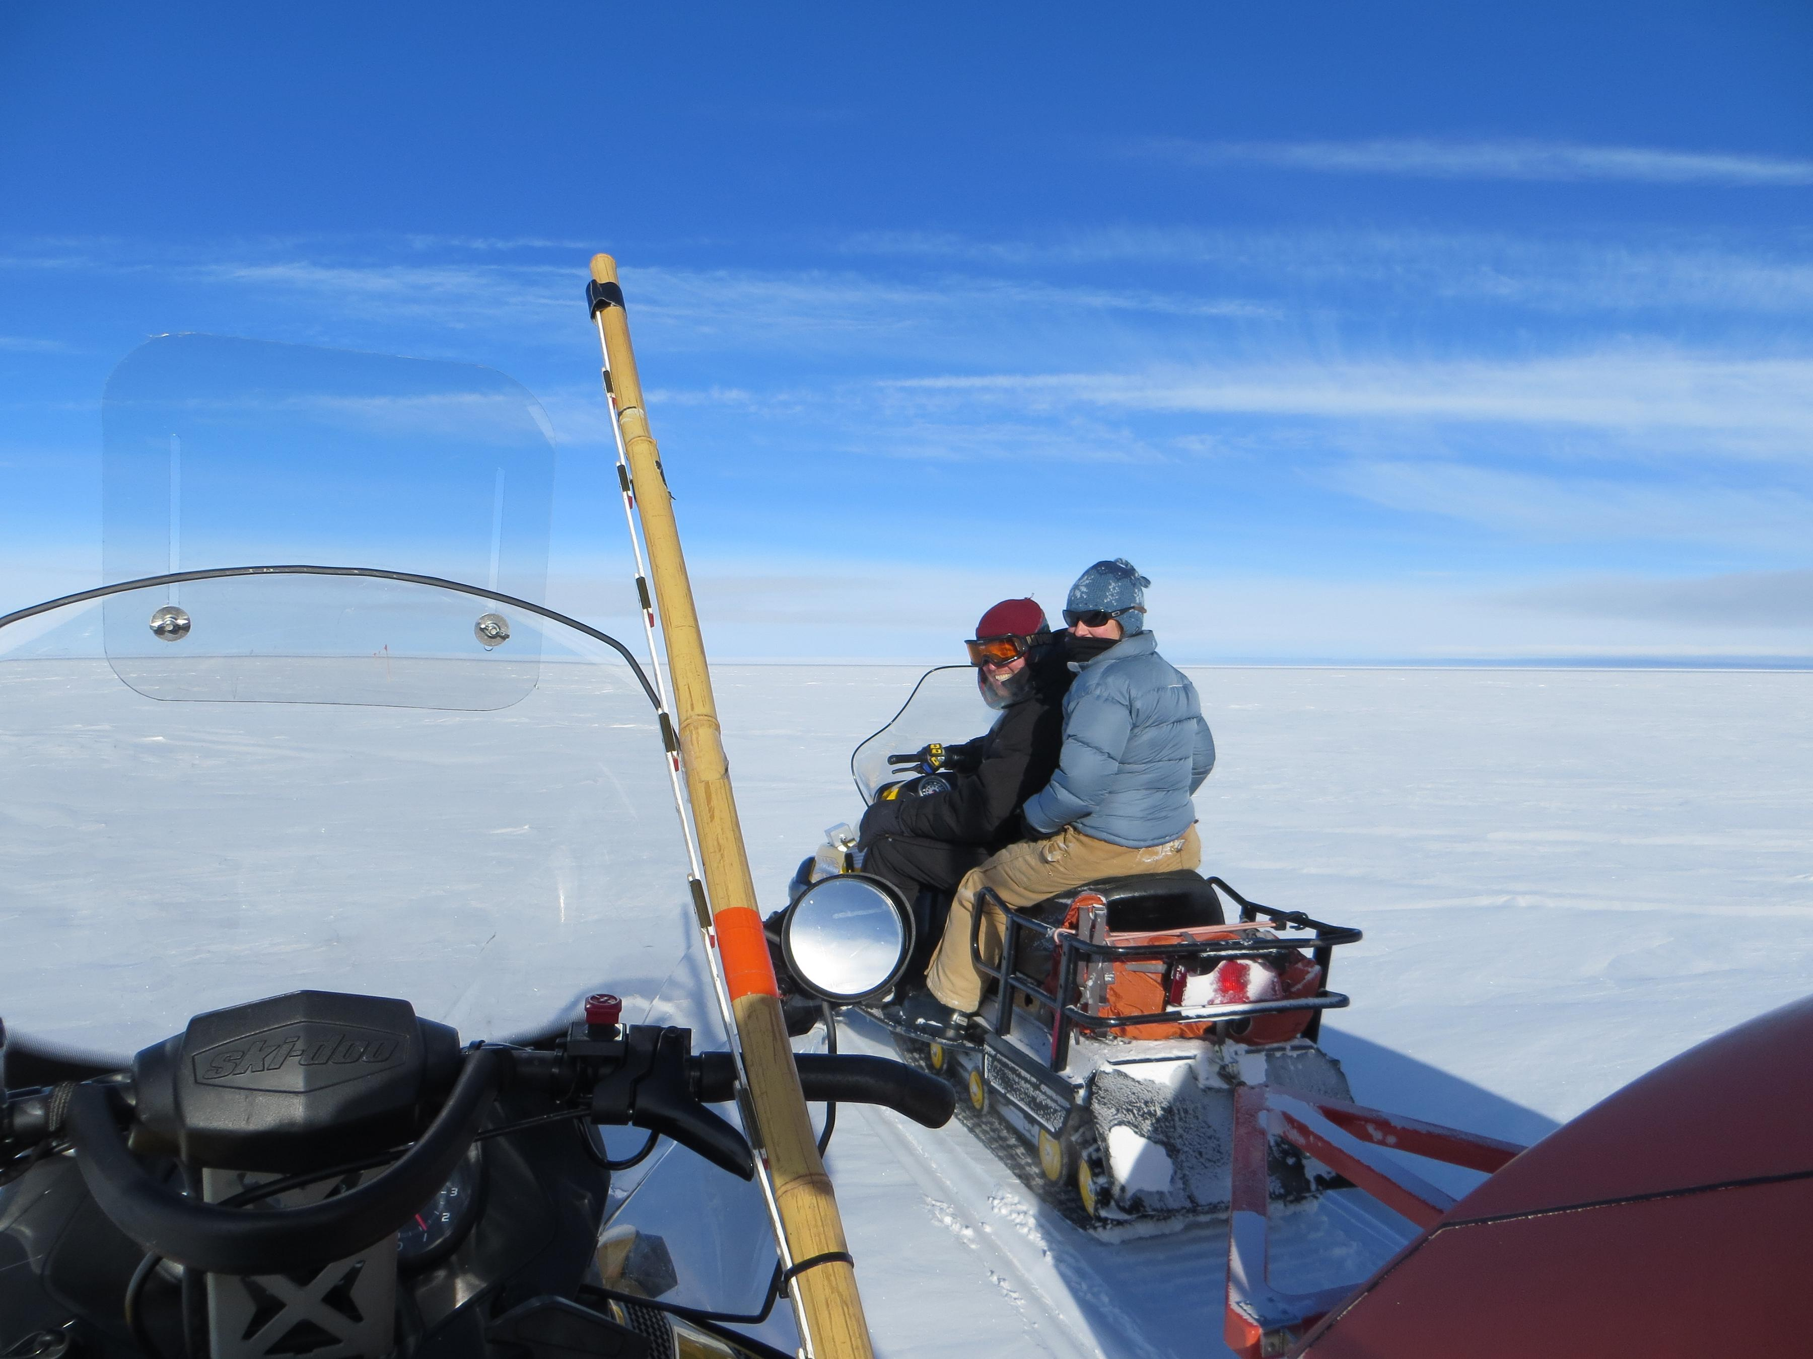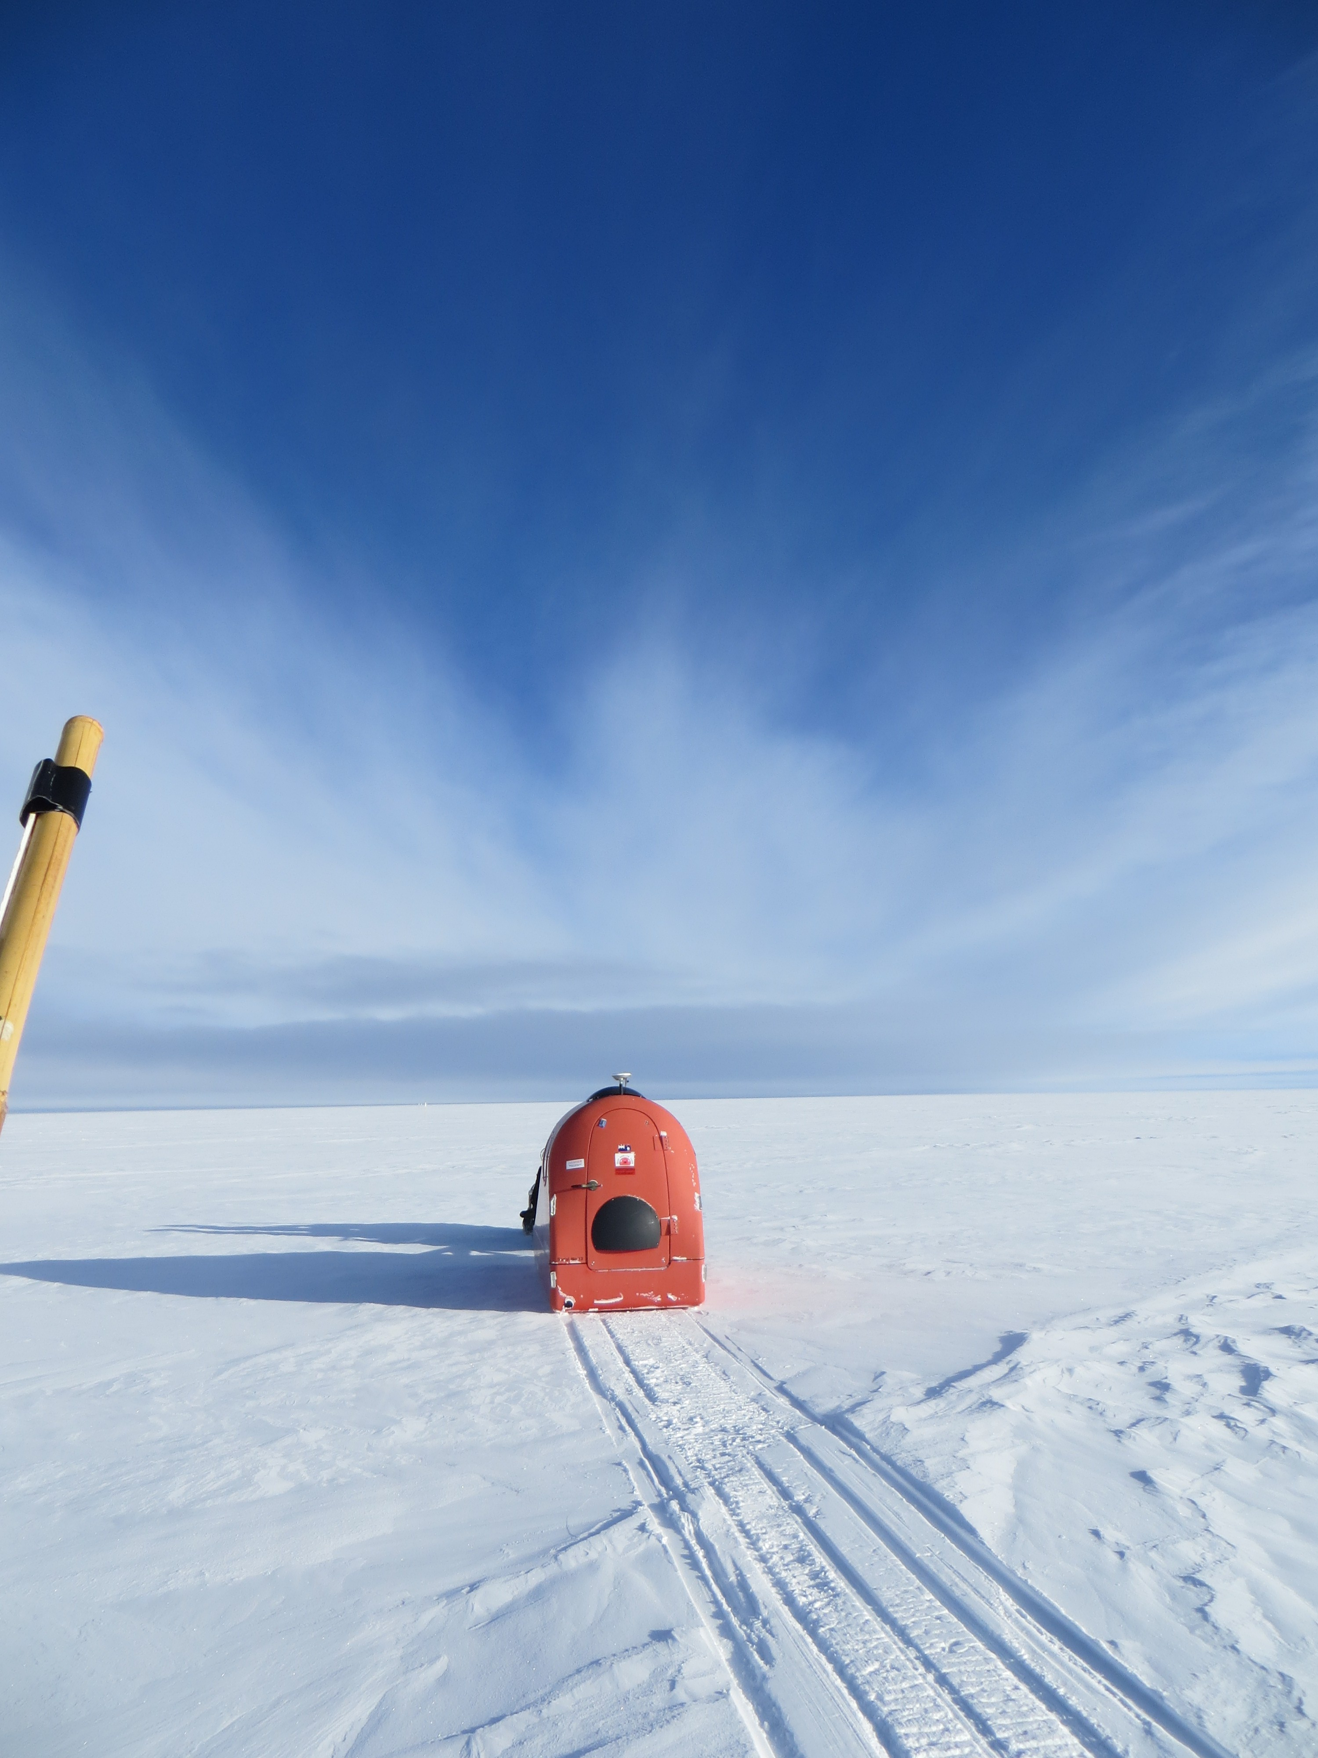
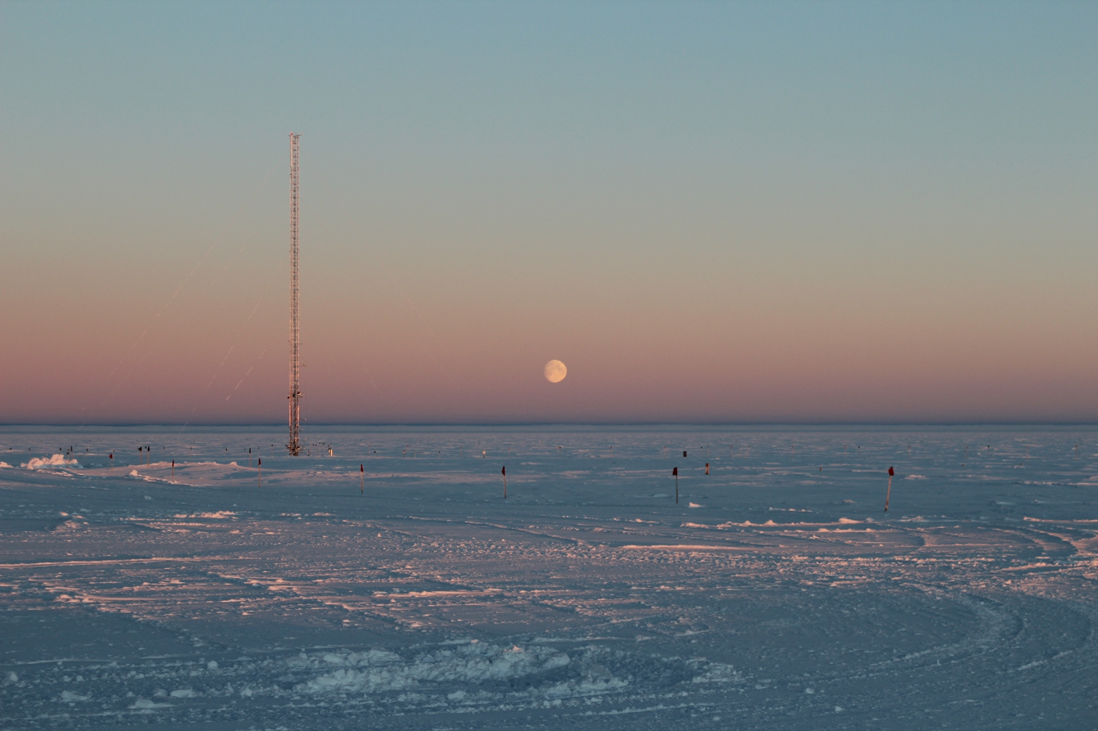

Please visit the clean air log at ftp://ftp.summitcamp.org/pub/data/GEOSummit/Clean%20Air%20Traffic/

Facilities | Comment
TAWO
MSF
Green House
Experiment | Notes
NOAA CATS GC | Comment:  % of time operating: 100%
NOAA CCGG flasks | Comment:  Sample collection date(s): 9/16/2013
NOAA HATS flasks | Comment:  Sample collection date(s): 9/16/2013
NOAA Surface Ozone | Comment:  % of time operating: 100%  Data on ftp server: 9/16/2013
NOAA Aethelometer | Comment:  % of time operating: 100%  Data on ftp server: n/a
NOAA Met Suite | Comment: 10M wind bird is online and running. We are continuing o diagnose issues for the new wind bird.  % of time operating: 100%
NOAA Ozonesonde | Comment: Dual launch with ICECAPS radiosonde throughout the summer months.  Date launched: 9/19/2013
NOAA Clidar | Comment: Not collecting data.  % of time operating: 0%
NOAA CLAP/PSAP/Neph | Comment:  % of time operating: 100%
NOAA Radiometers | Comment:  % of time operating: 100%
NOAA Firn Air Sampling | Comment:
Radionuclide filter | Comment:  % of time operating: 100%
Aerosol DRUM sampler | Comment: Taken offline and returned to PI.  % of time operating: 0%
UCM Surface Samples | Comment:  Sample collection date(s): 9/16/2013, 9/20/2013  Data on ftp server: 9/16/2013, 9/20/2013
DRI Surface Samples | Comment:  Sample collection date(s): 9/16/2013  Data on ftp server: 9/16/2013
UCM Snow Pit | Comment:  Sample collection date: 8/13/2013
UCM String Pit | Comment: Last laid String 9/2/2013.  Measurement date:
Bamboo Forest | Comment:  Observation date: 9/18/2013  Data on ftp server: 9/18/2013
ICESat accumulation | Comment:  Observation date: 9/20/2013
BSI UVSIMN | Comment:  % of time operating: 100%
Hanka Seismometer | Comment:  % of time operating: 100%
UNAVCO | Comment: Base Station was fried during high wind event, due to inadequate grounding . A new Base Station and surge protector are being sent up at the end of October.
Helmig GC | Comment:  % of time operating: 100%
Kramer NOx | Comment:  % of time operating: 100%
Feng Sampling | Comment:  Sample collection date(s): 9/19, 9/20, 9/22
Noone Snow Sampling | Comment:  Sample collection date(s): Site visited daily, surface samples collected daily, drift and rime samples collected when appropriate.
Noone Tower Instruments | Comment:
Hamilton Polarsondes | Comment:  Date launched:
Steffen Tower Instruments | Comment:  Data on ftp server: 9/16/2013
Steffen Solar Instruments | Comment:  Data on ftp server: 9/16/2013
Total Sky Imager | Comment: 9/17 TSI taken offline and removed from MSF roof for winter.  % of time operating: 0
ICECAPS Radiosonde | Comment:  Dates launched: Twice daily radiosonde launches (Thurs dual launch with ozonesonde)  9/17 Morning sonde (12Z) launched ~20min late due to bad battery (?)  9/20 Morning balloon (12Z) data not sent due to station-wide internet outage
ICECAPS MWR | Comment:  % of time operating: 100
ICECAPS SODAR | Comment:  % of time operating: 100
ICECAPS POSS | Comment:  % of time operating: 100
ICECAPS MMCR | Comment:  % of time operating: 100
ICECAPS CAPABL | Comment: Ongoing work by PIs to fix software/OS issues  % of time operating: 90
ICECAPS MPL | Comment:  % of time operating: 100
ICECAPS Ceilometer | Comment:  % of time operating: 100
ICECAPS PAERI | Comment:  % of time operating: 100
ICECAPS IcePIC | Comment: Pics taken 9/19 during precip event  % of time operating:
ASIAA MWR | Comment:  % of time operating: 100

