ICECAPS Weekly Report
October 28 – Nov 3, 2013
Lana Cohen/John Lyons

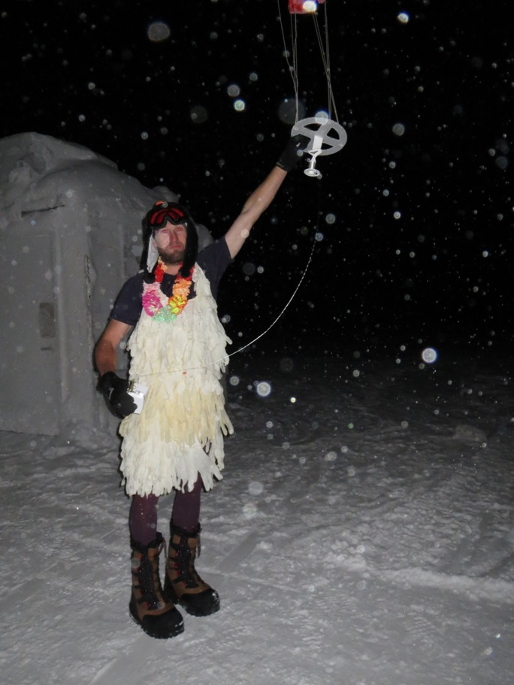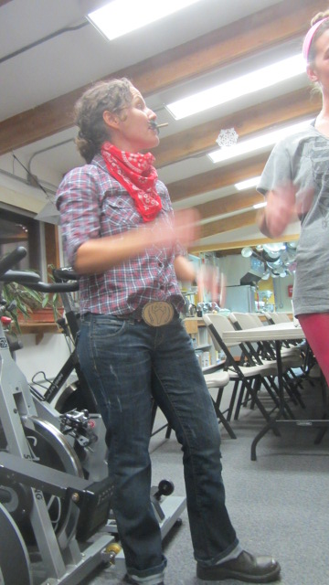

General:
• Phase 2 and 3 celebrated Halloween on Thursday night, and Phase 2 departed on schedule on Friday afternoon.

Significant Weather Observations:
• 10/28 winds: calm; clear sky, fog
• 10/29 winds: 10kn, overcast, some ice
• 10/30 winds: 210 at 8 kn, SKC > FEW, intermittent fog
• 10/31 winds: 6 kn, SKC, extensive feathery rime on S sides of everything
• 11/01 winds: 9kn, clear sky
• 11/02 winds: calm, SKC > FEW with intermittent fog passing through station
• 11/03 winds 240 at 15 kn , becoming cloudy and snowing. Sonde showed significant WSW winds increasing to just below tropopause (different from last 8 days), humidity profile much more uniform

Dataman Account:
• 10/31: USB disk ICECAPS#4 removed and replaced with ICECAPS#2

MWR:
•

SODAR:
• 10/28 Cleaned out sodar enclosures
11/02 Cleaned out sodar enclosure, microphone head fell off of receiver horn. Replaced head, data OK.

POSS:
• 10/31: posacq1 accidentally closed, but restarted

MMCR:
•

CAPABL:
• 10/31: PC seems to have restarted itself overnight; was found with laser running, but PC logged out and Labview not running. Restarted PC.

Every-other-day reboots ongoing.

MPL:
•

VCEIL:
•

IceCAM:
•

PAERI:
•

ASIA-A:
•

TSI:
• Offline for winter

IcePIC:
• 10/30: primarily columns and rime, some triangles, few prisms
10/31: similar to 10/30, plus attempted photos of feathery rime
11/03: rime, columns, prisms, few needles

Radiosonde:
• Twice daily sondes

