ICECAPS Weekly Report
November 4 – November 10, 2013
John Lyons

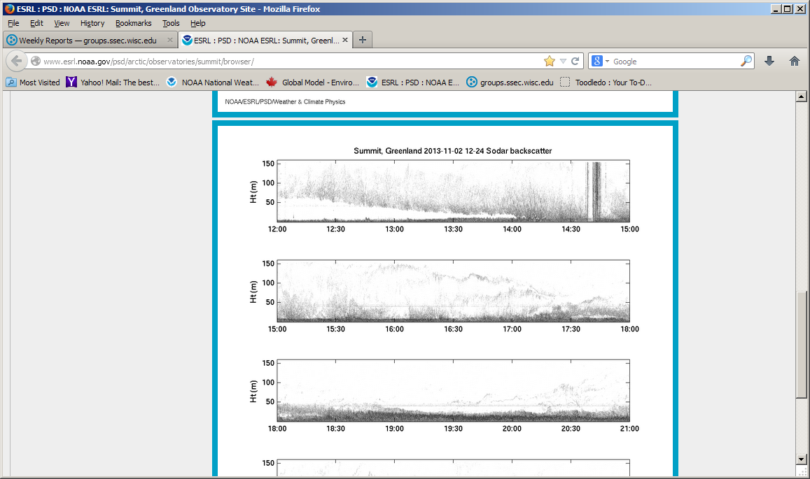

Any theories of why the descending density layer? Clear morning, winds roughly 5m/s, oddly coincident with a clear sunrise.

General:
- MSF facility operating normally.

Significant Weather Observations:
- 11/04: winds: 198 at 7kn, -40C, FEW-SCT, intermittent fog in afternoon, very light rime
- 11/05: winds: 223 at 7 kn, -45C, FEW
- 11/06: winds: 135 at 15kn, -53C, FEW, blowing snow/ground cloud layer moving in afternoon
- 11/07: winds: 150 at 15kn, -45C, FEW, significant blowing snow event from ESE overnight (10/6), diminished by 10Z on 11/07
- 11/08: winds: 224 at 11kn, -38C, FEW, ice crystals in air overnight (10/7) and again 10/8
- 11/09: winds 208 at 8 kn, -40C, FEW, thin ice fog present in AM
- 11/10 : winds 182 at 13 kn, -43C, FEW, fog increasing around 1400, diamond dust overnight

Dataman Account:
- Operating normally

MWR:
- 11/06: Receiver 2 temperature instability on the 90/150 unit at roughly 1415Z. Recvr temp drops from 311K to roughly 295K, seems to be associated with a 7K upward spike in Tb of the 150 GHz channel. Housekeeping is noting RED for Recvr 2 temp stability.
- 11/08 1253Z: Similar Recvr 2 temp instability on 90/150 as on 10/06
- 11/10 1440Z: Recvr 2 temp instability on 90/150

SODAR:
- 11/07: Cleaned sodar
- Operating normally

POSS:
- Operating normally
- 11/06: POSACQ1 was found shut down, restarted at 1302Z on 10/06 (cause uncertain)

MMCR:
- Operating normally
- 11/07: Antenna was cleared of snow by overnight wind event

CAPABL:
- Rebooting every other day, otherwise operating normally
- 11/06: CAPABL PC froze up while in shut down phase of restart. Had to hard shut it down (PC power button). Took an unusually long period to boot back – stuck on WindowsXP screen for a long while before Windows itself started to open. Other issues ensured, all communicated to Ryan and Robert. Required SR430 reboot, Robert is looking into data.

MPL:
- 11/08: Software froze up at ~2300Z 11/07. Restarted PC and Sigma MPL at ~1300Z, recorded exact times and errors in log
- Operating normally

VCEIL:
- Operating normally

IceCAM:
- Operating normally

PAERI:
- 11/08: 1247 – 1303: Data went null, then came back online (now with blue bars)
- 11/10: Data null event, unable to determine when it occurred, but back online by 1400 at latest
- Operating normally

ASIA-A:
- 11/07 1350Z: Communications error required reboot of radiometer and PC.
- Operating normally

TSI:
- Offline for winter

IcePIC:
- 11/04: Bullet rosettes, needles, hollow columns (from 10/3 evening precip)
- 11/05: rime, columns
- 11/07: rime, few prisms, messy photos due to rime coating
- 11/08: rime low on the slide, bullet rosettes and needles near top
- 11/10: present sample was rime and small columns, overnight sample was rimed needles/columns(?) and possibly rimed bullets

Radiosonde:
- Twice daily sondes
- 11/06 24Z sonde: First sonde failed due to high crosswinds (ascending balloon ripped string off of sonde during launch). Scrambled for second sonde, was launched 8 mins outside of window (2338Z). Second was successful.

