ICECAPS Weekly Report
November 11 – November 17, 2013
John Lyons

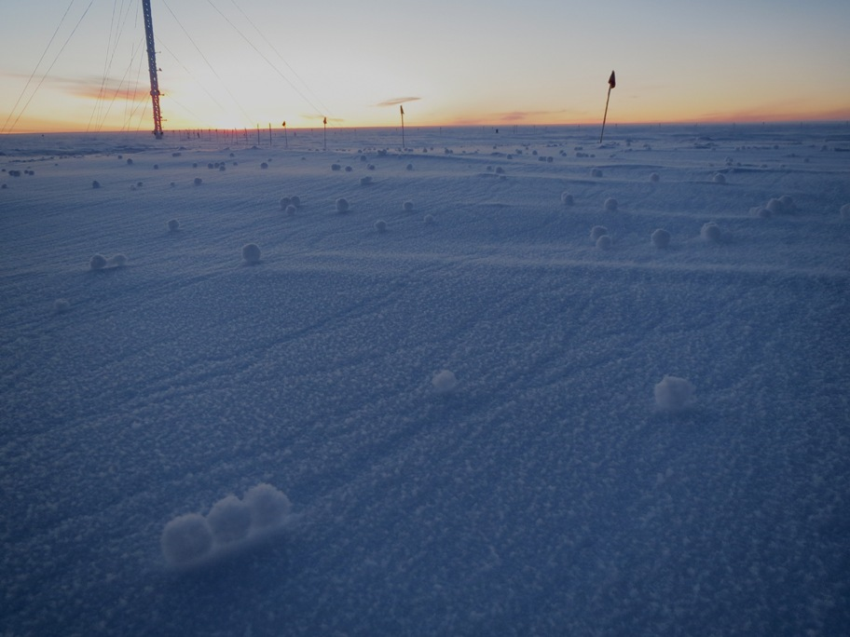

General:
- MSF facility operating normally.

Significant Weather Observations:
- 11/11: Winds 139 at 10kn, -36C, 72%, SCT, ice crystals falling, warming overnight and weakening of inversion overnight 10/10 – 10/11, calming winds and snow overnight 10/11 – 10/12
- 11/12: Winds 186 at 5 kn, -45C, 60%, FEW, wide halo around moon overnight to 11/13
- 11/13: Winds 224 at 5 kn, -52C, 55%, FEW, widespread yukimarimo on surface, documented in ICEPICs
- 11/14: Winds 136 at 24kn, -38C, 70%, OVC/BLSN. Clearing in evening, halo around moon overnight
- 11/15: Winds 302 at 12kn, -41.4C, 66%, SCT
- 11/16: Winds 316 at 10kn, -48.7C, 60%, FEW – generator exhaust plume passing through MSF periodically between ground and 20m AGL
- 11/17: Winds 285 (variable) at 8kn, -52.6, 57%, FEW – generator exhaust plume passing through MSF periodically between ground and 20m AGL

Dataman Account:
- 11/12: GPS time server has ceased to allow updating by PC’s b/c it has lost GPS signal. All PC clocks remain relatively accurate except sonde PC (see below). Issue corrected by Matt by 20Z (reset server from GPS sync to NIST or similar sync, looking into issue with antenna.
- 11/15: Dismantled and inspected antenna assembly, no sign of connector, cable or antenna damage. Reconnected and rebooted server, no change in GPS signal status.
- Operating normally

MWR:
- 11/11: Recvr 2 Temp Instability
- 11/14: Recvr 2 Temp Instability, occurred prior to or coincident with my arriving at the MSF, but BEFORE climbing the roof
- Operating normally

SODAR:
- 11/12: Cleaned snow out of sodar
- Operating normally

POSS:
- Operating normally

MMCR:
- 11/11: 1910Z (roughly): Local DwellDisplay froze up on –radar computer; radar ceased to operate. Contact Duane and Matt, and by 2200 UPS had by itself shut down all components and gone into alarm. Instructed by Duane to turn key to off and back on during the morning of 11/12. Back to normal operations by 1600Z 11/12
- Operating normally

CAPABL:
- 10/15 1320Z: Required unscheduled reboot of PC due to scan sequence, Meadowlark and SR430 control, stalling out
- Rebooting every other day, otherwise operating normally

MPL:
- Operating normally

VCEIL:
- Operating normally

IceCAM:
- Operating normally

PAERI:
- 11/12: LW/SW sensitivity alarm due to snow on the mirror; cleared
- Operating normally

ASIA-A:
- Communications error on afternoon of 11/14, found and reset by Pierre at 0215Z 11/15
- Operating normally

TSI:
- Offline for winter

IcePIC:
- 11/11: columns, rime, prisms, increasing bullet rosettes later in day and into evening (as snowfall increased)
- 11/13: yukimarimo surface sample; bullet rosettes in a matrix of long, fine needles.

Radiosonde:
- Twice daily sondes
- 11/12 12Z sonde: GPS time server errors (see above) caused this PC to reset itself overnight to a time 8:50:58 earlier than GPS time. Hence, times for this launch are inaccurate; correct times and offset were sent to Matt and logged in sonde log sheet. Matt corrected sounding data on 11/15.

