ICECAPS Weekly Report
November 18 – November 24, 2013
John Lyons

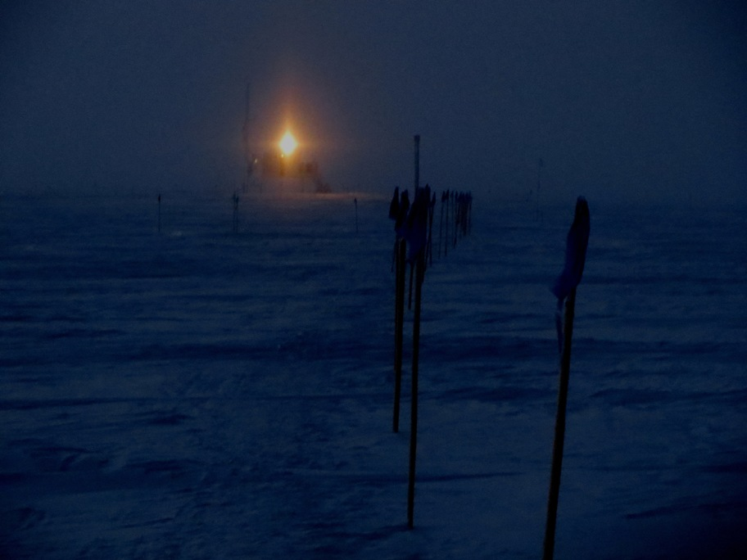
TAWO floodlight, 11/22 12Z (roughly)

General:
- NOAA/TAWO Met 2m temperature sensor down from 11/21 – 11/24 due to programming of Zeno DAS. NOAA webpage also down 11/23 – 11/25. Sonde ground check data from GH tower, supplemented with Swiss Tower RH data.
- Electric wall heaters not switched on yet, as warmer weather has required cooling rather than heating
- MSF facility operating normally.

Significant Weather Observations:
- 11/18: Winds 174 at 6 kn, -48C, 61%, SCT, SN from very thin cloud in late afternoon and evening, large halo around moon
- 11/19: Winds 310 at 9 kn, -49C, 60%, SCT-OVC
- 11/20: Winds 237 at 21 kn, -19C, 90%, SN/BLSN, moderating at midday, but picking back up at night
- 11/21: Winds 281 at 17 kn, -35C, 67%, DRSN, overnight and early AM was higher winds (gusts to 30+ kn) but moon visible
- 11/22: Winds 243 at 14kn, -46C, 63%, FEW, diamond dust overnight, plus vertical cross haloes around moon and TAWO floodlight in AM
- 11/23: Winds 194 at 14kn, -43C, 65%, SCT, some diamond dust overnight, above average riming this morning
- 11/24: Winds 227 at 25kn, -20C, 80%, SN-BLSN, occasional views upwards to moon

Dataman Account:
- Operating normally

MWR:
- 11/19: Calibration body fan on HATPRO frozen up and will not restart, even after cleaning
- 11/19: R2CH software froze up; Erik discovered and cleared
- 11/20: Recvr 2 Temp Instability on 90/150; not coincident with climbing roof (but high winds), cleared itself
- 11/24: Restarted HATPRO calibration body fan with help of wind

SODAR:
- Operating normally
- 11/19 Sodar cleaned of snow (mostly transmitter dish)
- 11/22 Sodar cleaned of snow

POSS:
- Operating normally

MMCR:
- 11/23: Contour display data found to be junk in AM (all vertical lines), all other checks OK. Three restarts attempted afternoon of 11/23; on third restart MMCR showed cyclical helix overcurrent fault; shut instrument down. Cleared to restart again 11/25 PM; successful.
- Operating normally

CAPABL:
- 11/20: Failed to startup again upon reboot.
- 11/22: Laser and Labview turned off

MPL:
- Operating normally
- 11/19: Afterpulse calibration
- 11/20: MPL mount to Dataman went down; remounted at 1300

VCEIL:
- Operating normally

IceCAM:
- Operating normally

PAERI:
- 11/20: LW and SW Responsivity alarms at 06Z and 13Z (at least). Self-clearing, probably due to SN-BLSN
- 11/21: Continuous LW and SW responsivity alarms from 0830Z (BLSN) until mirror manually cleared at 1645Z
- Operating normally

ASIA-A:
- 11/19: Communications error sometime between 04Z and 06Z, Pierre discovered and rebooted radiometer remotely.
- 11/20: 24hr stability testing initiated in early AM by Pierre
- Operating normally

TSI:
- Offline for winter

IcePIC:
- 11/18 2200Z: cruddy bullet rosettes, needles, hollow column, one triangular prism
- 11/20 1345Z: small prisms and rime, most poorly shaped
- 11/22 1400Z: mostly bullet rosettes, some columns, few triangular and stellar plates
- 11/24 1300Z: rime, prisms, poorly formed stellar plates

Radiosonde:
- Twice daily sondes

