ICECAPS Weekly Report
November 25 – December 1, 2013
John Lyons

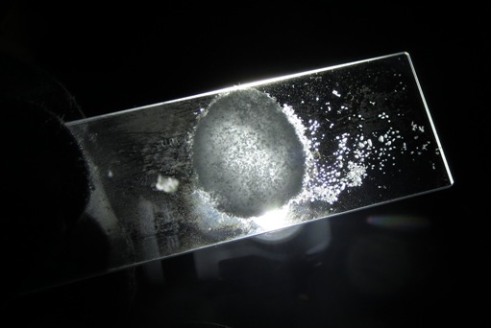
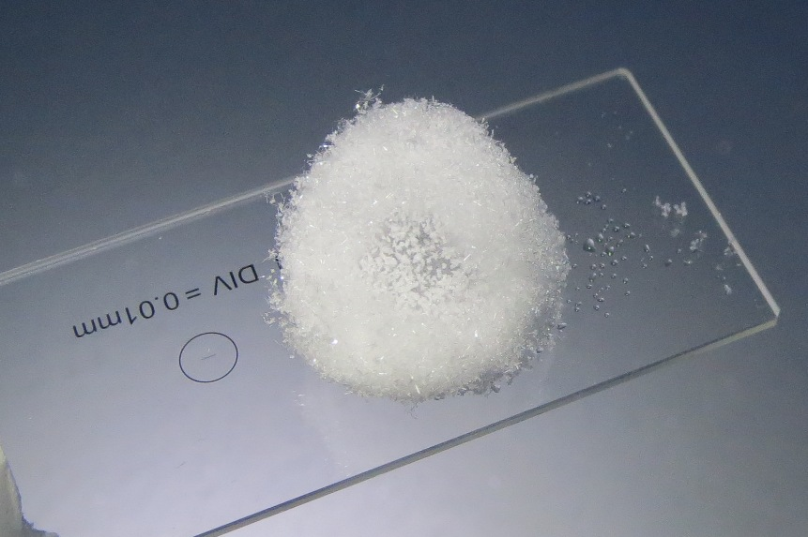
~2 cm yukimarimo on 11/28. Smaller, much more sparse than 11/13
(photos at ftp:\data\ICECAPS\Reports\Pictures\20131128 Yukimarimo JL)

General:
- MSF facility operating normally.

Significant Weather Observations:
- 11/25: Winds 193 at 17 kn, -22C, 65%, BKN-DRSN
- 11/26: Winds 213 at 8 kn, -30C, 79%, OVC-SN
- 11/27: Winds 252 at 11kn, -43.1C, 66%, FEW
- 11/28: Winds 201 at 7kn, -47C, 62%, FEW-SCT, 1-2 cm yukimarimo present on surface, VERY low density (<1 ball/m2), not moving
- 11/29: Winds 165 at 20 kn, -32C, 77%, BLSN, increasing to 40+ kn in evening, then calming overnight
- 11/30: Winds 228 at 12 kn, -40C, 69%, FEW, calming, surface hoar developed by 24Z, destroyed 12/1 AM by wind
- 12/1: Winds 123 at 19kn, -41C, 68%, SCT-DRSN

Dataman Account:
- Operating normally

MWR:
- Operating normally

SODAR:
- Operating normally
- 11/26: Sodar cleaned of snow
- 11/30: Sodar opened for inspection after storm, no cleaning needed

POSS:
- Operating normally

MMCR:
- Restored to operation with reboot 11/25 PM.
- Operating normally

CAPABL:
- No longer operating

MPL:
- Operating normally

VCEIL:
- Operating normally

IceCAM:
- Operating normally

PAERI:
- Operating normally

ASIA-A:
- 11/30: Radiometer PC found stuck in CALIBRATION, PC clock stalled, Radiometer Communication Error tab open. Rebooted R2CH, radiometer, and manually re-sync’ed clock. Contacted Pierre.

TSI:
- Offline for winter

IcePIC:
- 11/25: Bullets, bullet rosettes with prisms growing off (or stellar plates?)?
- 11/26: Bullet rosettes, hollow columns, prisms possibly growing off of rosettes?
- 11/28: 3 yukimarimo ball samples, 1 sample of air crystals, 1 surface sample
- 11/29: Rime, very small columns, prisms, rare rosettes

Radiosonde:
- Twice daily sondes
- 11/27 12Z: Balloon launched late due to ground station hardware issues (SPS311 needed to be rebooted). Data transferred on time.

