ICECAPS Weekly Report
December 16 – December 22, 2013
John Lyons

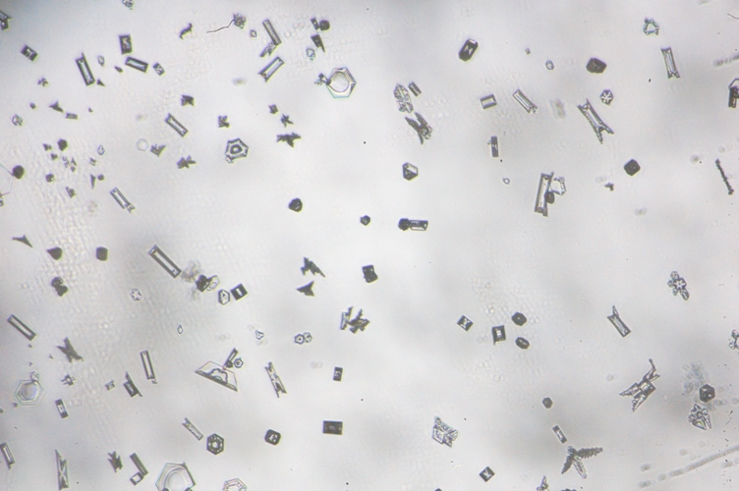
12/21 1420: Upwind slide as storm tapers off, while lidar high-Co-polarized-return cloud still present at ~1km. Note the hoar(?) growth on ends of some columns
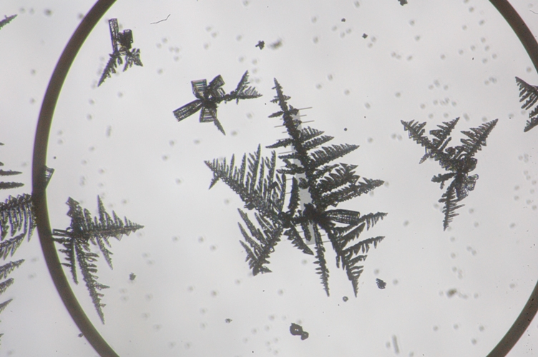
1500 – 1640: Downwind slide after transition to SKC, now bullet rosettes with secondary (?) hoar growth. Upwind slide (not shown) is bullet rosettes and thick needle growths, but none of the fern-like growth
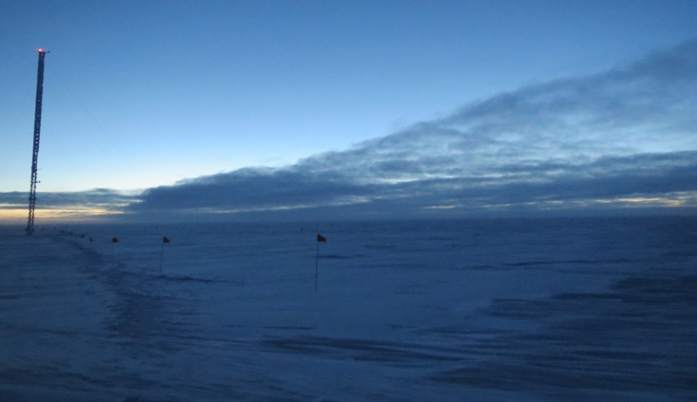
1km cloud layer moving E to W (L to R)

General:
- MSF not visited 12/20 due to extremely low vis in BLSN
- NOAA met tower 2m temperature malfunctioning from 12/18 – 12/22 14Z; all other data fields OK. GH temperature used for balloon surface temperature readings and for this report
- MSF facility operating normally

Significant Weather Observations:
- 12/16: Winds 034 at 15kn, -34C, 76%, OVC-DRSN-SN
- 12/17: Winds 107 at 10kn, -46C, 62%, FEW, diamond dust
- 12/18: Winds 105 at 9kn, -52C, 61%, SCT, halo around moon overnight with faint color rings
- 12/19: Winds 105 at 11kn, -38C, 73%, FEW moving to SCT and DRSN. Diamond dust transitioning to SN, two surface hoar layers (lower dense layer transitioning into upper, fluffier Shimizu hoar), actively being destroyed by increasing winds.
- 12/20: Winds 100 at 35 – 50 kn, -28C, 80%, BLSN (wind event began 12/19 at roughly 23Z)
- 12/21: Winds 108 at 10kn, -30C, 80%, BKN SN, rapid transition to SKC at roughly 15Z, associated with hoar development (see IcePICs)
- 12/22: Winds 094 at 13kn, -33, 76%, SCT DRSN

Dataman Account:
- 12/17: ToBoulder not empty; PAERI, IceCAM, sodar, POSS files remain
- 12/18: ToBoulder clear
- 12/21: 36 Icecam files left in ToBoulder
- 12/22: 12/21 Icecam and sodar data remain in ToBoulder

MWR:
- Operating normally

SODAR:
- 12/16: Sodar cleaned
- 12/21: Sodar cleaned; receiver compartment heavily snowed in, clearly impacting signal quality
- Operating normally

POSS:
- 12/20: Experienced two high noise events (blowing snow?), 0649 – 0658Z, 1634 – 1643Z

MMCR:
- Operating normally

CAPABL:
- No longer operating

MPL:
- 12/17 1245 – 1257Z: Afterpulse calibration

VCEIL:
- Operating normally

IceCAM:
- Operating normally

PAERI:
- 12/16: PAERI readings ceased from 0642 – 0658Z (empty records), then resumed
- 12/19: LW/SW responsivity alarm from roughly 00Z to 07Z (blowing snow, probably), self-cleared

ASIA-A:
- Operating normally

TSI:
- Offline for winter

IcePIC:
- 12/18: All small rime clumps, columns, needles, prisms
- 12/19: Three samples: downwind of MSF, upwind of MSF, and a sample of the surface hoar. Mostly needles (Shimizu), plus columns, bullet rosettes, ill-formed prisms, rime
- 12/21: Two samples:
  - 1420Z: small columns, prisms, sectored plates, some crystals, particularly columns on upwind slide have minor hoar(?) growths. Sample taken while still BKN-OVC and SN
  - 1500 – 1640Z: Bullet rosettes, upwind slide with needle (hoar?) growths, downwind slide with fern-like hoar growths, probably secondary growth on slide? Sample taken after transition to SKC
- 12/22: Small columns, bullets, bullet rosettes, prisms, needles, rime

Radiosonde:
- 12/17 12Z: Another possibly bad RH measurement – RH steady at 56% between 8300m (tropopause, possibly), and 12400m
- 12/19 24Z sonde destroyed on launch due to high winds
- 12/20 12Z and 24Z launches cancelled due to high winds
- 12/22 24Z sonde destroyed on launch due to high winds
- There are at least 225 K-sondes left in stock, so through July 2014?
- Twice daily sondes

