ICECAPS Weekly Report
December 23 – December 29, 2013
John Lyons

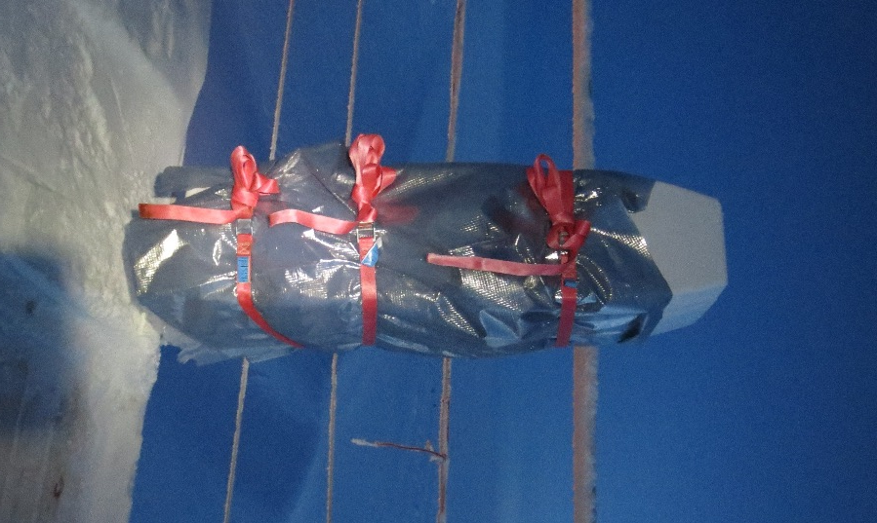
New Ceilometer Jacket

General:
- MSF facility operating normally.

Significant Weather Observations:
- 12/23: Winds 104 at 8 kn, -40C, 69%, FEW-SN (see IcePIC – rimed crystals) with a 0.5 – 1km cloud layer between 15Z and 18Z, layer lowering to ground FZFG, then clearing
- 12/24: Winds 51 at 11 kn, -42C, 67%, FEW, new dense hoar/rime layers on NE side of most structures/poles/etc.
- 12/25: Winds 122 at 14kn, -41C, 68%, SCT
- 12/26: Winds 155 at 10kn, -44C, 66%, SCT, SN later in day
- 12/27: Winds 150 at 10kn, -45C, 63%, FEW
- 12/28: Winds 170 at 6kn, -52C, 55%, SKC, qualitatively the “clearest atmosphere of the phase so far”
- 12/29: Winds vrb, 0 – 3kn, -48C, 63%, SKC, new layer of hoar frost, 2-3m thick patchy ground FZFG moving around summit

Dataman Account:
- 12/23: ToBoulder clear after several days of backlogs
- 12/28: ToBoulder has 54 Icecam images remaining
- 12/29: ToBoulder clear once again

MWR:
- Operating normally

SODAR:
- Operating normally
- 12/29 1403 - 1410: Sodar cleaned

POSS:
- Operating normally

MMCR:
- Operating normally

CAPABL:
- No longer operating

MPL:
- Operating normally

VCEIL:
- 12/23 1420: Insulation and mylar jacket installed around instrument body

Time | NOAA Ambient Temp | VCeil Outside Temp | Tdiff
Before Insul. | -40C | -35C | +5
12/23 1425 | -40C | -34C | +6
12/24 1300 | -42C | -33C | +9
12/25 1436 | -41C | -29C | +12
12/26 1400 | -44C | -20C | +24
12/27 1305 | -45C | -16C* | +29
12/28 1308 | -52C | -22C | +30
12/29 1340 | -48C | -21C* | +27
* Inside heater off, blower heater still on

IceCAM:
- Operating normally

PAERI:
- Operating normally
- 12/27 1600 - 1700: Motor end insulation installed and secured

Time | Outside Air Temp | Mirror Motor Temp | Tdiff
Before Insul | 225.5 | 244.1 | +18.6
12/28 1315 | 220.9 | 238.4 | +18.4
12/29 1345 | 230.0 | 251.0 | +21.0

ASIA-A:
- 12/26 2145: Communications error; reboot and re-time-sync required

TSI:
- Offline for winter

IcePIC:
- 12/23 1725Z: Rimed rosettes and columns, rime clumps, ill-formed crystals, columns, prisms, maybe associated with a low, possibly mixed-phase(?) cloud
- 12/25 1515Z: All very small rime pellets, ill-formed clumps, columns, needles, few prisms
- 12/26
  - 1700Z: Small rime pellets, columns, needles, very fine needles, prisms
  - 1845Z: Rime pellets, larger rime clumps, bullet rosettes, columns, prisms. Fewer needles than 1700Z, more, larger particles. Coincident with SN and change to higher reflectivity region on radar

Radiosonde:
- 12/26 12Z K-sonde likely erroneous RH reading (RH declines monotonically to 50%, then steady for rest of sounding
- 12/27 12Z – Bad K-sonde RH measurement; same symptoms as 12/26 12Z
- Twice daily sondes

