ICECAPS Weekly Report
December 30, 2013 – January 5, 2014
John Lyons

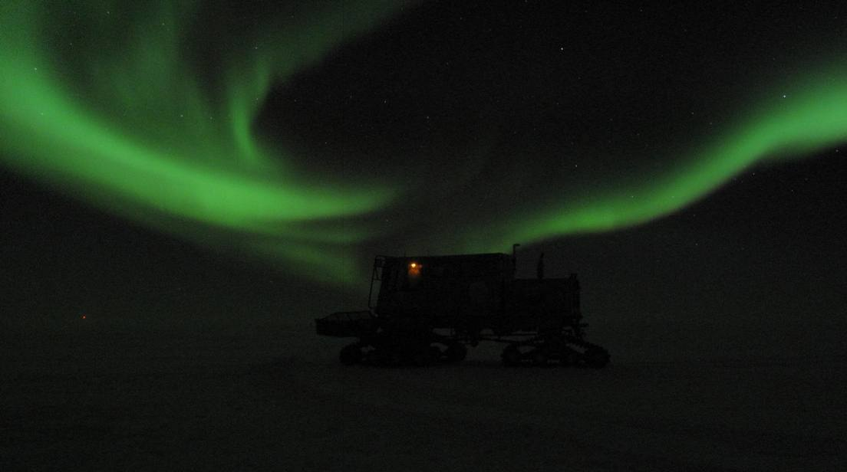
1/4 aurora, from north end of skiway

General:
- MSF facility operating normally.

Significant Weather Observations:
- 12/30: Winds 158 vrb 0 – 3kn, -54C, 56%, SKC, surface hoar present, 2-3m thick patchy ground FZFG moving through camp
- 12/31: Winds 125 at 20kn, -46C, 64%, FEW-DRSN, transition to OVC-SN (low layer) at ~1345
- 1/1/14: Winds 180 at 6kn, -33C, 76%, OVC-SN, similar low cloud layer as 12/31 PM
- 1/2: Winds 75 at 7kn, -42C, 67%, SKC
- 1/3: Winds 126 at 14kn, -41C, 67%, BKN-OVC
- 1/4: Winds 153 at 10kn, -35C, 74%, OVC
- 1/5: Winds 154 at 12kn, -41C, 68%, FEW

Dataman Account:
- Operating normally

MWR:
- Operating normally

SODAR:
- Operating normally

POSS:
- Operating normally

MMCR:
- 1/1/14 Between 12 – 13Z: Transmitted RF power spiked to 260W briefly, RF power in Health file was out of tolerance for 238 seconds of the hour

CAPABL:
- No longer operating

MPL:
- 12/31: Afterpulse calibration

VCEIL:
- 12/23 1420: Insulation and mylar jacket installed around instrument body

Time | NOAA Ambient Temp | VCeil Outside Temp | Tdiff
Before Insul (12/22) | -40C | -35C | +5
12/30 1245 | -54C (winds light) | -26C | +28
12/31 1305 | -46C (SE winds) | -27C | +19
1/1/14 1315 | -33C | -14C* | +19
1/2 1245 | -42C (E winds) | -37C | +5
1/3 1305 | -41C (SE winds) | -18C | +23
1/4 1440 | -35C (SE winds) | -17C | +18
1/5 1345 | -41C (SE winds) | -19C | +22
* Inside heater off, blower heater still on

IceCAM:
- Operating normally

PAERI:
- 12/30 1058 – 1115: PAERI lost data acquisition (blue flags)
- 12/30 1500 – 1800: PAERI lost data acquisition; manually restarted PC at 1800

Time | Outside Air Temp | Mirror Motor Temp | Tdiff
Before Insul (12/27) | 225.5 | 244.1 | +18.6
12/30 1315 | 220.2 | 240.4 | +20.2
12/31 1312 | 227.1 | 246.7 | +19.6
1/1/14 1318 | 240.8 | 259.2 | +18.4
1/2 1250 | 229.9 | 251.1 | +21.2
1/3 1305 | 232.5 | 250.9 | +18.4
1/4 1442 | 238.4 | 259.3 | +20.9
1/5 1350 | 231.9 | 250.3 | +18.4

ASIA-A:
- 1/5 1330: Communications error requiring reboot of radiometer and PC

TSI:
- Offline for winter

IcePIC:
- 12/31 1430: Very small rime pellets, clumps, columns, needles, few prisms, precip associated with <1km cloud layer that moved over at 1345
- 1/1/14 1330: rime clumps, rimed sectored plates, columns, ill-formed crystals, all generally larger than normal

Radiosonde:
- 1/1 24Z Launched Polarsonde #33
- Twice daily sondes

