ICECAPS Weekly Report
January 6 – January 12, 2014
John Lyons

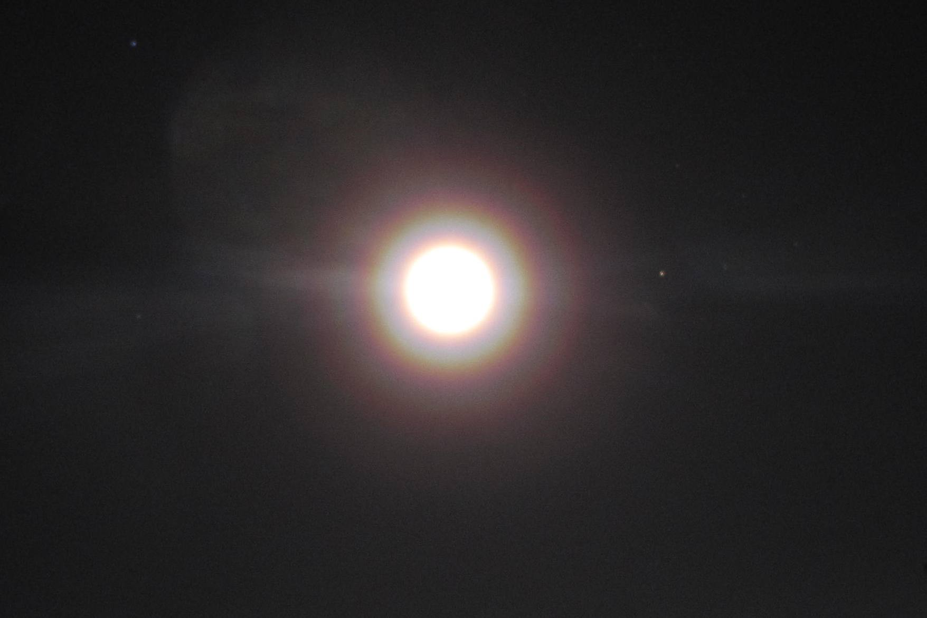
Moon with Ice Halo, 1/12 PM

General:
- 1/8 & 1/9: Roof not checked due to high winds
- MSF facility operating normally.

Significant Weather Observations:
- 1/6: Winds 177 at 8kn, -31C, 78%, OVC-SN (FZFG?), clearing later, then FEW-SN, moon visible with ice halo
- 1/7: Winds 123 at 10kn, -33C, 76%, BKN-SN, prominent ice halos around station lights, bullet rosettes visible to naked eye at ~11Z. 1215Z strong possible mixed phase stratiform cloud at 1.7km – interesting transition on MMCR
- 1/8: Winds 163 at 26kn, -27C, 83%, BLSN
- 1/9: Winds 132 at 25kn, -24C, 86%, OVC-BLSN
- 1/10: Winds 108 at 18kn, -40C, 70%, SKC-BLSN
- 1/11: Winds 121 at 10kn, -40C, 70%, SCT
- 1/12: Winds 173 at 10kn, -46C (dropping), 63%, SKC, surface hoar formed and widespread yukimarimo present (3 – 10 m^2), up to 4.5cm dia, in motion with wind. Ice halo around moon

Dataman Account:
- 1/7: ToBoulder has 80 Icecam images remaining
- 1/8: ToBoulder clear
- 1/10: ToBoulder has 97 Icecam images and one sodar file remaining
- 1/11: ToBoulder clear

MWR:
- Operating normally

SODAR:
- Operating normally

POSS:
- 1/8: DC Offset fault around 13Z
- 1/10: POSS found shut down, restarted script

MMCR:
- 1/7 1000Z: NetCDF file errors have re-appeared in the Elog’s. These were present at the beginning of the phase, but disappeared after the November reboots

CAPABL:
- No longer operating

MPL:
- Operating normally

VCEIL:
- Operating normally

IceCAM:
- Operating normally

PAERI:
- Operating normally

ASIA-A:
- 1/6 1320: PC and radiometer time mis-sync’ed; measurement OK. Rebooted radiometer and PC
- 1/10 0900: Radiometer communications error; discovered and rebooted by Pierre
- 1/11 1310: Radiometer communications error, time OK, rebooted PC and radiometer

TSI:
- Offline for winter

IcePIC:
- 1/6 2045: bullets, bullet rosettes, columns – generally large, then also small columns and pellets
- 1/12 1900: Sample from 4cm yukimarimo ball – Shimizu, larger needles, bullet rosettes, pellets and clumps

Radiosonde:
- 1/6 12Z –K sonde had a very noisy and erratic RH signal
- 1/11: 12Z –K sonde had a probably bad RH signal
- Twice daily sondes

