ICECAPS Weekly Report
January 13 – January 19, 2014
John Lyons

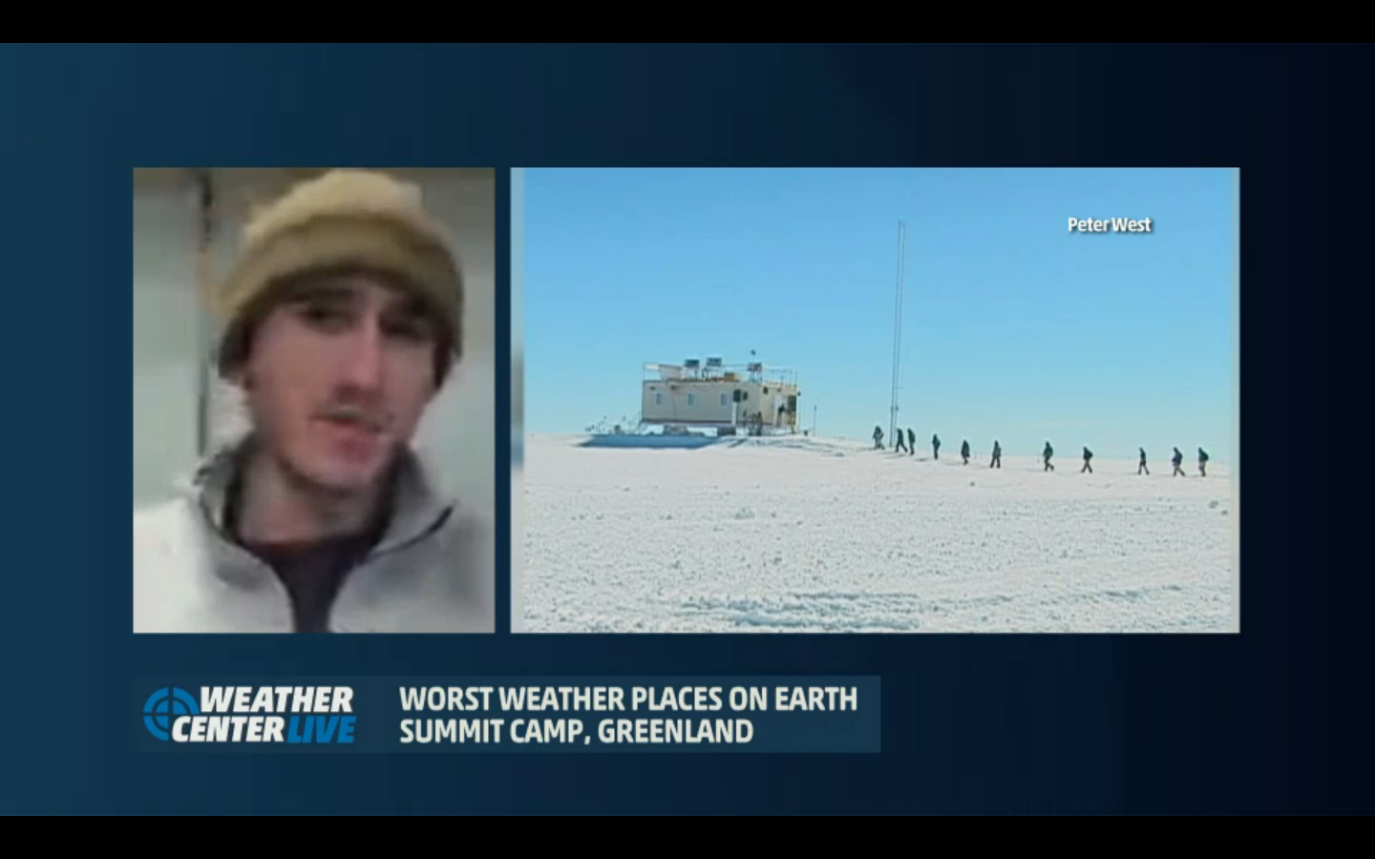
The MSF makes national TV (Weather Channel, 1/19)
http://www.weather.com/video/worlds-worst-weather-places-43507?

General:
- MSF facility operating normally.

Significant Weather Observations:
- 1/13: Winds 120 at 21kn, -32C, 77%, OVC-BLSN
- 1/14: Winds 125 at 6kn, -41C, 68%, FEW with scattered low ground FZFG in area
- 1/15: Winds 150 at 9kn, -46C, 63%, BKN changing to SKC, moon ice halo
- 1/16: Winds 185 at 8kn, -48C, 61%, FEW, moon ice halo, SN later in day
- 1/17: Winds 97 at 3kn, -41C, 68%, FEW becoming OVC
- 1/18: Winds 129 at 25kn, -30C, 80%, BLSN
- 1/19: Winds 150 at 15kn, -31C, 78%, SCT-DRSN

Dataman Account:
- 1/13: 144 files remaining: POSS, sodar, Icecam
- 1/14: 144 files (dated 1/13) remaining from PAERI, sodar, Icecam, POSS
- 1/15: ToBoulder clear
- 1/16: 97 files remaining: Icecam, sodar
- 1/17: 146 files (1/16 date) remaining: POSS, sodar, Icecam, PAERI, IcePIC
- 1/18: 146 files (1/17 date) remaining: PAERI, sodar, Icecam, POSS
- 1/19: 97 files (1/18 date) remaining, Icecam, sodar

MWR:
- Operating normally

SODAR:
- 1/14: Sodar cleaned
- 1/16: Exterior cleaned and measured for summer construction, cables raised, acoustic insulation on receiver repaired
  - Receiver/microphone cable jacket has damage from cold and abrasion on metal ties. Areas of missing jacket, plus lots of electrical tape, possibly from previous repairs?
  - Do we need acoustic foam for construction?

POSS:
- Operating normally

MMCR:
- 1/16 10:25: Rebooted system; required 5 reboots to bring the system up again, up again at 16:41

CAPABL:
- No longer operating

MPL:
- 1/14: Afterpulse calibration

VCEIL:
- Operating normally

IceCAM:
- Operating normally

PAERI:
- 1/14: Scene mirror required manual cleaning

ASIA-A:
- 1/15: Communication error, discovered and rebooted by Pierre
- 1/18: Communication error, PC and radiometer rebooted

TSI:
- Offline for winter

IcePIC:
- 1/16 1730: Larger bullet rosettes and columns, some with prism growths and riming, also smaller rime pellets and clumps
- 1/19 1715: Smaller columns, needles, prisms, rime pellets and larger rime clumps

Radiosonde:
- 1/13 1401: Polarsonde launched
- 1/15 12Z: First 12Z RS92-SGPD launch, 2 –SGPD’s per day until April 1
- 1/18 24Z: Poor radio reception early in launch, probably due to dense BLSN
- Twice daily sondes

