ICECAPS Weekly Report
January 27 – February 2, 2014
John Lyons

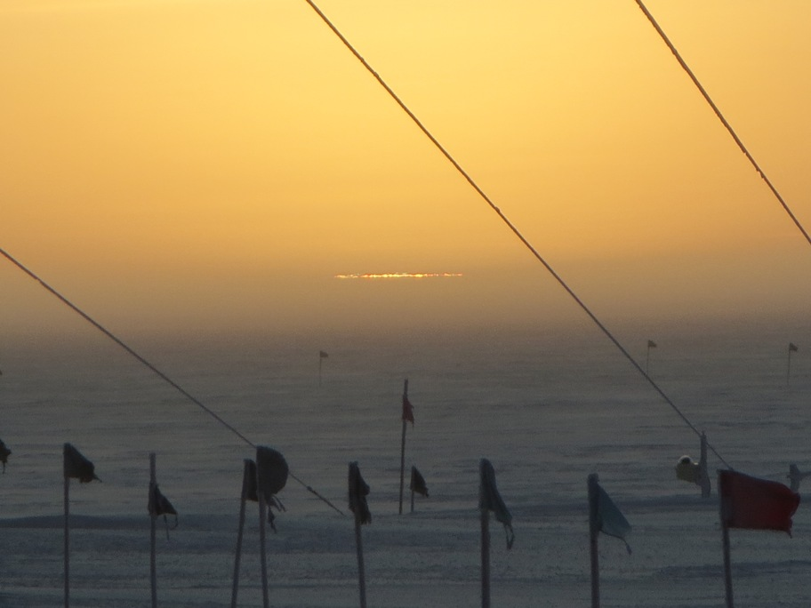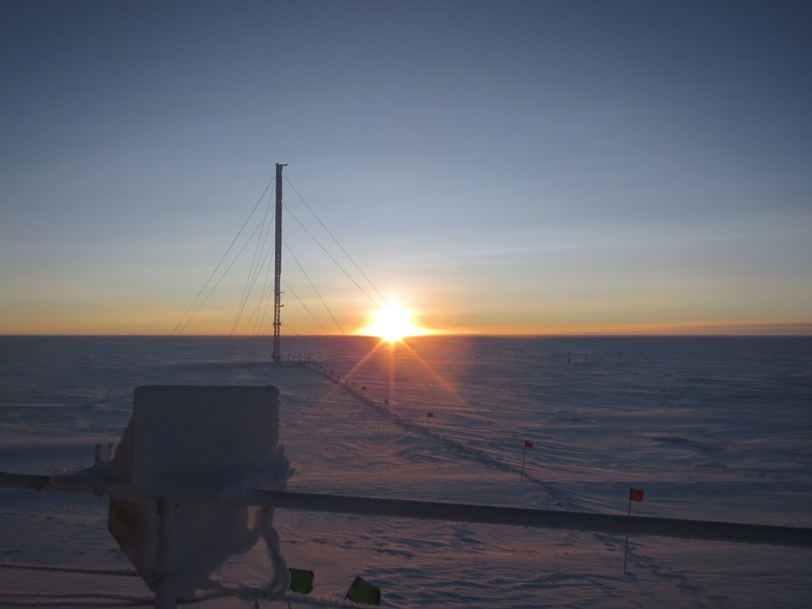
2/1: Sunrise, finally!

General:
- MSF facility operating normally.

Significant Weather Observations:
- 1/27: Winds 131 at 14kn, -32C, 78%, SCT-DRSN
- 1/28: Winds 176 at 10kn, -37C, 72%, SCT
- 1/29: Winds 158 at 13kn, -35C, 74%, SCT, mixed phase cloud layer at roughly 1200m from 0915 - 1345, good sonde trace through it, visible ice trails (virga?) falling from cloud, possibly imaged by ceilometer and MPL
- 1/30: Winds 100 at 15kn, -41C, 68%, FEW-DRSN
- 1/31: Winds 111 at 30kn (gusts to 40+), -27C, 82%. BKN-BLSN (Cond 1)
- 2/1: Winds 107 at 5kn, -36C, 72%, SKC, FZFG clearing at 13Z (interesting inversion in sonde data)
- 2/2: Winds 105 at 4kn, -37C, 73%, FEW, FZFG clearing at 1230Z (same inversion in sonde), fog returning later in day

Dataman Account:
- 1/27: 97 files remaining: sodar, Icecam. No PAERI data transferred because PAERI mount was down at time GetData script ran
- 1/28: 97 files remaining, sodar, Icecam
- 1/29: 97 files remaining, sodar, Icecam
- 1/30: ToBoulder clear
- 1/31: ToBoulder clear

MWR:
- 2/1: Significant accumulation of rime on south side of HATPRO and 90/150 windows, cleared

SODAR:
- 1/27: Sodar cleaned and measured for foam
- 2/1: Sodar cleaned; significant accumulation affecting data quality

POSS:
- Operating normally

MMCR:
- 2/1 12 – 13Z: single spike to 260W, RF power out of tolerance for 236 secs
- 2/2 1333Z: Dwell Display stalled out and Receiver/Modulator range resolution unchanging; initiated reboot, multiple attempts, succeed at 1635

CAPABL:
- No longer operating

MPL:
- 1/28: Afterpulse calibration
- 1/30 1900: Lost communication with AMCS card. Discovered and rebooted 1/31 13:10

VCEIL:
- 1/31: Window contamination and receiver crosstalk errors, probably due to blowing snow
- 2/1: Accumulation of snow above window, some cleared, but clearing leads to window soiling

IceCAM:
- Operating normally

PAERI:
- 1/27: Extended data dropout started at 0125Z, self-rebooted at least once (0800Z), no data collected from 0125 – 1225. Folder names corrected and manual reboot executed at 1225Z. Spectrum and data OK afterwards.

ASIA-A:
- 1/27: R2CH froze up in the midst of calibration, rebooted R2CH and radiometer twice, PC once

TSI:
- Offline for winter

IcePIC:
- 1/29: A lot rime and frosting on slide, then small columns, needles, prisms

Radiosonde:
- 1/31 12Z: RH trace somewhat erratic; probably due to sonde hitting the ground in 35kn launch
- Twice daily sondes

