ICECAPS Weekly Report
February 24 – March 2, 2014
Ward Handley

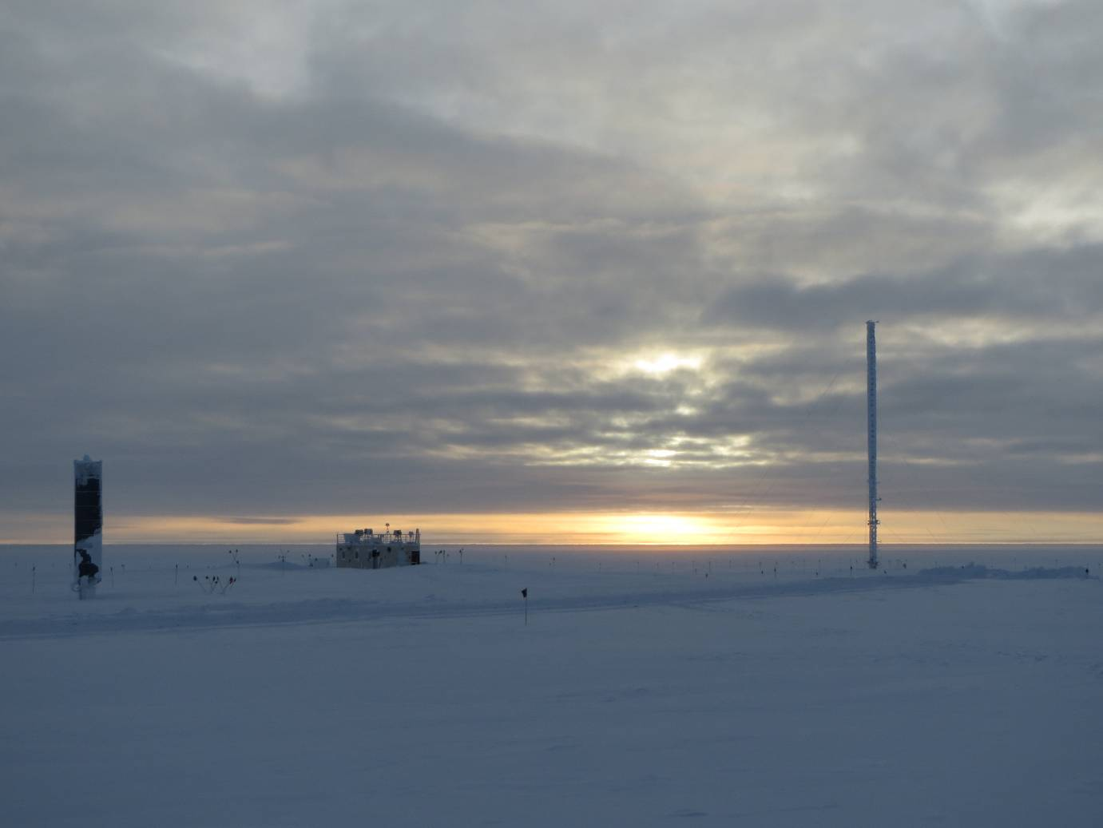
Broken cloud cover during the Polarsonde launch on 2/27 at 11:19UTC

General:
- Turn over with Ward Handley, the Phase 1 tech, was completed. Many thanks to John Lyons, the outgoing Phase 3 tech.
- 2/27: Two Twin Otters extracted the Phase 3 crew.
- MSF facility operating normally.

Significant Weather Observations:
- 2/24: Winds 13kn at 170˚, -52C, FEW-FZBR
- 2/25: Winds 4kn at 186˚, -55C, 57%RH, FEW-FZBR
- 2/26: Winds 12kn at 157˚, -38C, 71%RH, SCT
- 2/27: Winds 9kn at 180˚, -33C, 76%RH, VV100
- 2/28: Winds 7kn at 272˚, -25C, 84%RH, OVC
- 3/1: Winds 9kn at 47˚, -28C, 81%RH, OVC
- 3/2: Winds 5kn at 44˚, -36C, 74%RH, FEW-FZFG

Dataman Account:
- Operating normally

MWR:
- Operating normally

SODAR:
- Operating normally
- 2/28 @ 1345Z: transmitter and receiver dishes cleared of snow.

POSS:
- Operating normally
- 2/28 @ 1400Z: Divider cleared of rime.

MMCR:
- 2/24: Shut down for training purposes. Rebooted successfully on the first attempt.
- 2/24: TWTA desiccants replaced, used desiccants were recharged by baking @ 200F for 1+ hours.

CAPABL:
- No longer operating

MPL:
- 2/25 @ 2216Z - 2/26 @ 1400Z: AMCS card error. Computer rebooted and SigmaMPL restarted.
- 3/2 @ 0815 - 1443Z: AMCS card error. Computer rebooted and SigmaMPL restarted.

VCEIL:
- Operating normally

IceCAM:
- Operating normally

PAERI:
- 2/24-25: Very cold sustained temperatures (-55 to -61C) led to multiple red/yellow status lights. Despite this the PAERI continued to collect reasonable data.
- 2/28 @ 1350Z: Mirror cleared of snow.
- 3/2 @ 1315 – 1840Z: Fan frozen in place. It ran for a short while after rime was cleared, but ultimately seized up. Fan was replaced.
- 3/2: transient error on LW HBB NEN and SW HBB NEN (blue flag, NAN values).
- Ongoing: ABB Max Temp Diff consistently yellow (slightly higher than nominal) and HBB Max Temp Diff consistently yellow (significantly higher than nominal).

ASIA-A:
- 3/2 @ 0837 - 1538Z: R2CH software and clocks frozen, error “Master radiometer not calibrated!” cleared after multiple reboots.

TSI:
- Offline for winter

IcePIC:
- 2/25 @ 1830Z: Taken mainly for training purposes. Small (~100micron) bullet rosettes, small (~100micron) hollow columns, few prisms. T: -52 C, RH: 58%, wind: 3kn at 178, Sky conditions: SKC
- 2/28 @ 1653Z: ~700micron rimed crystals and irregular crystals of all sizes. MPL indicates a band of water droplets 1km high. T: -25C, RH: 84%, wind: 7kn at 272, Sky conditions: OVC

Radiosonde:
- 2/24 @ 24Z: two sondes had large RH sensor variations. The first was not launched; the second was launched as a last resort at 000847. The post-launch RH data appeared reliable despite the pre-launch variability.
- 2/25 @ 12Z: the aborted sonde from the night before was reconditioned and launched. It displayed the same characteristic: high variability in the RH measurements on the ground, but it appeared to be reliable following launch.
- 2/27 @ 12Z: Final polar sonde launched paired with the 12Z radiosonde to capitalize on a band of liquid water droplets at an altitude of 1km.
- 2/27 @ 24Z: High, but stable RH readings on the ground.
- 2/28 @ 12Z: Tandem launch with Ozonesonde coordinated with the MATCH campaign.
- 3/1 @ 24Z: GPS calculation failed even though sonde could see 8+ satellites.
- Twice daily sondes

