ICECAPS Weekly Report
March 3 – March 9, 2014
Ward Handley

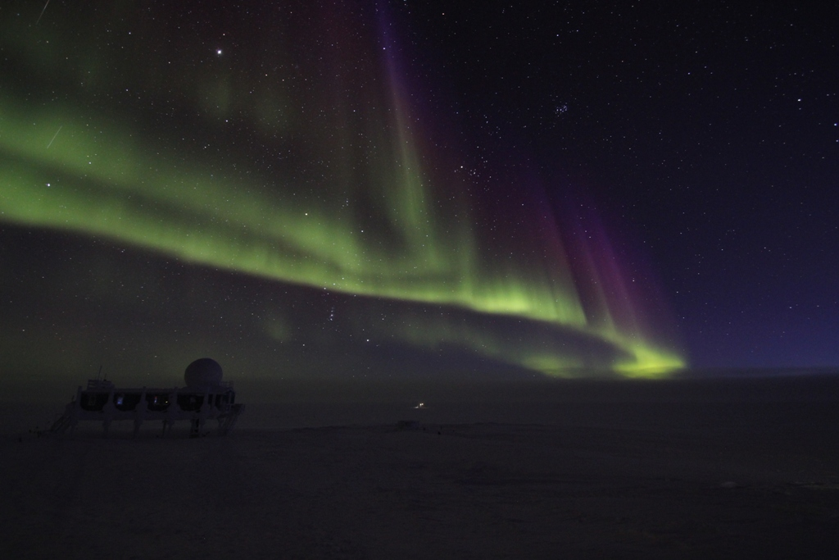
Clear atmospheric conditions made for excellent auroras and stargazing on the nights of 3/2-3/4. Photo credit: Scott Konu

General:
- MSF facility operating normally.
- 3/4 @ 1258Z: Time server reference changed to GPS following low temperature antenna installation on 3/1. All computers except Dataman and MMCR manually updated to new time by 1303Z.

Significant Weather Observations:
- 3/3: Winds 9kn at 181˚, -43C, 67%RH, FEW
- 3/4: Winds 1kn at 215˚, -33C, 76%RH, FEW
- 3/5: Winds 25kn at 87˚, -26C, 82%RH, OVC-BLSN
- 3/6: Winds 13kn at 102˚, -26C, 83%RH, OVC-DRSN
- 3/7: Winds 8kn at 90˚, -39C, 72%RH, FEW
- 3/8: Winds 8kn at 178˚, -42C, 68%RH, SCT (weak mixed phase)
- 3/9: Winds 7kn at 217˚, -46C, 65%RH, FEW

Dataman Account:
- 3/4: External hard drive #1 installed. Two additional drives arrived with the February resupply.
- Operating normally.

MWR:
- Operating normally.

SODAR:
- Operating normally.
- 3/5 @ 1815Z: SODAR dishes cleared of snow.

POSS:
- Operating normally.
- 3/8 @ 1305Z: Divider cleared of snow.

MMCR:
- Operating normally.

CAPABL:
- No longer operating.

MPL:
- Operating normally.
- 3/3 @ 1324-1348Z: AMCS card error. Computer rebooted and SigmaMPL restarted.
- 3/4 @ 0830-1245Z: AMCS card error. Computer rebooted and SigmaMPL restarted.
- 3/8 @ 0400-1300Z: AMCS card error. Computer rebooted and SigmaMPL restarted.
- 3/9 @ 0100Z: Unnecessary additional files created. Data appears to be normal.

VCEIL:
- Operating normally.

IceCAM:
- Operating normally.
- 3/9 @ 0500Z: corrupted image file.

PAERI:
- Operating normally.
- Ongoing: ABB Max Temp Diff consistently yellow (slightly higher than nominal) and HBB Max Temp Diff consistently yellow (significantly higher than nominal).

ASIA-A:
- Operating normally.
- 3/5 @ 0543-1339Z: R2HC and clocks frozen. System rebooted and time manually synched.
- 3/5 @ 1514-1526Z: R2HC and clocks frozen. System rebooted.
- 3/6 @ 1359-1420Z: Communication error. System rebooted.

TSI:
- Offline for winter

IcePIC:
- 3/6 @ 1455-1940Z: Needles and hollow columns up to 300 microns long, simple prisms ~50 microns in diameter.
- 3/8 @ 1325-1515Z: Hollow columns up to 1000 microns long, bullets 150-500microns long, bullet rosettes.
- 3/9 @ 1450-1635Z: No precipitation – windblown and surface grown crystals. 100 micron bullet rosettes. A few 150 micron hollow columns.

Radiosonde:
- 3/3: Desiccant in reconditioning unit replaced after lid was left open.
- 3/7 @ 24Z: High RH reading outside compared to NOAA MET data, but agreed very closely with Kestrel inside.
- 3/8 @ 12Z: Tandem launch with ozonesonde.
- 3/9 @ 24Z: Aborted sonde on ground due to 20% fluctuations in RH readings. A replacement sonde performed normally and was launched.
- Twice daily sondes.
- Background on the Ozonesonde Match Campaign from last week:
  - http://www.awi.de/en/research/research_divisions/climate_science/atmospheric_circulations/expeditions_campaigns/ozone_loss_campaigns_match/
  - The ozone abundance above an individual polar station changes constantly due to variable transport processes. Such dynamically caused fluctuations mask anthropogenic chemical loss and have to be separated from any chemical ozone loss signal. Instead of observing time series of ozone at fixed locations (i.e. in an Eulerian sense) the Match approach is based on Lagrangian measurements. The basic idea is to perform repeated measurements in individual air masses as they drift across the polar cap and sometimes happen to approach one of many ozonesonde stations distributed in the polar region. The principle advantage of this procedure is that the advection terms which dominate ozone changes in the Eulerian framework disappear in the Lagrangian formulation of the continuity equation. The impact of diffusion terms in the continuity equation can also be limited by careful selection of the observed air masses based on properties of the flow. Hence, changes in the concentration of ozone during the time interval between two measurements can be attributed to a chemical depletion. The statistical analysis of a very large number of such pairs of measurements it is possible to directly observe anthropogenic chemical ozone depletion and to measure chemical ozone loss rates in situ.

