ICECAPS Weekly Report
March 17 – March 23, 2014
Ward Handley

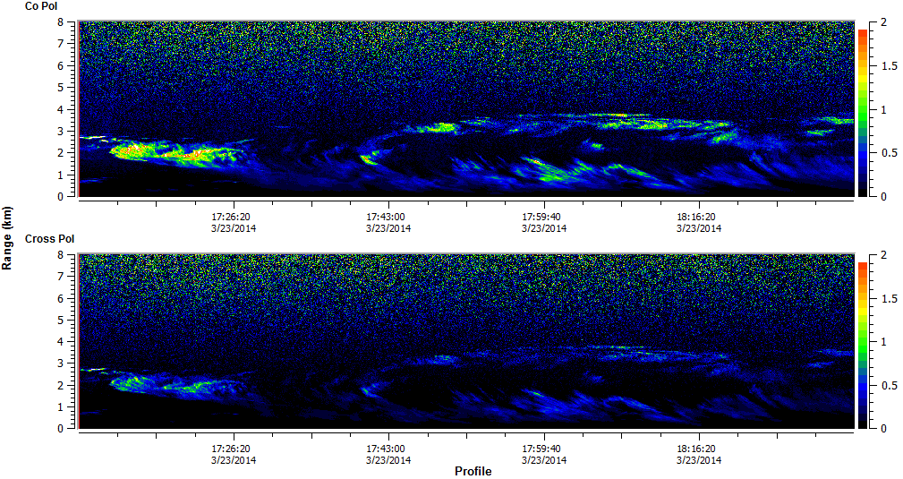
Interesting cloud structure captured by the MPL on 3/23

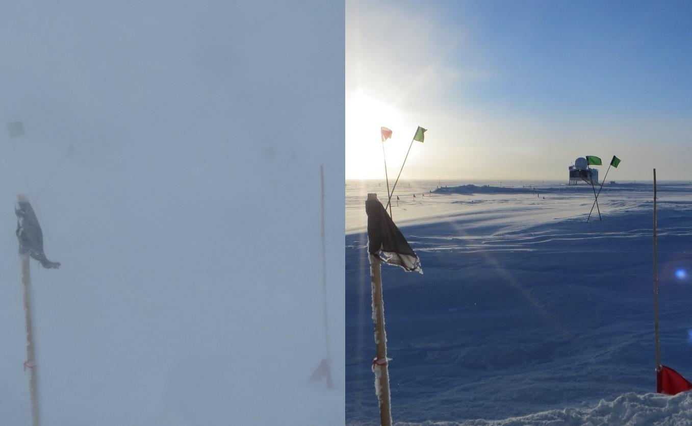
View from the front door of the MSF: 3/18 and 3/21
General:
- MSF facility operating normally.
- Power outage on 3/21 from 1220-1231Z. UPS power covered the outage.

Significant Weather Observations:
- 3/17: Winds 13kn at 29˚, -50C, 60%RH, FEW
- 3/18: Winds 34kn at 126˚, -34C, 74%RH, VV025-DRSN-BLSN
- 3/19: Winds 23kn at 150˚, -36C, 72%RH, VV100-DRSN-BLSN
- 3/20: Winds 14kn at 171˚, -38C, 70%RH, SCT-DRSN (weak mixed phase)
- 3/21: Winds 6kn at 206˚, -48C, 67%RH, FEW
- 3/22: Winds 8kn at 231˚, -56C, 59%RH, SKC
- 3/23: Winds 13kn at 179˚, -42C, 66%RH, SCT

Dataman Account:
- Operating normally.
- 3/22 @ 0130Z: Icecaps.bash hung on poorly named ICEPIC files. Computer unresponsive and rebooted at 1710Z. RAID remounted with a different path so Icecaps.bash was not able to collect the day’s data for transfer back to Boulder. Fixed by Matt Shupe on 3/23 and the backlog of files started to be transferred.

MWR:
- Operating normally.

SODAR:
- Operating normally.
- 3/20 @ 1314-1322: SODAR dishes checked for snow.

POSS:
- Operating normally.
- 3/22: posacq stopped multiple times for Icecaps computer reboot.

MMCR:
- Operating normally.
- 3/18: TWTA was squealing intermittently this morning (as in the startup phase).

CAPABL:
- No longer operating.

MPL:
- Operating normally.
- 3/16 @ 1830 – 3/17 @ 0135Z: AMCS card error.
- 3/17 @ 1413: “Out of storage buffers” error coincided with the computer lagging out for several minutes. I had to go into task manager to unfreeze SigmaMPL.
- 3/18 @ 0840-1307Z: AMCS card error.
- 3/18 @ 1453 – 3/19 @ 1403Z: AMCS card error.
- 3/19 @ 1830-2232Z: AMCS card error.
- 3/23: Interesting cloud profile. See above.
VCEIL:
- Operating normally.

IceCAM:
- Operating normally.
- 3/21 @ 1230Z: Another corrupted image file. 0 byte .jpg file where MIME type is “text/plain” – maybe this is the default MIME for an empty file of all extensions?
- 3/22: Icecaps.bash hung at 0130Z. IceCAM did not take pictures until the following day.

PAERI:
- Operating normally.
- 3/23 @ 0730-1430: PAERI scan mirror frozen in place. PAERI rebooted.

ASIA-A:
- Operating normally.
- 3/18 @ 2051 – 3/19 @ 1422Z: ASIAA software and clocks frozen. Communication error.
- 3/20 @ 0219Z: Communication error. Software rebooted.

TSI:
- Offline for winter

IcePIC:
- 3/17 @ 1435-1705Z: 100-200 micron bullets and needles. Few needle and bullet rosettes. Few 50 micron simple prisms. The upwind slide is heavily populated with pulverized wind blown crystals.
- 3/20 @ 1355-1640Z: Must be carefully analyzed. Significant crystal growth occurs between beginning and end of pictures. Compare DSC_0005 and DSC_0038. Needles up to 300 microns. Bullet rosettes up to 250 microns, but many 100 micron rosettes. Hollow columns from 50 microns up to a few 400 microns long. 50 to 150 micron simple prisms. Rimed and irregular crystals.
- 3/21: Yukimarimo formed over night, but the winds stayed too light to continue forming them during the day. A series of IcePIC micrographs, surface pictures, and video were taken throughout the day.
- 3/23 @ 1725-1915Z: Needles averaging 300 microns but a few as long as 600 microns. Bullets and bullet rosettes to 600 microns. Simple plates 50-200 microns across. Few radiating plate dendrites up to 300 microns.
- Fix rear bayonet on standard lens?

Radiosonde:
- 3/18 @ 12Z: no radiosonde prepped due to high winds (34kn with 40kn gusts).
- 3/18 @ 24Z: partially failed sounding in high winds. GPS, wind and pressure data collected, but no RH or temperature data collected.
- 3/21 @ 12Z: tandem launch with ozonesonde.
- 3/22 @ 24Z: two radiosondes with large RH variations (square wave profile). First was aborted, second was launched due to time constraints. Aborted sonde launched 3/23 @ 24Z.
- Switch to morning K-sondes next week?
- Twice daily sondes.

