ICECAPS Weekly Report
March 24 – March 30, 2014
Ward Handley

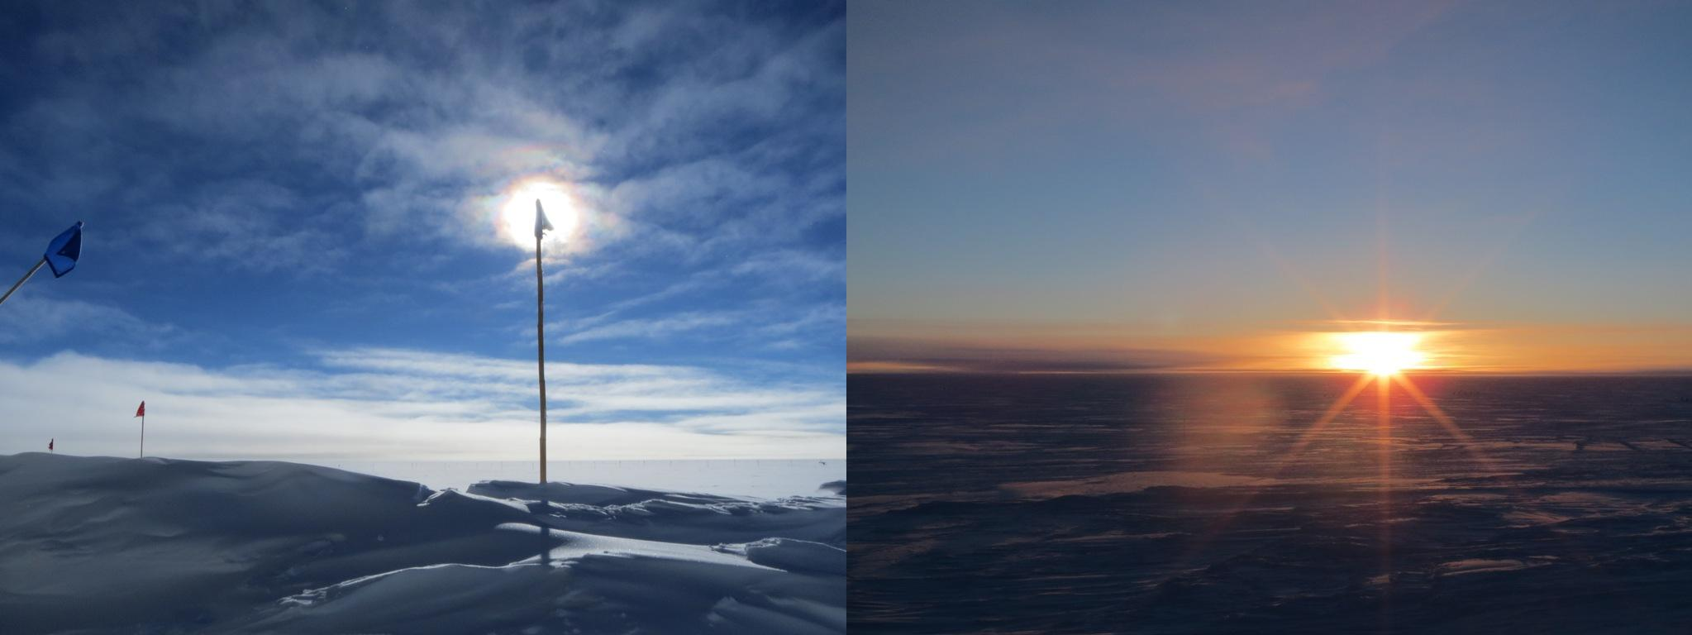
Mixed cloud cover on 3/27 @ 1400Z and 2115Z

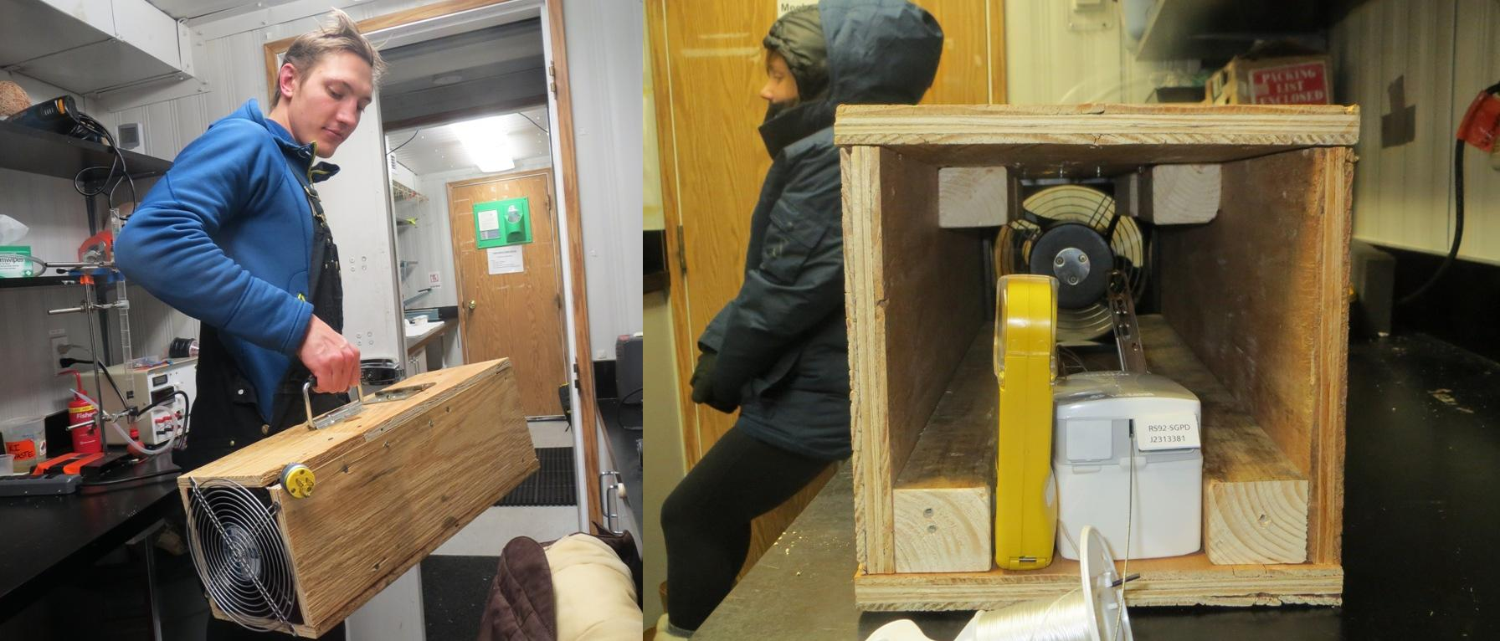
The new radiosonde “Wind Tunnel”

General:
- MSF facility operating normally.
- Radiosonde computer and MSF “admin” computer upgraded to Office 2010. Thanks Matt!
- Local daylight savings time change occurred on 3/29.

Significant Weather Observations:
- Strong mixed phase clouds throughout the week.
- 3/24: Winds 15kn at 167˚, -36C, 73%RH, FEW-DRSN-BLSN
- 3/25: Winds 20kn at 127˚, -31C, 78%RH, BKN-DRSN
- 3/26: Winds 37kn at 127˚, -28C, 80%RH, VV030-DRSN-BLSN
- 3/27: Winds 10kn at 210˚, -27C, 82%RH, OVC-FZBR
- 3/28: Winds 13kn at 177˚, -34C, 75%RH, BKN-FZBR
- 3/29: Winds 18kn at 213˚, -26C, 83%RH, SCT-FZBR-DRSN
- 3/30: Winds 10kn at 190˚, -25C, 84%RH, SCT

Dataman Account:
- Operating normally.

MWR:
- Operating normally.

SODAR:
- Operating normally.
- 3/24 @ 1815-1858: SODAR cleared of snow. Door on receiver was frozen closed.

POSS:
- Operating normally.

MMCR:
- Operating normally.

CAPABL:
- No longer operating.

MPL:
- Operating normally.
- 3/24 @ 0705-1257Z: AMCS card error. Autostart for SigmaMPL defaults to incorrect operational settings: Laser Control should be off and Bin Resolution should be 15m.
- 3/25 @ 1314-1331Z: Afterpulse calibration.
- 3/26: Four AMCS card errors.

VCEIL:
- Operating normally.

IceCAM:
- Operating normally.

PAERI:
- Operating normally.
- 3/26 @ 0514-0529: data dropped out, all indicators blue. Came back online by itself.
- 3/27 @ 1335Z: PAERI fan tube cleared of heavy snow build up, which deposited snow on the mirror. The mirror was cleaned.

ASIA-A:
- Operating normally.
- 3/24: Pierre started a 24 hour stability test.
- 3/26: Communication error. System rebooted.

TSI:
- Offline for winter

IcePIC:
- 3/27 @ 1445-1725Z: Very few crystals collected. 500 micron rimed bullets and 1000 micron rimes bullet rosettes. Irregular crystals up to 800 microns. Mixed phase cloud at 0.4km.
- 3/28 @ 1450-2100Z: 10-20 micron rime droplets, 50-100 micron simple prisms, needles to 600 microns, columns to 150microns. Upwind slide also had large 300Wx600L micron columns.
- 3/29: thawed and cleaned microscope due to fogginess in previous two IcePIC sets.

Radiosonde:
- Twice daily sondes.
- 3/28: PAERI fan box for aspirating sondes on calm days was built.

