ICECAPS Weekly Report
March 31 – April 6, 2014
Ward Handley

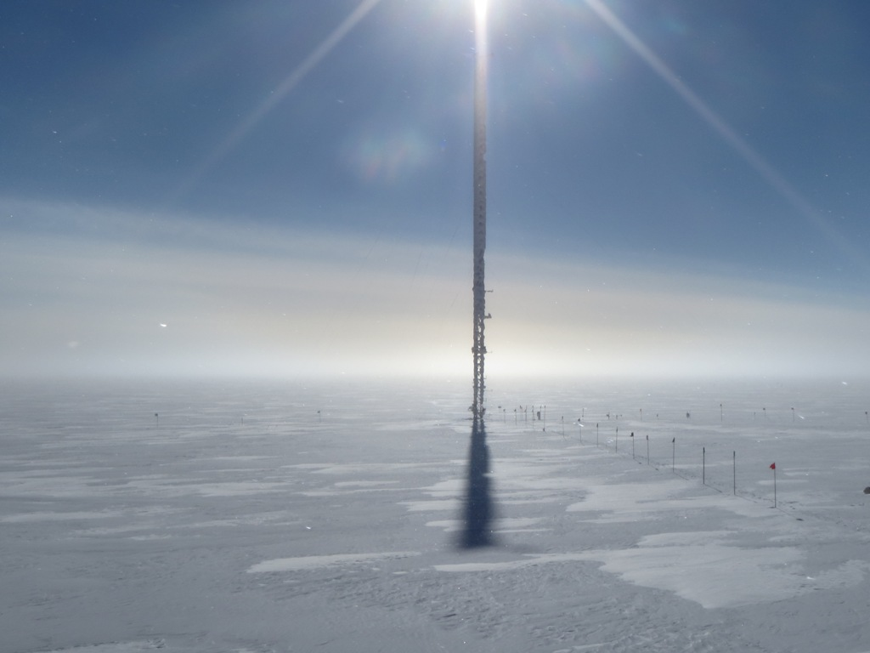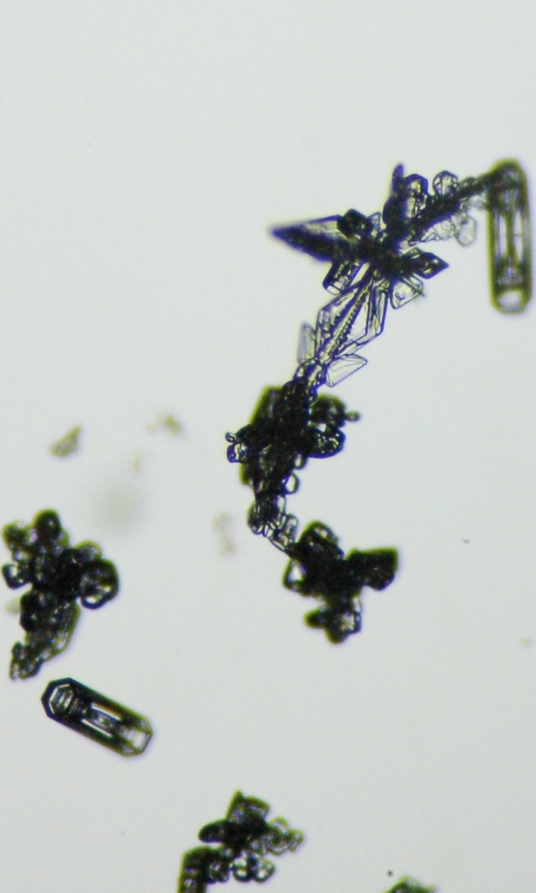
View from the roof just before IcePIC slides were set out on 4/3

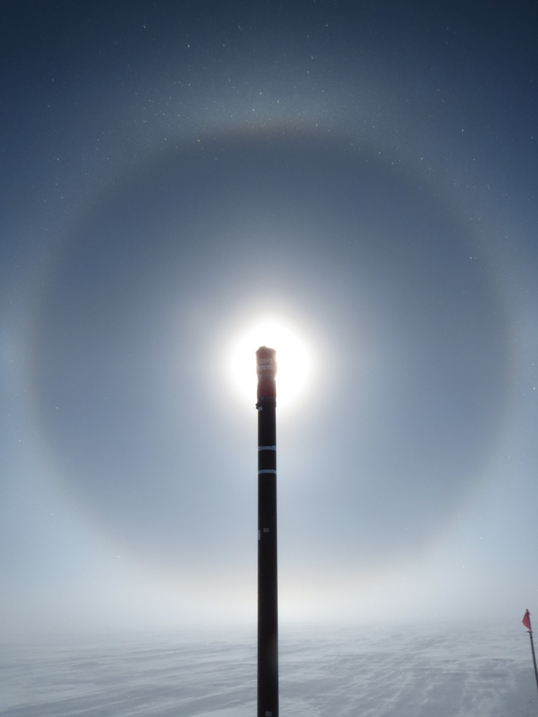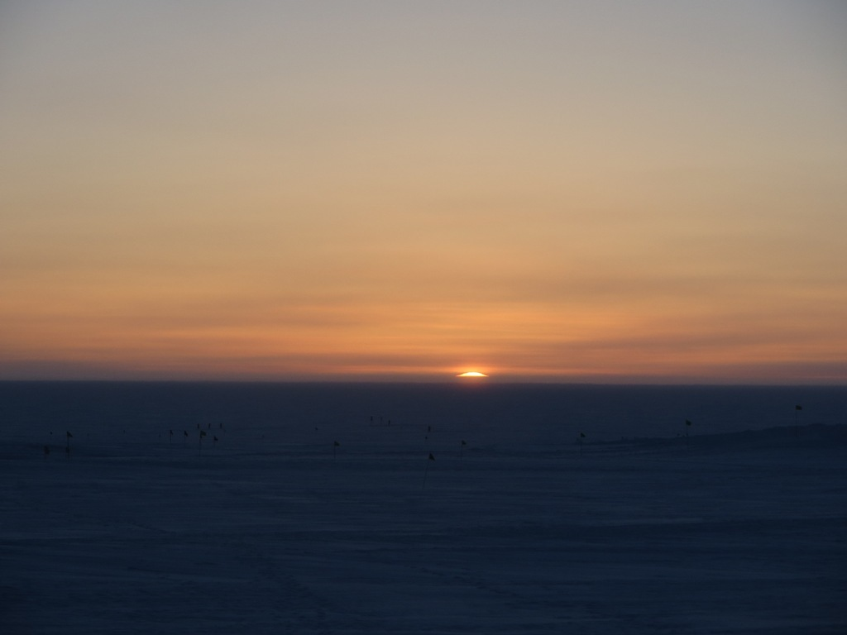
Using the GISP2 borehole to occult the sun on 4/4, and a nice sunset on 4/3
General:
- MSF facility operating normally.
- Two 433MHz antennas for communicating with the Swiss instruments on the 50m tower and solar platforms were installed at the bottom of the southern roof handrail near the TSI mount.
- Are there any studies on the frequency and intensity of solar halos at Summit? Stephan Nyeki of the Swiss group wants to know: stephan.nyeki@pmodwrc.ch

Significant Weather Observations:
- 3/31: Winds 8kn at 167˚, -25C, 85%RH, BKN
- 4/1: Winds 14kn at 201˚, -25C, 84%RH, BKN-DRSN
- 4/2: Winds 10kn at 151˚, -27C, 80%RH, SCT-FZBR
- 4/3: Winds 11kn at 227˚, -30C, 75%RH, SCT-FZBR
- 4/4: Winds 16kn at 191˚, -32C, 74%RH, FEW-FZBR
- 4/5: Winds 16kn at 180˚, -25C, 78%RH, FEW-BLSN
- 4/6: Winds 24kn at 154˚, -20C, 87%RH, VV013-BLSN

Dataman Account:
- Operating normally.

MWR:
- Operating normally.
- 90/150 power cable is damaged, but functional. All other HATPRO and 90/150 cables are sound. Replacement required this summer.

SODAR:
- Operating normally.
- 4/3: Noise from equipment ops visible in data from 1300Z throughout the remainder of the day.

POSS:
- Operating normally.

MMCR:
- Operating normally.

CAPABL:
- No longer operating.

MPL:
- Operating normally.
- 4/5 @ 0505-1320Z: AMCS card error.

VCEIL:
- Operating normally.

IceCAM:
- Operating normally.
- 4/1 @ 1045Z: Screen shot file created, but no data written.
- 4/6 @ 1600Z: Screen shot file created, but no data written.

PAERI:
- Operating normally.
- Was it possible to download the Yukimarimo videos from the Summit FTP site?
- 3/6: local AERI display did not come up when the computer rebooted at midnight. Ingest is running so all data files are present and quicklooks are reasonable.

ASIA-A:
- Operating normally.
- 3/31: ASIAA level slightly off in East-West direction. PI has been notified.
- 4/5 @ 0037-1328Z: Communication error. Clocks resynched and computer rebooted.

TSI:
- Offline for winter

IcePIC:
- 3/31 @ 1640-1830Z: Large irregular crystals to 1000 microns. Simple prisms to 300 microns. Columns to 400 microns. 600 micron bullet rosettes. Many crystals appear partially melted - not sure if this was natural, or due to handling that warmed the slide.
- 4/3 @ 1320-1645Z: Irregular crystals up to 800 microns. Bullet rosettes to 300 microns. Hollow columns to 200 microns.

Radiosonde:
- Twice daily sondes.
- Wind tunnel testing ongoing.
- 3/31: Ground station desiccant reconditioned by baking at 250C for 3 hours per manual.
- 4/2 @ 24Z: radiosonde not closed out on time.
- 4/3 @ 12Z: tandem launch with NOAA ozonesonde.
- 4/5 @ 12Z: Digicora could not see the GPS base station. Aborting the sonde and restarting Digicora fixed the issue.

